Berkswell Church of England (VA) Primary School
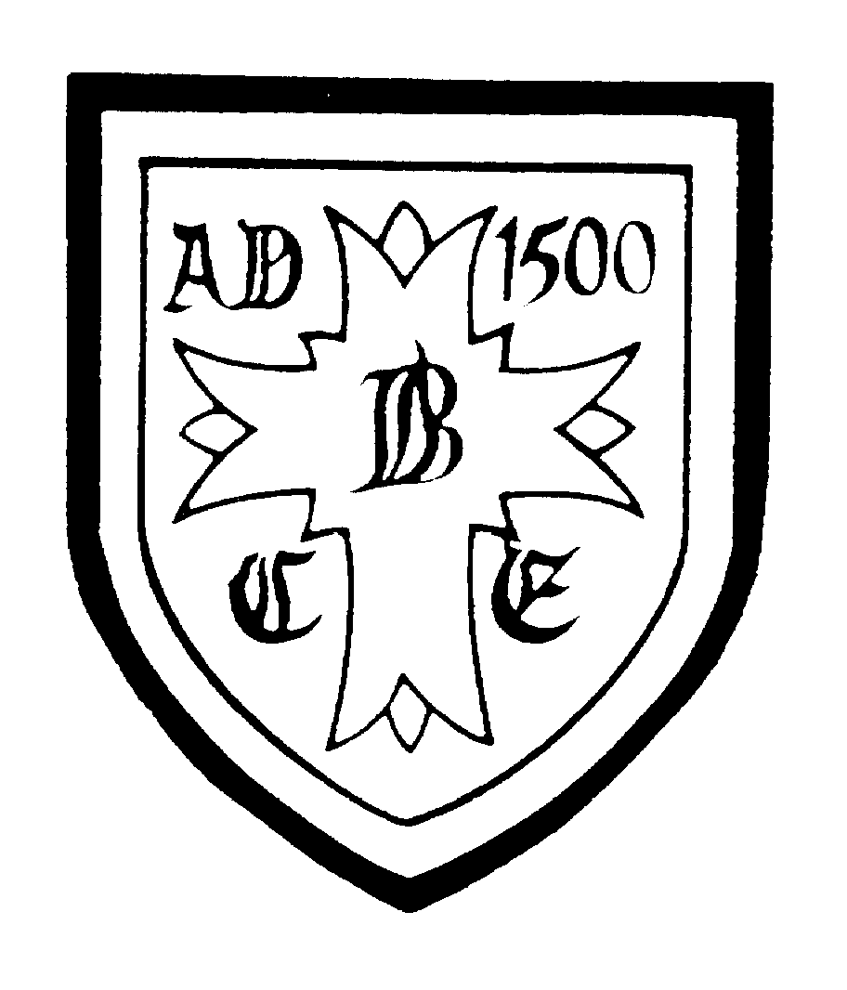

Church Lane, Berkswell, Coventry, CV7 7BJ
01676 532141
office@berkswell.solihull.sch.uk

KS2 Teaching Assistant
Temporary contract (in the first instance) from 1 September 2021 – 31 July 2022
20 hours term time only plus INSET days
Band B - £18812.00 - £19562.00 pro rata

For September 2021
NOR 236 (including Nursery)

Berkswell CE Primary School is an ‘Outstanding’, oversubscribed, one form entry school with a strong Christian ethos and a great sense of community. We are looking for an experienced KS2 Teaching Assistant to join our well-established team from September 2021.

The Governors are looking to appoint a dynamic and enthusiastic teaching assistant who:
- will support and promote the Christian ethos and values of the school
- is able to support the class teacher and deliver interventions
- has recent experience of working with children in KS2
- has high standards and expectations in every aspect of school life
- is committed to working as part of our KS2 team
- has experience of supporting children of all ability ranges including SEN/EAL/AGT
- is an inclusive practitioner who firmly believes that all pupils can succeed
- is able to communicate effectively with parents/carers
- is committed to continued professional development

We offer:
- a school where every individual child is of the utmost importance
- children who love school and are fully engaged in their learning
- an excellent team of supportive staff, governors and parents
- a commitment to continued professional development
- an enriching learning environment in a beautiful rural setting

Visits to the school are very much encouraged, they currently will need to take place after school following our COVID rules; please telephone the school office to make an appointment.

Closing date: 9am, Monday 17 May 2021
Interviews: Wednesday 19 May 2021

The school is committed to safeguarding and promoting the welfare of children and young people and expects all its staff and volunteers to share this commitment. An enhanced DBS check is required for all successful applicants.

