Thank you for considering Ferndown Middle School for your next appointment.

Ferndown Middle School is part of the Southern Education Trust – a Trust which prides itself on putting children first always and puts its values of Respect, Independence, Creativity and Inclusion at the heart of everything we do.
It is the staff in our academies who make our schools vibrant places of learning – who do all they can to make sure our children become confident individuals, successful learners and responsible citizens. Our staff want to make a real difference to the lives of the children they work with and are learners themselves who relish professional development opportunities.
Working in a Southern Education Trust school, you will be working with other forward thinkers, who see possibilities and are optimistic. You will have the support of like-minded colleagues and together we will ensure everyone has a great work life balance. Being part of the Southern Education Trust means there are a whole host of opportunities for you to develop and flourish.
Ferndown Middle School is situated in Ferndown adjacent to Ferndown First and Ferndown Upper Schools. The school has up to 600 pupils, covering the age range 9 to 13 years old (year groups 5 to 8).

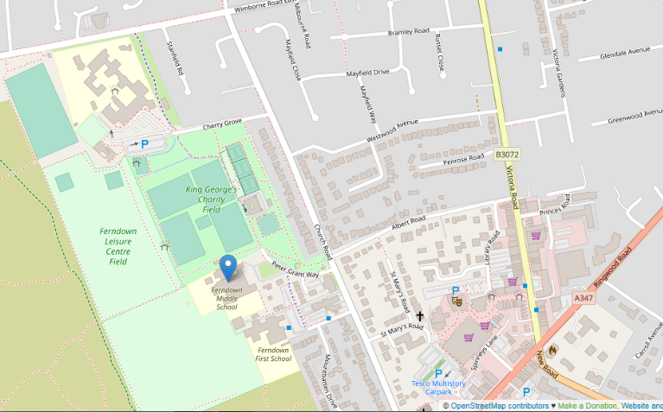
Contact Details
Ferndown Middle School
Peter Grant Way
Ferndown
Dorset
BH22 9UP

Telephone: 01202 876556

Email: office@fernmid.dorset.sch.uk

Website: www.fernmid.dorset.sch.uk

School Vision
At Ferndown Middle School, we have three core outcomes; to develop confident and successful learners; to exemplify and cultivate responsible citizens and to inspire children to be aspirational individuals.
Our vision is for all children at Ferndown Middle School to be confident and successful learners; well-equipped and resourced for the world they will inherit. This will of course start by ensuring all children make excellent academic progress and achieve their highest potential. However, learning at Ferndown Middle School is deeper than just this; it is about guiding children to develop a genuine love of learning and an understanding of both the purpose and importance of learning beyond the classroom.
We also want our children to become responsible citizens in the world they live in. This is about helping them to see how the choices and decisions they make not only impact themselves, but also those around them. This begins locally; with friendship groups, school communities, clubs and our locality but has much farther-reaching impacts as children consider their roles and responsibilities in our wider, global community. Ultimately, it is about shifting the children’s focus from primarily thinking about themselves and instead, to consider deeply, the impact they have on those around them.
Finally, our vision is for all children to leave us aspirational individuals. By guiding children to consider their purpose and place in not only our school community but also the global community, they can begin to develop a vision of how their future selves will play an important role in the society they live. Whilst all adults have high aspirations for every child, our vision is that children are aspirational, taking it upon themselves to be the best they can be.
We aim to equip your child with the skills, knowledge and character to achieve a lifetime of fulfilment.

Intent
At the heart of our curriculum lie three core values: excellence for all, the explicit teaching of learning to learn, and crucially, the development of character education.

Excellence for All
Excellence for All is fundamental within our ethos. The children’s acquisition of a deep body of knowledge within subject disciplines will enable them to express their learning to the highest standard. When children achieve excellence, this gives them the confidence to challenge themselves further. Through this process of experiencing success, they will develop character, for example resilience, determination and self-confidence.
We ensure that we offer a wide range of curriculum experiences that go beyond subject disciplines. Each of our experiences are underpinned by Ferndown Middle School’s principles which include, learning at all times being real, relevant, engaging, progressive and at the same time, allow children to think and act like scientists, historians, artists, writers, mathematicians etc.

Character Education
Whilst academic success remains a core priority, developing character is also an essential for the development of your child. Our school gives children opportunities to make a positive impact on society. We want them to grasp the possibilities and opportunities of life beyond the classroom, to enable them to thrive at each and every challenge they face in life and make a difference to themselves and those around them. To do this the development of character is essential. Supporting the engendering of positive character traits not only prepares our children to meet the challenges of later life but also supports academic excellence.

Learning to learn
Our curriculum not only focuses on achieving character whilst pursuing excellence for all, but also emphasises deep knowledge through developing the skills of learning. We use an enquiry approach to drive our learning experiences, making the reflective learning process explicit. In addition to this, tools for thinking will be taught to support children’s higher order thinking, synthesis of knowledge and the creation of new thinking. At Ferndown Middle School, metacognition revolves around each child understanding the learning process, where their ability to think for themselves, reflect and evaluate their learning is fundamental in preparing them for their current and future success.

Opportunities for English
Reading is prioritised in our curriculum - both in terms of financial investment and in terms of the provision of time. All our children have daily opportunities to read with the aim of promoting a love of reading, supported by access to our well-stocked library. High-quality texts are carefully matched to children’s reading ability, at all stages in school. Assessments are used for the early identification of children who need additional support, and this is provided speedily so that all children are able to succeed.
Opportunities to incorporate reading and writing within learning experiences will be taken. Children will have access to rich texts to not only deepen knowledge of the subject they are studying but also to be immersed in high quality vocabulary and language. They will not only read to deepen comprehension, but they will also read to help inform writing to achieve high quality outcomes. Curriculum rigour including, handwriting, grammar and spelling are essential skills which the children will demonstrate with great flair in the many opportunities we give them to write.

Mathematics
Our approach to the teaching of mathematics is founded on the principles of mastery mathematics and the aims of the National Curriculum. We will ensure that our children acquire deep understanding of mathematical concepts using metacognition to reflect upon the connective model (concrete, pictorial and abstract) and to achieve academic excellence. Through the study of mathematics, they will also develop their character through the way that they approach problems, working in teams, seeking challenges, and presenting their thinking.
Children will achieve academic excellence through becoming fluent in the fundamentals of mathematics, including arithmetic. We will achieve this through building in deliberate, frequent practice and revision with increasingly complex problems over time so that pupils develop conceptual understanding and the ability to recall and apply knowledge rapidly and accurately.
We will develop the children’s ability to reason mathematically by following a line of enquiry, conjecturing relationships and generalisations, and developing an argument, justification or proof using mathematical language. The children will learn to solve increasingly sophisticated problems, using metacognition to break down problems into a series of simpler steps, and developing character while persevering in seeking solutions.

Enriching Learning
To deepen learning, every opportunity will be taken to enrich the curriculum by providing memorable experiences through access to experts and visits. Our children will be immersed in the experience of being a historian, scientist or writer through first hand, active learning.
Our intent is to offer a curriculum that gives new experiences to all learners, beyond those contained within the National Curriculum. We want our children to build on their own identified talents and have the opportunity to discover new interests and perhaps develop a passion for these that may shape their future lives.
In a world where communication is crucial, we prioritise supporting our young people to become confident and articulate speakers having had the opportunity to work with experts and refine these skills through public speaking and presentation.
Through the core values of Excellence for All, Character Development and Learning to Learn, our children will flourish.

Special Educational Needs
At Ferndown Middle School, we aim to provide effective opportunities for all pupils, including those with Special Educational Needs, in all areas of the curriculum. We are a good school with good and outstanding teachers and therefore the majority of needs are met by universal, targeted, differentiated, quality-first teaching in each classroom. We have high aspirations and expectations of all our pupils and set appropriate learning challenges for each pupil’s level of ability both in the lesson and for homework. Individual and group interventions are provided for those identified as requiring structured programmes and support. At Ferndown Middle School, we use the Three Wave Model, a graduated approach to special needs.
Wave 1
Wave 1 is on offer for all students, in inclusive, high-quality learning classrooms. Teachers will use the SENDCo’s guidance and within their subject aim to remove barriers and meet need. The next stage is about teachers knowing and deciding at what point, for any individual pupil good, universally targeted quality-first teaching is not enough. This is when support will move to Wave 2.
Wave 2
Staff record evidence to show the strategies tried and demonstrate what has worked and what has not worked. This information forms evidence to inform the next steps.
Wave 3
Wave 3 is the final stage when there is a trail of evidence that Wave 1 and 2 interventions do not meet identified need. At this point, the SENDCo and possibly external professionals become more closely involved in identifying, planning, monitoring and reviewing individual support across the curriculum.

Pupil Premium
The pupil premium is a Government initiative that provides specific funds targeted at improving outcomes for students from deprived backgrounds. Research has indicated that this group of students underachieve when compared to non-deprived peers. The premium is provided in order to support these pupils in fulfilling their potential and not being disadvantaged.

Safeguarding
Ferndown Middle School recognises that the welfare of the child is paramount and takes seriously its responsibility to safeguard and promote the welfare of the children and young people in its care.
Mrs Allen is the Designated Safeguarding Lead and Mrs Giddens is the deputy. Both have had specialist training in safeguarding and child protection.
Our full Child Protection Policy can be found on our website along with further government guidance and support documentation.

E-Safety
At Ferndown Middle School, we take e-safety extremely seriously. We believe that it is the right of all children to feel safe and secure when using technology. Our E-Safety Policy contains detailed information about how we ensure our children remain safe in their use of technology.
We teach children to use the internet and other technologies safely, and we show them how to behave in an appropriate manner. It is important to encourage a healthy lifestyle with regard to the use of technology and teach children about the risks of exposure to inappropriate content or too much time in front of a screen. We show children how to keep their data and security safe, and we teach them to be critical of the things they see online.

