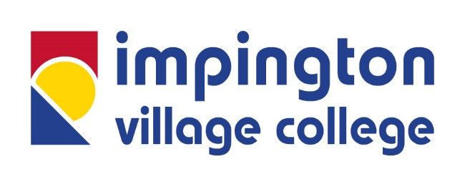

Impington Village College (IVC)
Lead Practitioner for History
Required: September 2021
Salary: IVC Leadership Scale 3-7

Join East Anglia’s “State Secondary School of the Year” 2020
This role, suitable for an experienced Lead Teacher looking for a promotion to a senior middle leadership position, is a unique chance to develop your leadership capacity and transform your career opportunities. This is an exciting new role, arising from a need to expand and develop the leadership and teaching capacity in History, where you will have the opportunity to shape the future of History in the College. History is our most popular option subject at IVC, at both KS4 and KS5, and delivers consistently excellent outcomes. You will also have the opportunity to contribute to the wider development of the College, including the delivery of whole-College CPD and involvement in quality assurance, as part of your Lead Practitioner role.
The successful candidate will benefit from:
- £2000 Personal Professional Development Bursary including funding and support to complete Masters Level qualification in Educational Leadership and Management
- Coaching from a member of SLT
- 2 Year Professional Development Programme in Leadership and Management and the opportunity to complete accredited courses including the NPQML or NPQSL in 2021-22
With a truly comprehensive intake, student progress is regularly in the top 5% of all non-selective schools in the country, and the College has now been voted by the Sunday Times Parent Power as one of the top three comprehensive schools in the UK for two years running. In 2020 it was also voted East Anglia’s State Secondary School of the Year. The College has also received a number of other national accolades, including the Gold Carnegie Medal for its work in supporting mental health and wellbeing, and SSAT Awards for progress, attainment, leadership and curriculum design, as well as the British Council International Schools Award.
Student attainment is exceptionally high, with 15% of all grades at Grade 9, 43% at 7-9 (or equivalent) and 95% of grades at 4-9. As an IB World School, the College offers a unique and innovative curriculum, with a weekly enrichment programme for all students as part of the College timetable, and with a focus on wellbeing at its heart.
History outcomes at GCSE are consistently excellent for both attainment and progress across a large cohort of students (typically around 150). In the first two years of the reformed GCSEs, the results have been very strong, with 20% of all students obtaining a Grade 9 and 45% achieving at least a Grade 7. History attracts a genuinely comprehensive cohort, and we successfully run the entry level course alongside the GCSE for a small number of students. Outcomes are similarly strong in the sixth form, with large numbers of students achieving above the IB World Average and History being a popular choice for university applications, including Oxbridge, Russell Group and several prestigious overseas universities.

You will be joining an innovative and collaborative faculty where staff are highly committed to professional development and to developing students' love of History. You will lead five other colleagues who teach within the department, and support a range of trainees. The team run a range of exciting extra-curricular activities and trips to support the curriculum. September 2021 is a particularly exciting time to be joining IVC, as we will be launching the IB Middle Years Programme at KS3 to transform students’ experiences, and will become the only state school in the UK to offer three IB programmes.

With your knowledge and passion for History you will have the opportunity to build upon the successful curriculum embedded at IVC and to establish your own vision for delivering a high quality learning experience to our inspirational students.
In return IVC and the Eastern Learning Alliance (ELA) can offer you:
- a competitive salary including a recruitment and retention allowance for the right candidate
- reduced contact time for all teachers to facilitate professional learning/reduce workload
- further reduction in contact time for teachers new to the College, to support effective transition into post
- the opportunity to teach all key stages including the International Baccalaureate in our Sixth Form
- the opportunity to work for a faculty where collaboration is a high priority and the programme of professional learning is outstanding
- the chance to play a significant role in the future development of the College as a Lead Practitioner, in a place where middle leaders are highly respected and valued
- excellent career pathway opportunities with a culture of looking to promote from within, including responsibility across the Trust
- access to the opportunities created by our newly established Eastern Learning Alliance, where IVC is the Lead School
- support to undertake a Masters in Education through our links with Cambridge University, the “SUPER Programme” and other L5 accredited providers
- support in an organisation where wellbeing is at the heart of everything we do and which has led to the introduction of a successful wellbeing directory to improve wellbeing and work-life balance and where flexible working is encouraged
- subsidised access to the ELA’s sports centre leisure facilities available for use before, during and after the school day

The Eastern Learning Alliance is committed to Equal Opportunities and to safeguarding and promoting the welfare of children and young people and expects all staff to share this commitment. All post holders are subject to employment checks and a satisfactory enhanced Disclosure and Barring Service check.
Closing Date: 9am Wednesday 3 February

An application pack is available from our website www.impington.cambs.sch.uk. Applicants must complete a College application form - we cannot accept CVs. Potential applicants are strongly encouraged to visit the College and please contact our HR Team on hrenquiries@ivc.tmet.org.uk to arrange a visit.

