

Lead Teacher for Key Stage 3 Science
JOIN OUR TEAM
For Appointment of:
Based in Tonbridge, Kent, Hillview School for Girls is an 11 to 18 girls’ all-ability school with a thriving, mixed Sixth Form. We chose to become an academy in August 2011 and are one of the highest-achieving non-selective girls’ School in Kent. Our dynamic Performing and Visual Arts specialisms have a profound impact upon learning and contribute to the purposeful, friendly and stimulating atmosphere that permeates the school. We foster
self-esteem and high aspirations.

By encouraging a ‘can-do’ culture, our students become astute, ambitious and independent. Visitors often comment about how articulate and enthusiastic our students are. We believe in the pure potential of every child within the school, to develop, mature and thrive, leaving education fully ready for the world of employment. We place a high emphasis on education beyond grades, actively exploring a wide range of opportunities to develop the awareness and engagement of our students in the world around them.

Hillview is a fully inclusive school where independence is developed through an innovative education and inspirational opportunities.

Our vision is that: students unlock their pure potential to drive their future and thrive in society.

The pure potential belief is integral to everything that we do in school and the outcomes we expect for our students. The skills and beliefs at the heart of the pure potential graphic pull together the Performing Arts values, the desirable attributes of a future employee and awareness of the world. Hillview believes in success and achievement beyond grades and highly values the breadth of character and experience that enables our alumni to stand out from the crowd and secure a successful role in the ever-changing modern world. Through our inclusive Hillview society, we actively develop and promote the independent learner and thinker, encouraging students to try, make mistakes and learn for themselves.

We help students develop a range of transferable skills from teamwork, leadership and independence through to communication, self-expression and time management. Our strong pastoral system ensures that behaviour is excellent and there is a relaxed but purposeful atmosphere throughout the school where young people can thrive and feel supported.

We have a vibrant, mixed Sixth Form that provides a variety of pathways for students to extend their learning, gain work experience with one of our many industry partners and prepare for university or work.

Further details of the school, including breakdown of performance figures, can be accessed through: www.hillview.kent.sch.uk

Applicants are warmly invited to visit the school before applying.

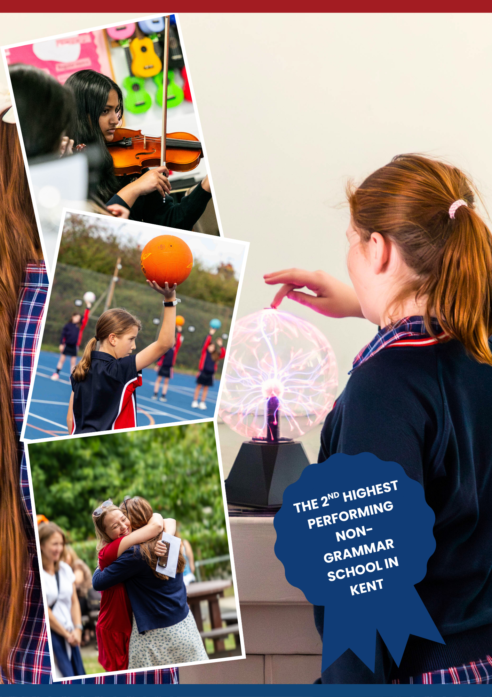


Line Manager: Director of Science

Core purpose of the post
- To ensure Key Stage 3 students’ Science skills are enhanced through regular tracking and appropriate intervention to provide a high quality educational experience for all children.

General duties and responsibilities
- To carry out the duties of a schoolteacher as set out in the School Teachers’ Pay and Conditions Document,
- To continue to meet the required standards for Qualified Teacher Status.
- To be fully involved in the department including the leading of extra-curricular clubs and activities.

Knowledge and understanding
- Understand how pupils’ learning is effected by their physical, intellectual, emotional and social development and understand all stages of child development.
- Have a sound knowledge of the Art curriculum.

Planning, teaching and class management
- Provide clear structure for lessons and for sequences of lessons, which maintain pace, motivation and challenge.
- Prepare sequences of lessons that ensure students are able to meet requirements for coursework within the set timescales;.
- Plan for assessment windows and provide colleagues with suitable materials to ensure robust and standardised assessments in the subject.
- Make effective use of assessment information on pupils’ attainment and progress and in planning future learning.
- Ensure effective teaching of whole classes, groups and individuals, supporting colleagues in establishing high expectations of behaviour and attainment, so that teaching objectives are met.
- Monitor and intervene when supporting colleagues to ensure sound learning and discipline and maintain a safe environment in which pupils feel confident.
- Support colleagues in using a variety of teaching and learning approaches to keep all pupils engaged.
- Provide coaching, model and share good practice to improve performance, where necessary.
- Be familiar with the SEN Code of Practice and policies to support in the identification, assessment and support of pupils with additional educational needs.
- Evaluate your own teaching and that of others critically to improve effectiveness.

Job Title: Lead Teacher for Key Stage 3 Science
Location: Tonbridge, Kent

MPS/UPS + TLR 2c
JOB DESCRIPTION



Monitoring, assessment, recording, reporting and accountability
- Monitor and evaluate Key Stage 3 students’ attainment in Science, ensuring the Director of Science is aware of any issues and the implications for expected levels of progress.
- Work with the Director of Science and other department leader(s) to implement strategies across the department, to ensure all students make expected progress or better and tackle underachievement in Science by the end of the year/ Key Stage 3.
- Interpret comparative data regarding students’ performance in Science.
- Model and share good practice for teaching and assessment at Key Stage 3.
- Monitor and be responsible for the objectives identified within the Department Improvement Plan relating to students’ achievement in Science in Key Stage 3.
- Liaise with the SENCO and appropriate Learning Support Assistants in order to develop strategies for differentiation and improving students’ progress.
- Lead on the creation, implementation and improvement of Key Stage 3 schemes of learning, resources and assessments.
- Keep up-to-date with subject developments and innovations that lead to improvement in student performance.
- Lead and facilitate department meeting and CPD opportunities for the whole department for and beyond for Key Stage 3.

Leading and Managing Staff
- Work with individuals where necessary to enhance the consistent performance of the whole team.
- Create, maintain and enhance effective relationships so that the potential of those in the team is realised.
- Identify practice that is found to be less than good in order to maintain high standards and work with the Director of Science to address any issues.

Person Specification
The following selection criteria are the skills and experience required for this position.
- Knowledge and understanding of the demands of the Science syllabus.
- An ability to differentiate effectively and to use a variety of teaching and learning styles.
- A commitment to developing teaching and learning styles in Science.
- Confidence to be pro-active and a good role model.
- A strategist, who can provide clear vision and high expectations.
- A positive record of building strong working relationships, with a strong emotional intelligence.
- The ability to think logically, analyse situations and recognise cause and effect.
- Commitment to developing additional opportunities for learning: external links; extra- curricular clubs.
- Confidence and belief in own ability to be effective and to take on challenges.
- The aptitude and energy to set clear expectations and parameters.
- The ability to lead and motivate others to achieve shared goals.
- Commitment to continuous professional development.
- To work with middle and senior leaders to ensure whole school improvement.
- A positive outlook with a good sense of humour.
- A proven record of building strong working relationships and to work well with colleagues from across the school staffing body.
- A confident and positive approach to communicating with parents and students.
- Competence in the use of ICT packages, including data analysis tools.

The Science Department at Hillview School for Girls has operated as part of an Academy since 2011, and the school uses Rosenshine’s Principles of instruction to underpin classroom practice across all departments.

Staffing
The Department is comprised of the equivalent of 10 full-time teachers, all graduate specialists. They are supported by two full-time technicians. The current department structure comprises of a Head of Department and a Second in Department.

The Department is involved in initial teacher training where staff from the Department deliver some of the theoretical aspects of the training as well as the day-to-day practical mentoring of the trainees.

Courses
Hillview School for Girls has a 2-week timetable that consists of 25 periods per week, and each period is 1 hour in duration. In Key Stage 3, Year 7 and Year 8 classes have 6 periods of Science, and we use the AQA ‘Big Ideas’ as a working framework. We operate an accelerated curriculum in the Science department and the Key Stage 3 course is mainly delivered over 2 years which provides a solid foundation for GCSE sciences. There is a heavy emphasis on practical work and discovery as well as developing investigative skills.

As part of Hillview’s Accelerated Curriculum, Key Stage 4 students start their study in AQA Biology, AQA Chemistry and AQA Physics courses in Year 9. In Year 9 all pupils study all 3 Sciences and have the option of either taking all 3 Separate Sciences or taking the Combined GCSE course for their further study into Years 10 and 11. In Years 9, 10 and 11, students studying the Combined course have 8 periods per fortnight, split between the two GCSEs over the three year course. Separate Sciences have 13 hours per fortnight, split between the three Sciences over Years 10 and 11.

Sciences are an increasingly popular choice in the Sixth Form. We are looking to keep developing this interest with our KS4 students. We currently offer GCE Biology, GCE Chemistry and AAQ BTEC Applied Science. Year 12 and 13 GCE students have 10 hours of study per fortnight with an additional fortnightly assessment hour which is supervised directed study time, while BTEC students have 1 hour less.

Extracurricular activities
Each Key Stage has its own homework club/drop-in sessions available to pupils to consolidate or receive help across all subjects. The Department is looking to expand the enrichment opportunities offered across the department. Key Stage 3 students can also currently attend a Science Club and have enrichment trips to Herstmonceux and Wakehurst. We would also like to work towards the Eco-Schools Green Flag Award and are always looking at STEM opportunities to develop understanding and engagement in Science across the school. KS5 Students also have the opportunity to attend public conferences that focus on new advances in scientific research.

The Post
We are seeking to appoint a committed member of staff with a passion for Science, who is capable and enthusiastic about teaching with the ability to deliver high quality lessons and achieve excellent results across all key stages. If you have a passion for Science and want to share this with students, then we want to hear from you.

Members of the department are encouraged to attend relevant CPD to keep themselves updated on teaching strategies and changes to the examination system. The school is committed to staff development and provides excellent opportunities for career development.

They are also expected to contribute to the various activities undertaken by the department including interventions to support A Level and GCSE students and revision classes.

A key attribute of the successful candidate will be the skill to further develop the talents of highly committed and enthusiastic Science teaching and support teams.

The Science Department Arts


A completed application form should be sent, by post or by email, to Mrs. A. Dennett (HR Manager) dennetta@hillview.kent.sch.uk

Closing date for applications: Friday 30 January 2026

Interview date: To be confirmed

THE APPLICATION PROCESS


Website:
https://www.hillview.kent.sch.uk/
Telephone:
01732 352793

Email:
dennetta@hillview.kent.sch.uk
Hillview School for Girls
Brionne Gardens
Tonbridge
Kent, TN9 2HE
SAT NAV POSTCODE: TN9 2DQ

