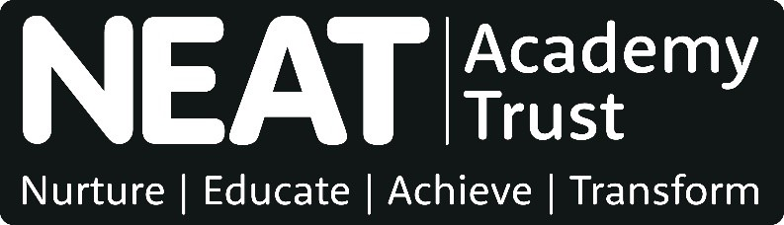
Job Description

Job Title: |  | Lead Teacher – Whole School Numeracy, Literacy or STEAM (Science, Technology, Engineering, the Arts and Mathematics)
School: |  | Benfield School
Date: | September 2019 | Status: | Final | Pay Range: | Main/Upper Pay Range plus TLR 2a
Responsible to: |  | Assistant Headteacher – Achievement Key Stage 4/Whole School Curriculum
Responsible for: |  | Not applicable
Job purpose: |  | To be accountable for educational outcomes of learners across Key Stages 3-5 by effectively leading the development of whole school numeracy, literacy or STEAM across all curriculum areas and enabling effective teaching and learning.

Main responsibilities

The following is typical of the duties the post holder will be expected to perform. It is not necessarily exhaustive and other duties of a similar nature and level may be required from time to time.

General

1 Carry out the professional duties of a Teacher as set out in the School Teachers' Pay and Conditions Document. Carry out teaching duties in accordance with the school's schemes of work and the National Curriculum.

Lead Teaching and Learning Responsibilities

- Lead, develop and evaluate numeracy, literacy or STEAM across all curriculum areas to provide an ambitious curriculum that meets the needs of all learners and improves their outcomes, and contribute to the development of an integrated trust-wide approach for all age groups.

- Lead learning of numeracy, literacy or STEAM across Key Stages 3-5 including developing and implementing assessment, data analysis and appropriate intervention strategies to ensure that all learners are well prepared for the next stage of education, employment or training.

- Lead, develop and enhance the teaching methods and practice of others through coaching, professional development and promoting improvement strategies to secure effective teaching and learning for all learners.

- Facilitate a culture across the school which encourages colleagues to work collaboratively, share knowledge and understanding, celebrate success and accept responsibility for outcomes.

Generic Teaching and Learning Responsibilities

- Establish a positive, purposeful and safe learning environment and develop positive relationships to support learners to manage their own behaviour constructively. Establish and maintain a consistent and supportive culture in line with the school’s Behaviour Policy by establishing and maintaining a clear and positive framework for discipline and a supportive culture in line with the school’s behaviour policy.

- Contribute to the monitoring and development of a designated area of learning and/or age phase, and pupil attainment and progress across the curriculum, to ensure appropriate opportunities are provided for learner aspirations to be met.

- Plan effectively in the short, medium- and long-term and prepare effective learning sequences, lessons and work across a series of lessons to ensure coverage of the curriculum and the bespoke needs of learners are met. Plan and prepare homework and other out of class work.

- Be aware of and apply a range of teaching and learning strategies, including implementing inclusive practices, to ensure that the diverse needs of learners are met. Deliver lessons to groups of learners or classes. Demonstrate the positive values, attitudes and behaviour expected from learners.

- Assess, record and report on the development and progress of learners and analyse relevant data to promote the highest possible aspirations for learners and target expectations and actions to raise learners’ achievements. Provide timely, accurate and constructive feedback on learners’ attainment, progress and areas of development.

- Demonstrate ongoing development and application of teaching practice, expertise and subject, specialism and/or phase knowledge to enrich the learning experience within and beyond the teacher’s assigned classes or groups of learners.

- Communicate effectively and work collaboratively within and beyond the classroom with support staff (including directing their day-to-day work), teachers, other professionals, parents, carers, agencies and communities, to enhance teaching and learning and promote the positive contribution and well-being of learners.

- Contribute to the development and implementation of priorities, policies and activities in order to enable the achievement of whole school and trust aims.

- Take responsibility for ensuring an awareness and understanding of local opportunities which support our school communities.

In addition, Upper Pay Range teachers are expected to:

- Make significant contributions to implementing workplace policies and practice and to promote their implementation.

- Give advice on the development and wellbeing of children and young people, if required.

- Promote collaboration between colleagues and contribute to their professional development through coaching and mentoring, demonstrating effective practice, and providing advice and feedback.

Trust responsibilities

- Work to fulfil the vision and values of the trust.

- Assist in maintaining a healthy, safe and secure environment and act in accordance with the trust’s health and safety policies and the school’s/central team’s health and safety procedures.

- Promote and implement the trust’s equality and diversity policy in all aspects of employment and service delivery.

- Promote and safeguard the welfare of children and young persons s/he is responsible for, or comes into contact with, in accordance with the trust’s safeguarding policy and school’s child protection policies and protocols.

- Assist in ensuring the trust’s responsibilities to protect personal data and to share information as a public authority are implemented effectively.

- Participate in appraisal, training and development and other activities that contribute to performance management.

- Attend and participate in regular team and 1:1 meetings.

