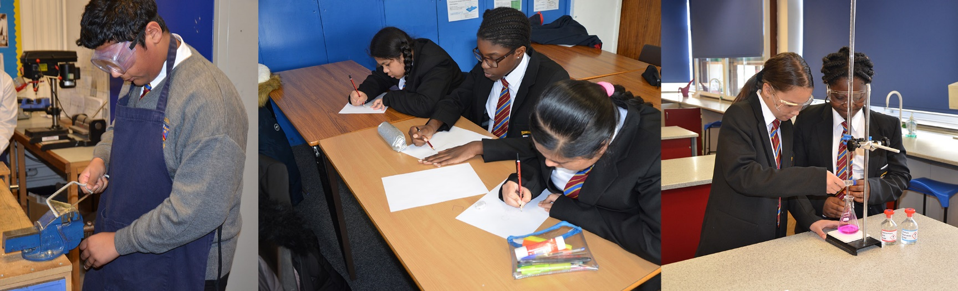

**Lead Teacher of Performing Arts – Music & Drama**

**Saint John Wall Catholic School is a highly successful oversubscribed 11‐16 school with a mixed and diverse population, serving the community of North West Birmingham. Over 50% of our pupils qualify for additional Pupil Premium funding, and there are over 50 different languages spoken by members of our school community!**

**The Role**

**As the Lead Teacher of Performing Arts you will lead on the delivery of music and drama to maintain and further develop the effective delivery of an outstanding curriculum, which will enable the highest quality of education within the department. You will lead a highly professional team, and will promote outstanding academic and personal achievement, working in a nurturing and rigorous environment.**

**Responsibilities**

**You will strive to deliver a highly engaging and challenging curriculum that inspires children and develops their skills and subject knowledge.**

**The Individual**

**You are someone who understands the difference a great education can make to pupils’ lives. You are committed to our mission statement and are a great role model for pupils and colleagues. You must be educated to degree level or above and have experience in delivering a consistently outstanding curriculum to pupils of all ages and abilities. You will need to be a great team player and teacher with a resilient character and strong personal drive.**

**Saint John Wall Catholic School** [**enquiry@sjw.bham.sch.uk**](mailto:enquiry@sjw.bham.sch.uk) **Archdiocese  
Oxhill Road, Handsworth 0121 554 1825** [**www.sjw.bham.sch.uk**](http://www.sjw.bham.sch.uk) **of  
Birmingham B21 8HH Birmingham**



**Saint John Wall Catholic School – *A Catholic School For All  
‘To educate each and every unique child in our care  
 to hear and respond to what God calls them to be’***

**Salary**

MPS/UPS + TLR2b

To start 1 September 2022

**Closing Date**

9.00am 23 May 2022

**Informal visits**

**I**nformal visits to school prior to application can be arranged by contacting Mrs Page on 0121 554 1825 or by email to [enquiry@sjw.bham.sch.uk](mailto:enquiry@sjw.bham.sch.uk)

**Application form and Job Description can be found at** [www.sjw.bham.sch.uk\About](http://www.sjw.bham.sch.uk\About) Us\Vacancies

***As a Catholic School we will expect that you actively support the Catholic ethos, and help us to follow the highest standards of safeguarding for our pupils. The successful candidate will be subject to enhanced DBS and any other relevant employment checks.***