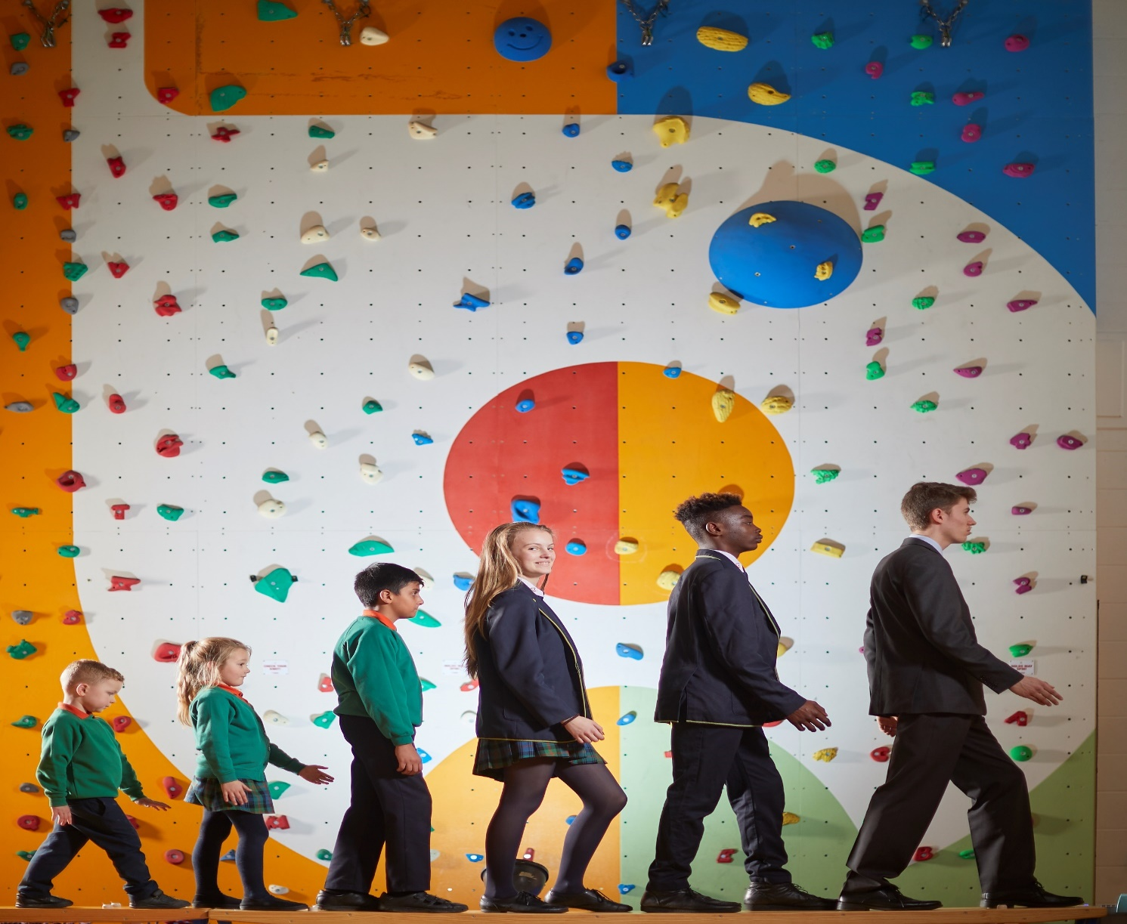

Contents

• Letter from Executive Principal

• Job Description

• Person Specification

• Information for Applicants

Dear Applicant

Thank you for requesting details about a support role at Bradford Academy. Our vision describes our mission:

Known by God
Valued as unique
Understood and accepted
Guided to be the best we can be
We are a shining light in our community
Using opportunities to change our lives and those of others
“A city on a hill cannot be hidden”
Our mission is to make a difference.
You have shown interest in us at an exciting time. We are a "Good" school as recognised by OFSTED both in February 2013 and December 2017. We are rightly proud that all aspects of our provision; Early years, Primary, Secondary and Post-16 are consistently good and have been since 2013. You can read the full report in the OFSTED section of our website.
As a Church of England academy, faith sits at the heart of all that we do, I am proud to lead a team of dedicated staff who are enthusiastic about learning, and committed to our young people and their educational and spiritual journey. We work with a range of partners to ensure that the experience of our young people is personalised, appropriate and challenging. Our work in building a strong community and collaborating innovatively with partners has been recognized by being awarded the prestigious Times Education Supplement award for Community and Collaboration. Our strong community builds a solid foundation from which all can excel.
With over 1800 learners from the ages of 2 to 19, we have transformed the community in which we are deeply rooted. We have two resourced provisions in our Secondary Phase (DSP); one for Physical Disability and one for Autism. This reflects the breadth and diversity of society and in addition to providing education and experiences for learners with additional needs, it also teaches all our students to value and respect everyone as equals. The majority of our youngsters remain with us into Post-16 and 70% of learner’s progress to higher education each year.
You will appreciate that this is no mean feat and we don’t sit still. We invest in supporting our students and our teaching staff and we know that the various support roles are integral to our success.

I have lived and worked in Bradford throughout my teaching career. It holds a vibrant, diverse community and possesses unique character. Its diversity reflects Britain. The Academy plays an important part in preparing young people for life in our complex society. Students are prepared to be active participants in their own communities through developing relationships and understanding the importance of exercising their voice. We hold this dear and believe it to be a major reason behind our success. We are developing leaders for the future; both staff and students.

I have worked at the Academy since its inception and am incredibly proud of our achievements. Success is down to working hard. We listen to each other. We do not shy away from challenge.

Why do you want to work for this Academy? I would ask you reflect on the following:

- Your tenacity in being the best.
- Your sense of moral purpose.

You need to be committed to improving the life chances of our students for whom educational success is the only secure route to raising the quality of their future lives. Can you demonstrate how you would contribute to our team to get results? You get things done.

We need colleagues who share our values and aspirations.

Does this resonate with you? Are you inspired? Then start your journey and submit your application.

Yours sincerely,

Tehmina Hashmi
Executive Principal

If you would like more information please contact our HR Department on
01274 256789 or by email to recruitment@bradfordacademy.co.uk

Job Description
Learning Assistant

Main purpose
The Learning Assistant will:
- Work with class teachers to raise the learning and attainment of pupils
- Promote pupils’ independence, self-esteem and social inclusion
- Give support to pupils, individually or in groups, so they can access the curriculum, take part in learning and experience a sense of achievement

Duties and responsibilities
Teaching and learning
- Demonstrate an informed and efficient approach to teaching and learning by adopting relevant strategies to support the work of the teacher and increase achievement of all pupils including, where appropriate, those with special educational needs and disabilities (SEND)
- Promote, support and facilitate inclusion by encouraging participation of all pupils in learning and extracurricular activities
- Use effective behaviour management strategies consistently in line with the school’s policy and procedures
- Support class teachers with maintaining good order and discipline among pupils, managing behaviour effectively to ensure a good and safe learning environment
- Organise and manage teaching space and resources to help maintain a stimulating and safe learning environment
- Observe pupil performance and pass observations on to the class teacher
- Supervise a class if the teacher is temporarily unavailable
- Use ICT skills to advance pupils’ learning
- Undertake any other relevant duties given by the class teacher

Planning
- Contribute to effective assessment and planning by supporting the monitoring, recording and reporting of pupil performance and progress as appropriate to the level of the role
- Read and understand lesson plans shared prior to lessons, if available
- Prepare the classroom for lessons

Working with colleagues and other relevant professionals
- Communicate effectively with other staff members and pupils, and with parents and carers under the direction of the class teacher
- Communicate their knowledge and understanding of pupils to other school staff and education, health and social care professionals, so that informed decision making can take place on intervention and provision
- With the class teacher, keep other professionals accurately informed of performance and progress or concerns they may have about the pupils they work with
- Understand their role in order to be able to work collaboratively with classroom teachers and other colleagues, including specialist advisory teachers
- Collaborate and work with colleagues and other relevant professionals within and beyond the school
- Develop effective professional relationships with colleagues

Whole-school organisation, strategy and development
- Contribute to the development, implementation and evaluation of the school’s policies, practices and procedures, so as to support the school’s values and vision
- Make a positive contribution to the wider life and ethos of the school

Health and safety
- Promote the safety and wellbeing of pupils, and help to safeguard pupils’ well-being by following the requirements of Keeping Children Safe in Education and our school’s child protection policy
- Look after children who are upset or have had accidents

Professional development
- Help keep their own knowledge and understanding relevant and up-to-date by reflecting on their own practice, liaising with school leaders, and identifying relevant professional development to improve personal effectiveness
- Take opportunities to build the appropriate skills, qualifications, and/or experience needed for the role, with support from the school
- Take part in the school’s appraisal procedures

Personal and professional conduct
- Uphold public trust in the education profession and maintain high standards of ethics and behaviour, within and outside school
- Have proper and professional regard for the ethos, policies and practices of the school, and maintain high standards of attendance and punctuality
- Demonstrate positive attitudes, values and behaviours to develop and sustain effective relationships with the school community
- Respect individual differences and cultural diversity
The Learning Assistant will be required to safeguard and promote the welfare of children and young people, and follow school policies and the staff code of conduct.
Please note that this is illustrative of the general nature and level of responsibility of the role. It is not a comprehensive list of all tasks that the teacher will carry out. The postholder may be required to do other duties appropriate to the level of the role, as directed by the headteacher or line manager.

Person specification
criteria | qualities  You may wish to classify these as “essential” or “desirable” depending on your expectations for the role
Qualifications  and experience | - Level 2 or 3 Certificate in Supporting Teaching and Learning in Schools, Level 3 Diploma in Childcare and Education, or other relevant qualification in nursery work or childcare is desirable (or willingness to work towards a qualification if not already held)  - GCSEs at grades 9 to 4 (A* to C) including English and maths is essential  - Experience of working with children is essential  - Experience of planning and leading teaching and learning activities (under supervision) is desirable
Skills and knowledge | - Good literacy and numeracy skills  - Good organisational skills  - Ability to build effective working relationships with pupils and adults  - Skills and expertise in understanding the needs of all pupils  - Knowledge of how to help adapt and deliver support to meet individual needs  - Subject and curriculum knowledge relevant to the role, and ability to apply this effectively in supporting teachers and pupils  - Excellent verbal communication skills  - Active listening skills  - The ability to remain calm in stressful situations  - Knowledge of guidance and requirements around safeguarding children  - Good ICT skills, particularly using ICT to support learning  - Understanding of roles and responsibilities within the classroom and whole school context
Personal qualities | - Enjoyment of working with children  - Sensitivity and understanding, to help build good relationships with pupils  - A commitment to getting the best outcomes for all pupils and promoting the ethos and values of the school  - Commitment to maintaining confidentiality at all times  - Commitment to safeguarding pupil’s wellbeing and equality

Notes:
This job description may be amended at any time in consultation with the postholder.

Last review date: 2nd December 2021

Next review date: December 2022

Information for Applicants

Safeguarding

Bradford Academy is committed to safeguarding and promoting the welfare of children and vulnerable adults and expects all staff and volunteers to share in this commitment. All successful candidates will be expected to undergo an enhanced DBS check and any offer of employment will be subject to its return plus receiving satisfactory references, children’s barred list check and section 128 check (where relevant). Please see our DBS Policy in the Academy Info/Policies area for our policy pertaining to the recruitment of ex-offenders.
It is an offence to apply for a role if you are barred from engaging in regulated activity relevant to children.

Job Description

This tells you the main responsibilities of the post and explains what we are looking for. It tells you about the personal and professional qualities you need for this post. These criteria will be used to make the appointment.

Person Specification

This specification sets out which criteria will be used to shortlist candidates for interview.

Visiting

We welcome informal visits from all Applicants before they apply. If you wish to do so, please contact recruitment@BradfordAcademy.co.uk to arrange an appointment.

Applying

If you decide to apply for this post please complete the enclosed application form. Your formal letter of application (supporting statement) should be no longer than 3 sides of A4 and should address the selection criteria and competences detailed in the person specification. The Academy must receive a signed copy of the form.

Please email to;

recruitment@BradfordAcademy.co.uk

Or

Post to HR, Bradford Academy, Teasdale Street, Bradford, BD4 7QJ.

Interviews

Shortlisted candidates will be contacted within two weeks of the closing date.

