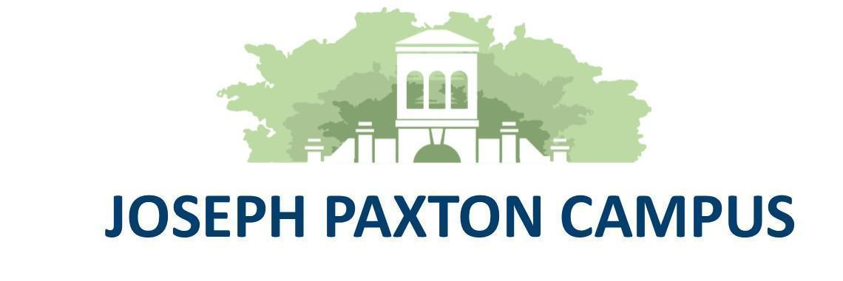

**Wirral Hospitals’ School**

***“Working together to make everything better”***

**An Ofsted “Outstanding” School**

**Headteacher: Mr P Arrowsmith**

Joseph Paxton Campus, 157 Park Road North, Claughton, Wirral. CH41 0DD

Tel: 0151-488-7680

e-mail: [schooloffice@wirralhs.co.uk](mailto:schooloffice@wirralhs.co.uk) Website [www.wirralhs.co.uk](http://www.wirralhs.co.uk)

**LEARNING BEYOND THE CLASSROOM (LBTC) COORDINATOR**

Required for 24th November 2025

Did you come into education to make a difference?

Are you committed to going above and beyond to improve the lives of our young people and their families?

Would you like to grasp the opportunity of working in a unique educational provision that serves some of the most vulnerable young people on the Wirral?

If you can answer yes to the questions above, the position of LBTC Coordinator at Wirral Hospitals’ School could be your perfect job.

The successful candidate will be expected to have:

* Substantial experience of working to support young people, ideally within a school setting.
* Substantial experience of outdoor education and leading school trips and visits.
* Experience of either leading or supporting residential trips for young people.
* Experience of helping young people overcome barriers to education and go on to achieve personal and academic success.
* Full clean driving licence - either including D1 or with the ability and willingness to obtain D1 within the first 12 months in role.
* Experience of a multi-agency approach to improving outcomes for young people.
* Experience of working with young people who have mental health difficulties.
* A drive and determination towards continued professional development and a desire to always give the very best to our young people.

The Headteacher welcomes informal discussion and/or show rounds with all potential candidates during the week beginning 13th October 2025. Please contact Jenny Macdonald on 0151 488 7680 or at [jmacdonald@wirralhs.co.uk](mailto:jmacdonald@wirralhs.co.uk) to arrange a visit.

Please note that the closing date for application is noon 17th October 2025, with interviews to take place on or prior to Friday 24th October 2025.

Wirral Hospitals’ School is committed to the highest standards of safeguarding and promoting the safety and welfare of our children, including protection from radicalisation CSE, FM, FGM and expects the same level of commitment from all staff. This post is subject to an Enhanced Level CRB check.

Please note: The ability to communicate effectively in the spoken language of English is an essential requirement for this role.