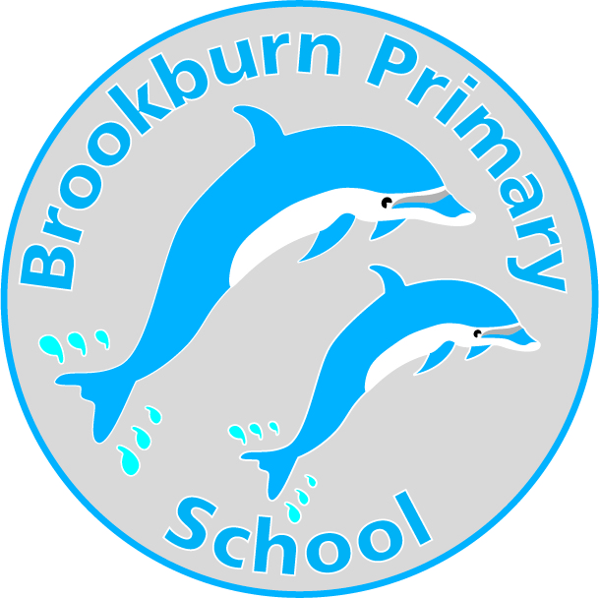

March 2023

Dear Applicant,

I am very pleased to forward the application pack and hope, that after consideration, you apply for the post of Learning Mentor at our school.

The following information will enable you to make a positive choice about applying to join our team. Please read the information carefully.

Brookburn Primary School is located in Chorlton, Manchester and is part of Link Learning Trust. Barlow Hall Primary School is the other school in LINK Learning Trust. We are a two form entry primary school and currently have 448 children on roll. This includes a 39 place nursery. Approximately a third of our school population come from ethnic minority backgrounds with about 7% of our children having English as an additional language. Approximately 10% of our children are identified as vulnerable learners and 9% of children are eligible for pupil premium funding. The majority of our vulnerable children are or have been previously looked after and therefore inclusive practice and fostering a strong sense of belonging is at the heart of everything we do. We believe that relationships are key to the successful inclusion of all.

To join our team, you will need to have a strong commitment to supporting all children so that they feel personally respected, accepted, included and supported. You will have a strong commitment to ensuring that our children are able to flourish emotionally, academically and socially with an understanding that ‘every minute counts’. Our children’s achievements are very important and the adults at Brookburn Primary work with great dedication and enthusiasm to make sure that each child achieves the very best they can.

We can offer the successful candidate an enjoyable work place with highly trained and supportive staff as well as a commitment to your own learning journey and continuing professional development.

The closing date for applications is Friday 14th April 2023 at 12pm. If applicable, please state the vacancy reference number for the position you are applying for.

Successful candidates will be invited for interview week beginning Monday 17th April 2023.

Yours faithfully,

Jen Holden

Head of School

Important safeguarding information for all applicants

At Brookburn Primary we take safeguarding very seriously. As part of our commitment to promoting the welfare of our children the following procedures will be followed for all new applications.

On receipt of your application any anomalies or discrepancies such as gaps in your employment history will be scrutinised and may affect the shortlisting of your application. Please, therefore, complete your application carefully giving full details. CVs will not be accepted.

Applicants shortlisted will be subject to an online search. This is not part of the shortlisting process itself, you will be able to address any issues of concern that arises during the search at the interview.

References will be followed up and any appointment will be subject to satisfactory written references being received. Any information on your reference which causes concern will be raised with you at interview.

If you are invited to interview you must bring with you the following:

- Two forms of photo ID such as a driving licence or passport.
- Birth certificate.

- Proof of required qualifications as listed in the application pack.

- Proof of National Insurance (i.e.NI Card or letter from HMRC)

- Proof of address within last 3 months (i.e. bank statement, utility bill)

These documents must be the original certificates, photocopies are not acceptable.

Copies will be taken of the documents you bring with you and placed on file until the successful candidate is appointed. After this point the documents of unsuccessful candidates will be shredded.

Any offer of employment is conditional upon the satisfactory completion of the pre-appointment checks and after appointment will be subject to a successful Disclosure and Barring Service (DBS) and medical health check.

These pre and post recruitment are statutory as laid down in ‘Safeguarding Children & Safer Recruitment in Education, 2007.

Please note that appointment to all non-teaching posts will be subject to the successful completion of a probationary period.

Please complete & return the following CRB information

There is nothing I would like to make you aware of before interview

regarding my DBS check □

There is an issue I will need to discuss prior to interview

regarding my DBS check □

