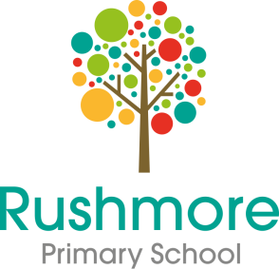

Rushmore Primary School

Elderfield Road

**Learning Mentor**

Scale 5 / Spine Point 12 - 15

£26,544 - £28,005pa. Full Time Equivalent

Term time only

35 hours per week

Permanent contract

Are you interested in the mental health and wellbeing of young people? Are you looking for opportunities to support children with a variety of needs? Are you solution focused?

Do you have the desire and drive to work in a school setting with SEND/ SEMH children?

Are you an energetic and positive person committed to supporting all children to achieve the very best that they can?

Rushmore Primary School is looking to appoint a Learning Mentor. You will be part of a passionate and professional team dedicated to ensuring that children receive excellent pastoral and learning support and the best possible care in a vibrant and purposeful environment.

As a Learning Mentor, you will be required to work flexibly, use your initiative, face challenges, find solutions, build and sustain a positive ethos, take the lead on drawing up individual action plans as well as communicating efficiently and effectively with parents and teams of other professionals. Working with teaching staff, you will be responsible for assisting in the comprehensive assessment of children and their needs. Working with the SENCo and specialist advisors, you will plan and deliver mentoring activities which will help to overcome barriers to learning.

This vacancy offers the opportunity to be a valued member of Team Rushmore, and to contribute to the smooth running of a vibrant, warm, welcoming community school as well as supporting Rushmore’s on-going improvement.

If you have the passion, skills, resilience and drive to make a significant and powerful difference to the lives of children who really need your support, are a graduate or have experience of working in schools with a minimum of NVQ 3 please request and send completed application forms to Canev Aziz at CAziz@rushmore.hackney.sch.uk.

**Application closing date: Monday 24th January 2022 @ 4:00pm**

**Interviews: - Monday 31st January 2022**

At Rushmore School, we are committed to the safeguarding and welfare of children and young people. All posts are subject to an enhanced DBS check. We welcome applications from all sections of the community regardless of gender, race, religion, disability, sexual orientation or age.