
Kirkby High School
Recruitment Pack
Learning Supervisor


MAXIMISING OUR POTENTIAL


CONTENTS
Letter from Headteacher
About us
Continuous Professional Development
Job Description
Person Specification
How to Apply
Application Form
Welcome
Dear Applicant,
Thank you for your interest in the Learning Supervisor position at Kirkby High School required as soon as possible.
We are seeking to appoint a dedicated and enthusiastic individual who is ambitious and has an excellent work ethic to start as soon as possible.
Our vision is a community driven by high expectations and mutual respect providing all individuals with the belief and opportunities to succeed now and in the future.
To help you decide if the job would suit you, please find enclosed some details, which we hope will give you a flavour of what Kirkby High School and The Rowan Learning Trust are about.
If your values and ambitions mirror ours and you believe you can deliver that vision, then we would be delighted to receive an application from you.
If you have any specific queries please contact my PA, Jo Barrett j.barrett@kirkbyhighschool.net
We are committed to safeguarding all members of our community; therefore, all posts are subject to enhanced disclosure procedures and pre-employment checks.
Yours faithfully,
Mrs A Dobson
Headteacher



Kirkby High School
Kirkby High School is an Ofsted rated 'Good' 11-16 mixed comprehensive. All staff at Kirkby High School fully embrace our vision: “A community driven by high expectations and mutual respect providing all individuals with the belief and opportunities to succeed now and in the future”.
Kirkby High School stands at the centre of our local community and we believe that we offer our young people guidance and aspiration to be the best they can be in all aspects of life. Quality teaching and learning, supported by reliable pastoral systems, ensure that students are preparing well for later life.
We believe in building a culture of resilience and tolerance in which our students can thrive. Our aim is to increase our students’
self-belief and to show them that they can be what they want to be.
Confidence Kindness Aspiration Respect Resilience


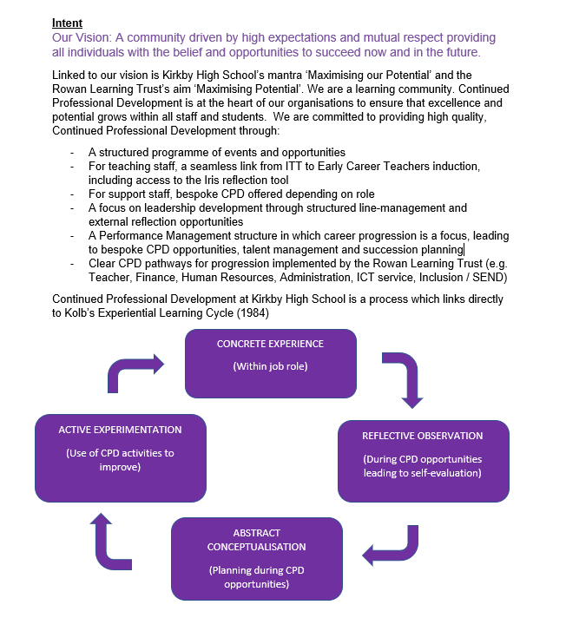

Continued Professional
Development Framework

- Encourage students to interact and work co-operatively with others and engage all students in activities.
- Promote independence and employ strategies to recognise and reward achievement of self-reliance.
- Provide feedback to students in relation to progress and achievement.

Support for the Teacher
- Work with the teacher to establish an appropriate learning environment.
- Work with the teacher in lesson planning, evaluating and adjusting lessons/work plans as appropriate.
- Monitor and evaluate students’ responses to learning activities through observation and planned recording of achievement against pre-determined learning objectives.
- Provide objective and accurate feedback and reports, as required, to the teacher on student achievement, progress and other matters ensuring the availability of appropriate evidence.
- Be responsible for keeping and updating records as agreed with the teacher, contributing to reviews of systems/records as requested.
- Undertake marking of students’ work and accurately record achievement/progress.
- Promote positive values, attitudes and good student behaviour, dealing promptly with conflict and incidents in line with established policy and encourage students to take responsibility for their own behaviour.
- Liaise sensitively and effectively with parents/carers as agreed with the teacher within your role/responsibility and participate in feedback sessions/meetings with parents, as directed.
- Administer and assess routine tests and invigilate exams/tests
- Provide general clerical/admin support, for example, photocopying, basic typing, filing, money, administer coursework, and produce worksheets for agreed activities.

Learning Supervisor
Reports to: Deputy Headteacher / Senior Operations Manager
Location: Kirkby High School, Bracknell Avenue, Kirkby, L32 9PP
Salary: SCP 12-17, Pay Grade F, £28,598 - £31,022 pro rata
(actual salary £25,298 - £27,442 per annum)

Hours: 36 hours per week x 46 weeks per year
(includes 5 inset days and a workback element)
(Monday 8.00am-4.30pm and
Tuesday to Friday 8.00-3.30pm)
Job Description

Overall Purpose of the Post
- Supervise whole classes during the short-term absence of teachers, maintaining good order and keeping students on task.
- Respond to questions and generally assist students to undertake set activities.
- Work under the guidance of teaching/senior staff and within an agreed system of supervision, in or out of the classroom.
- Implement agreed work programmes, assisting the teacher in the whole planning cycle and the management/preparation of resources. This could include those requiring detailed and specialist knowledge in particular areas.
- Enable the access to learning for students.
Support for Students
- Use specialist (curricular/learning) skills/training/experience to support students.
- Assist with the development and implementation of IEPs.
- Establish productive working relationships with students, acting as a role model and setting high expectations.
- Promote the inclusion and acceptance of all students within the classroom.
- Support students consistently whilst recognising and responding to their individual needs.


Support for the Curriculum
- Implement agreed learning activities/teaching programmes, adjusting activities according to student responses/needs.
- Implement local and national learning strategies, for example, literacy, numeracy, KS3 and early years, and make effective use of opportunities provided by other learning activities to support the development of relevant skills.
- Support the use of ICT in learning activities and develop students’ competence and independence in its use.
- Help students to access learning activities through specialist support.
- Determine the need for, prepare and maintain general and specialist equipment and resources.

Support for the School
- Be aware of and comply with policies and procedures relating to child protection, health, safety and security, confidentiality and data protection, reporting all concerns to an appropriate person.
- Be aware of and support difference and ensure all students have equal access to opportunities to learn and develop.
- Contribute to the overall ethos/work/aims of the school.
- Establish constructive relationships and communicate with other agencies/professionals, in liaison with the teacher, to support achievement and progress of students.
- Attend and participate in regular meetings as may be reasonably directed
- Participate in training and other learning activities as may be reasonably directed.
- Recognise own strengths and areas of expertise and use these to advise and support others.
- Provide appropriate guidance and supervision and assist in the training and development of staff as may be reasonably directed.
- Supervision of students including visits, trips and out of school activities as may be reasonably directed.
- To assist with the display of students work.

Person Specification
The successful candidate will possess:

Essential:

- A commitment to safeguarding and equality

- An empathy with children.

- The ability to establish effective working relationships with staff and students.

- A high degree of organisation.

- The ability to work both as a supportive team member and under one’s own initiative.

- A willingness to undergo further professional development.

- An understanding of the confidentiality necessary when working with students.

- Excellent attendance and punctuality records from previous employment.

- Level 2 or equivalent Mathematics and English Language.

- ICT Competence.

Desirable:

- Previous experience of working with children.

- Level 3 qualification or higher or evidence of the equivalent QCF credit value.

Please submit the enclosed application form and a supporting statement of no more than two sides of A4 outlining why you are interested in the opportunity and how your application addresses the requirements of the role.
Applications should be returned electronically to j.barrett@kirkbyhighschool.net
Alternatively, send a hard copy to:
Mrs A Dobson
Headteacher
Kirkby High School
Bracknell Avenue
L32 9PP

Closing date: 12noon, Monday 27th April 2026

How to Apply


The Trust will make any necessary reasonable adjustments to the job and the working environment to enable access to employment opportunities for disabled job applicants or continued employment for any employee who develops a disabling condition.
All appointments are subject to satisfactory references, proof of qualifications and eligibility to work in the UK.
The Trust is committed to safeguarding and promoting the welfare of all children and young people and expects all staff to share this commitment. An enhanced DBS check will be required.

The Trust will make any necessary reasonable adjustments to the job and the working environment to enable access to employment opportunities for disabled job applicants or continued employment for any employee who develops a disabling condition.
All appointments are subject to satisfactory references and eligibility to work in the UK.
The Trust is committed to safeguarding and promoting the welfare of all children and young people and expects all staff to share this commitment. An enhanced DBS check will be required.


The Rowan Learning Trust
Registered Office: Carr Lane, Wigan, WN3 5NY
Company Number 8010464



KIRKBY HIGH SCHOOL

JOB APPLICATION FORM FOR SUPPORT STAFF IN SCHOOLS

The School and Governing Body are committed to equal opportunities in employment and welcome applications from all sections of the community.

BRACKNELL AVENUE,

KIRKBY, MERSEYSIDE, L32 9PP

TELEPHONE: 0151 477 8710

EMAIL: admin@kirkbyhighschool.net

- POST APPLIED FOR

Post Applied For:
School: | Kirkby High School
As advertised in: |  | On date:

2. PERSONAL DETAILS

SURNAME: |  | FORENAME:
TITLE:  (Optional) |  | Date of Birth:  (Optional)
Address:
POSTCODE: |  | Email:
Telephone No: |  | Mobile No:

3. CURRENT POST
CURRENT EMPLOYER AND JOB TITLE:
DATE OF APPOINTMENT: |  |  | SALARY:
NOTICE PERIOD:
MAIN DUTIES AND RESPONSIBILITIES
Reason for this application

4. EMPLOYMENT HISTORY
Post | Dates |  | Employer | Grade/Salary | Reason for Leaving
 | From | To

5. GENERAL EDUCATION
School | From | To | Qualifications – Grades, awarding bodies and dates

6. FURTHER AND HIGHER EDUCATION
Name of College/ University | From | To | Qualifications – Grades, awarding bodies & dates

7. ANY OTHER RELEVANT QUALIFICATIONS
Please give details of any other relevant qualifications you have for this post.

8. ADDITIONAL INFORMATION
Are you related to, or a close friend of, any member of the Trust or of the Governing Body of the school? (If yes, please state relationship) | Yes / No
Have you left any previous job for the reason of redundancy or are you in receipt of an occupational pension? If yes, please give details, including dates, post held and employer. | Yes / No
Have you ever been dismissed from any previous employment on the grounds of misconduct or incapability? If yes, please give details of dates and resources. | Yes / No
Do you hold a current and valid driving licence?  (if yes, please state the category) | Yes / No
The Rowan Learning Trust is committed to providing equal opportunities and supporting all applicants. If you require any reasonable adjustments to allow you to participate in the application process please let us know.  Do you require any reasonable adjustments? | Yes / No
Do you have any unspent conditional cautions or convictions under the Rehabilitation of Offenders Act 1974? | Yes / No
Do you have any adult cautions (simple or conditional) or spent convictions that are not protected as defined by the Rehabilitation of Offenders Act 1974 (Exceptions) Order 1975 (Amendment) (England and Wales) Order 2020? | Yes / No
In line with Keeping Children Safe in Education, The Rowan Learning Trust will undertake general online searches for all shortlisted candidates which may include social media and video platforms. Online searches will only examine data which is publicly available, and the aim is to identify any incidents or issues. Any areas of concern will be discussed during the interview process.

The information provided by you will be used for pre-employment recruitment monitoring and checks only and will supplement or form part of your application.

To enable the check to be undertaken, it would assist if you could detail your username for the relevant social media platforms below:

- Facebook
- Instagram
- Twitter
- LinkedIn
- TikTok
- Youtube

9. STATEMENT IN SUPPORT OF APPLICATION
Please attach a supporting statement, indicating any matters which you feel may be relevant to this application.
Please head additional documentation with your name and post applied for.

10. REFERENCES
Please state the names and addresses and telephone numbers of two persons from whom references may be obtained. One must be your current or most recent employer. In the absence of previous employment experience, a reference from your last place of full-time education will be a suitable alternative.
REFEREE 1 |  | REFEREE 2
TELEPHONE NO: |  | TELEPHONE NO:
EMAIL: |  | EMAIL:
Can this reference be taken up immediately  YES/NO |  | Can this reference be taken up immediately  YES/NO

11. FURTHER INFORMATION FOR CANDIDATES
- In the interests of the protection of children, all posts are subject to enhanced criminal record and other relevant disclosures through the Disclosure & Barring Service (DBS). A criminal record will not necessarily prevent you from obtaining a position.
- Please note that it is the policy of the Trust and the Governing Body to preclude employment of persons over the age of 65.
- You will receive no further communication unless selected for interview. If you have therefore not been contacted within three weeks of the closing date for applications, you should conclude that, unfortunately, you have been unsuccessful on this occasion.
- Under the Data Protection Act, the Trust and the Governing Body will use the information given for the purpose of recruitment and selection. Strict confidentiality will be observed and if you become an employee, the information will be used for personnel, pay and pensions administrative purposes only.

THANK YOU FOR YOUR INTEREST SHOWN IN THIS APPOINTMENT

12. DECLARATION
To the best of my knowledge and belief all the particulars I have given are true. I understand that any false statements may disqualify me from employment or render me liable for dismissal. I also understand that no offer of employment made to me will be binding unless confirmed in writing.
I also understand that this post is subject to a satisfactory enhanced Disclosure and Barring Service (DBS) check and to satisfactory medical clearance and the provision of documentary evidence (e.g. NI Number) that shows I am entitled to work in the U.K.
Signature:…………………………………………………………………………… Date:………………

