Hodgson Academy

Imagine...Believe...Achieve

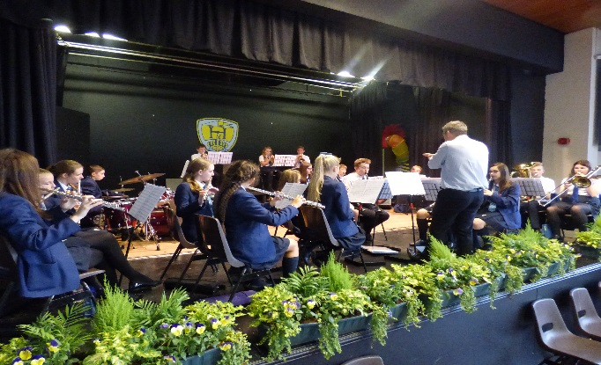

Appointment of Learning Supervisor
Permanent Post Starting ASAP

Moorland Road, Poulton-le-Fylde, FY6 7EU

Learning Supervisor
NJC Grades 5/6: Points 9-14
Term Time Only + 5 days
Learning Supervisor

A term time only + 5 days position
Expected hours are 8am-4pm daily, although reduced hours with a 8:30am start and 3:10pm finish can be implemented for a successful candidate should their individual circumstances require this.
We are also willing to discuss a part-time appointment for the right candidate.

NJC Grades 5/6: Points 9-14
Full time salary equivalent: £25119-£27334
Actual Salary: £21239-£23112

Hodgson Academy is seeking to recruit to this new position which combines in-class learning support, small group withdrawal and lesson cover.

This post will appeal to individuals who have the desire and commitment to significantly contribute to supporting the learning experience of all our students at Hodgson Academy.

Further details are available from Emma Wallace: e.wallace@hodgson.lancs.sch.uk

Hodgson Academy, Moorland Road, Poulton Le Fylde FY6 7EU

Closing date for applications Monday 8th April 2024 (9am).

The school is strongly committed to safeguarding and promoting the welfare of children and young people and expects all staff and volunteers to share this commitment. You shall be required to undertake an enhanced DBS disclosure and a range of other recruitment checks.

Learning Support at Hodgson
Hodgson Academy’s Learning Support department is a forward thinking, resourceful department and is committed to providing an enjoyable, successful experience of learning for all its students. We support students with a wide range of barriers to their learning. We are committed to helping all our students flourish whilst at school but also enjoy their learning experience.
Our department has a drive to improve our students’ literacy and numeracy skills. Therefore the department predominantly supports and provides intervention in English, maths and science lessons.
At Hodgson Academy, we have a number of students who have an Education and Health Care Plan. For these students, we will support in other subject areas dependent of the students’ individual needs.
The department is fortunate in that it is provided with two newly refurbished rooms with ICT facilities, including interactive whiteboards in both our learning support suites. We have an extensive range of intervention resources and tools to help our students progress.
Our Learning Support department is led by Laura Foley (Assistant Headteacher and SENCO) and Linda Beaumont (Assistant SENCO). Within our fantastic team, we have two Level 3 Teaching Assistants and eight Level 2 Teaching Assistants.
The department meets each morning to be briefed about the day ahead and all our colleagues are part of the whole school Teaching and Learning CPD. New members of our department will be provided with a support mentor to ensure that they settle into the busy department quickly and seamlessly.
Our department is invested in offering co-curricular activities for our students and there are opportunities for our team to add the school’s co-curricular offer or support with the current provision in place. Every lunch time, our team offers a Homework Club within our library to support students with their studies where necessary.
The Governors and the Leadership team are seeking new members of the team who will provide high quality and impactful support for our students with barriers to their learning.

Person Specification
Job Description

Job Title: Learning Supervisor

Grade: NJC Grade 5/6: Points 9-14
Responsible to: Headteacher
Deputy Headteacher
Assistant Headteacher and SENCO
Assistant SENCO
Responsible for: None
Hours of duty: Typically 08:00 start and 16:00 finish.
Working times to be negotiated with the Headteacher.
There may be instances where additional working hours are necessary. These would be mutually agreed prior to the event with the Headteacher and / or Finance Director and for which payment will be made in accordance with conditions of service

Any Special Conditions: The Academy has a policy of non-smoking throughout the whole site

MAIN DUTIES

Support for Teaching and Learning
- Under the clear guidance of the class teacher/line manager implement structured learning activities and to assist individual students / groups of students to complete tasks
- To undertake activities to assist in monitoring the personal, social and emotional needs of students
- To develop positive relationships with students to assist in student progress and attainment
- To assist in the devising of student’s individual targets and their monitoring and review
- Support students as part of a planned inclusion programme
- To assist in the specific medical / care needs of students when specific training has been undertaken
- To assist in the monitoring / recording of student progress, problems and developmental needs
- To assist in the production of teaching aids
- To assist in student supervision and assist in the management of student behaviour
- To provide information to the class teacher to assist in the planning of work programmes
- Administer routine tests and assist in the invigilation of exams
- To undertake routine classroom administrative tasks including class lists
- To assist in providing an atmosphere in which effective learning can take place
- To supervise After School / Homework clubs
- To assist with routine administration in the Learning Support Department
- To attend staff meetings and training as appropriate
- To work within School policies and procedures
- To take care for their own and other people’s health and safety
- To be aware of the confidential nature of issues related to home / student / teacher / school work
- To support the promotion of positive relationships with parents and outside agencies.
- To provide lesson cover for absent teachers, ensuring a classroom environment that enables students to complete pre-planned and prepared work.

The above represents a broad outline of the specific duties and responsibilities currently attached to this role. Depending on the needs of the Academy, these may be altered from time to time in consultation with the Headteacher.

Person Specification

QUALIFICATIONS AND EXPERIENCE | Essential | Desirable
Level 2 qualification in English/Literacy and Mathematics/Numeracy (e.g. GCSE at Grade 4/C or better, functional skills level 2) | *
Recognised Level 3 qualifications (e.g. A levels, BTEC Level 3) |  | *
Experience of working with children | *
Experience of working in a classroom environment |  | *
Experience of supporting children with challenging behaviour |  | *
Experience of supporting children with schoolwork |  | *

KNOWLEDGE AND SKILLS | Essential | Desirable
Ability to work with children | *
Ability to relate to and form professional relationships with children | *
Ability to work as part of a professional staff team | *
Ability to manage a classroom | *
Time management and organisational skills, including use of IT | *
Knowledge of, and ability to enact, the concept of confidentiality | *
Knowledge of the National Curriculum |  | *

OTHER ATTRIBUTES | Essential | Desirable
Commitment to safeguarding and protecting the welfare of young people | *
Commitment to equality and diversity | *
Commitment to health and safety | *
Commitment to attendance at work | *
Commitment to attend in-service training | *

Safeguarding Commitment
This school is committed to safeguarding and protecting the welfare of children and young people and expects all staff and volunteers to share this commitment. We will carry out pre-employment checks in line with the latest version of the DfE’s ‘Keeping Children Safe in Education’ document. This may include an online search.

Job Description and Person Specification prepared by: Iain Siddall Date: January 2024

Agreed by post holder: ________________________________________ Date: ____________________

