Dear Applicant

LSA (1-1 SEN Support)
BG5 or BG7 (depending on experience - please state grade applying for)
Part time, 21 hrs 15 mins hours a week TTO
Start date – 4 January 2022

We invite you to apply for this LSA position to become part of our school family. This is an exciting opportunity to contribute to the vision of our ‘Outstanding’ school.

Governors are looking to appoint a dynamic, highly motivated individual who is an excellent LSA and has high expectations in terms of children’s achievement and behaviour to support children with special education needs. The successful candidate will be able to motivate and inspire pupils in their learning within the catholic ethos of the school.

If you think this is you then we would love to hear from you! To apply, please submit a letter of application that details why you want to work at St. Teresa’s Catholic Primary School Bristol, what you can offer the school and how you would fulfil the requirements of the person specification together with a completed CES application form.

As stated in the advert, the closing date for applications is Tuesday 4 January 2022 (midday).

I look forward to receiving your application by the closing date.

Yours sincerely,
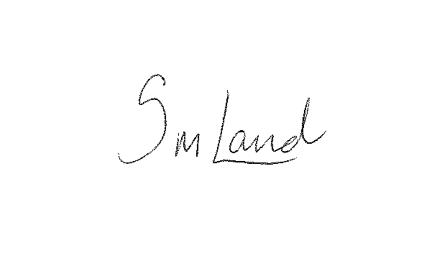

Mrs Samantha Land
Headteacher


St. Teresa’s Catholic Primary School
Luckington Road, Monks Park, Bristol BS7 0UP
Tel: 0117 9030412
E-mail: school@stteresas.org.uk
Acting Headteacher: Mrs Samantha Land

‘Inspiring each other to excellence,
in the Light of Christ.’

LSA (1-1 SEN Support) Maternity Cover
Required to start 4 January 2022 or as soon after.
BG5/BG7 (Please state grade of post applied for) £19,183 – £21,998 pro-rata
Contract: 21 hrs 15 mins per week (Monday – Friday 8.45pm to 1.15pm), TTO.

Would you like to join our school family at St. Teresa’s Catholic Primary School Bristol?

This is a fantastic opportunity for an energetic and enthusiastic individual to work in a friendly and supportive team, who put the needs of children first. Experience of working with children with ASD, or as a 1:1 support worker would be an advantage, along with experience of working with younger children, but primarily we are looking for an individual with a willingness to learn, be flexible and work in creative ways to meet our children’s needs.

There will be training and support available to aid the successful candidate in further developing their skills and understanding.

If so, we would like to hear from you. If you would like to visit school ahead of applying please ring the school office on 0117 9030412.
Closing date: Tuesday 4 January 2022 (midday)

‘We are committed to safeguarding and promoting the welfare of children and expect all staff and volunteers to share this commitment and undergo an enhanced DBS check.’

