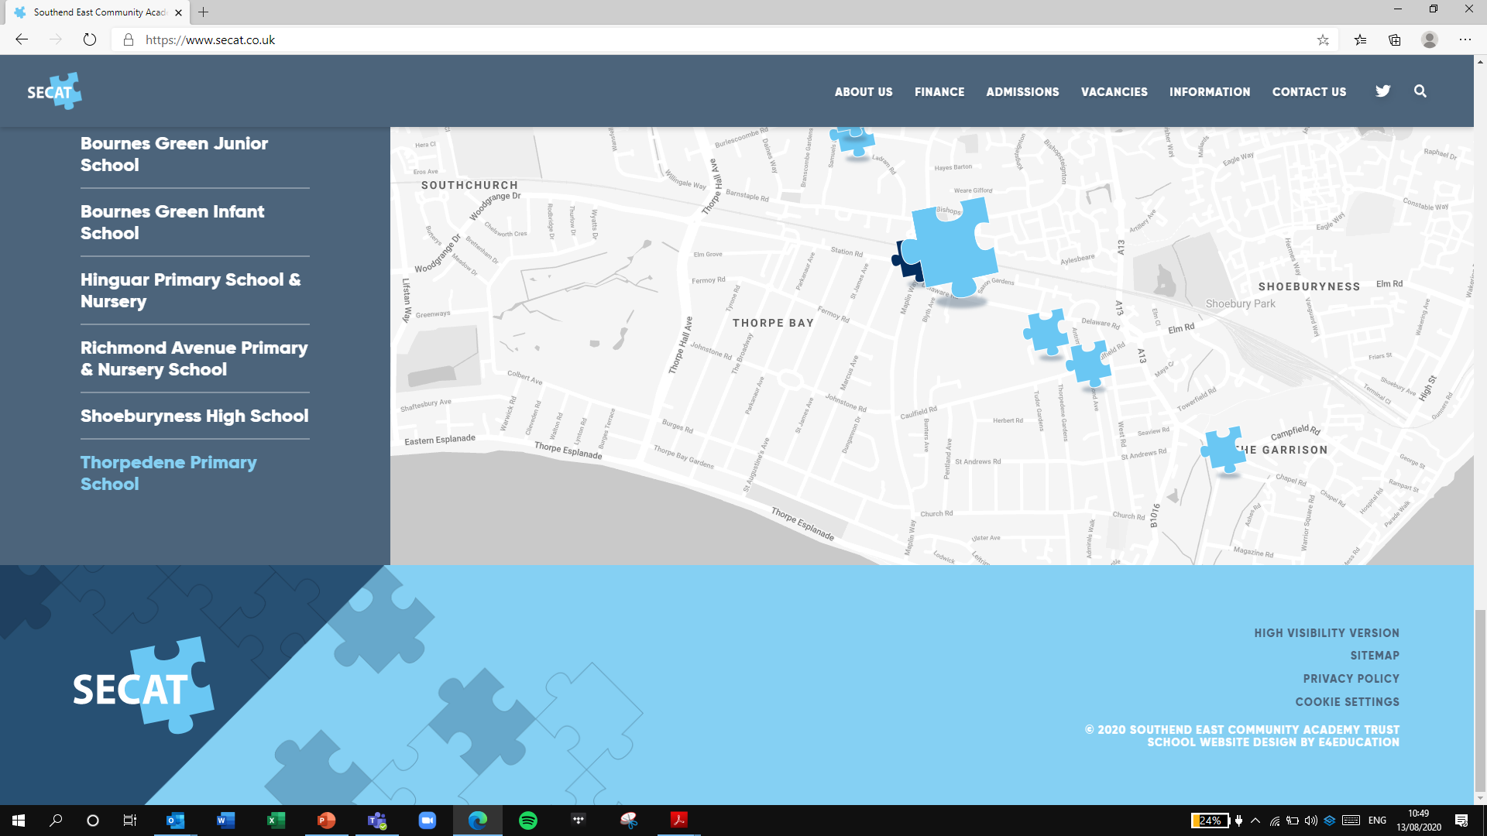
Building strong schools
Building strong partnerships
Building strong communities
SOUTHEND EAST COMMUNITY ACADEMY TRUST

Thank you for your interest in the Learning Support Assistant position at Shoeburyness High School.

Please visit our online recruitment platform via www.secat.co.uk to complete the online application process.

We look forward to receiving your application.

