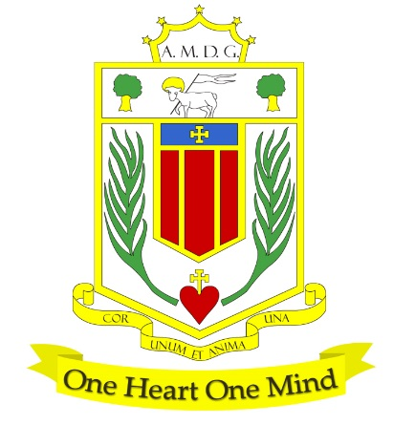
BROUGHTON HALL CATHOLIC HIGH SCHOOL
Yew Tree Lane

Liverpool, L12 9HJ

Telephone 0151 541 9440 / Fax 0151 259 8448
Email: smithg@broughtonhall.com
Head Teacher: Mr G M Preston, B.A. (Hons), NPQH, PGCE

LEARNING SUPPORT ASSISTANT
FULL TIME / TERM TIME

SALARY: NJCJE Scale 3 points 5 - 9, £23,500 to £25,119 (full-time equivalent)
CONTRACT TYPE: Permanent/35 hours per week
CLOSING DATE: Monday, 15th July 2024
INTERVIEWS TO BE HELD: As soon after the closing date as possible
START DATE: 1st September 2024

Governors are seeking to appoint an enthusiastic and committed Learning Support Assistant to our dedicated and caring SEND Team. The role will include a range of responsibilities as well as working in partnership with class teachers to support learning with individual students under the direction of teaching staff.

We believe that to enable our pupils to learn effectively, they need to feel safe in their environment and be both socially and emotionally ready to learn. We understand the importance of holistic development and look to offer nurturing and enriching experiences to enable to the development of the whole child and look forward to welcoming the right person to our team.

This post is subject to satisfactory references being received and a satisfactory Enhanced Disclosure being obtained from the Disclosure and Barring Service (DBS).

Application forms, together with a job description are available from the school’s website.

Our Trustees are the Sisters of Mercy.

How to Apply:- Please complete the school’s Application Pack and email to smithg@broughtonhall.com

All posts are subject to an enhanced DBS check and full pre-employment and on-line checks, to comply with the current Keeping Children Safe in Education statutory guidance for schools.

All staff will be expected to follow Broughton Hall Catholic High School’s child protection policies, code of conducts and managing allegations against staff procedures.

Induction, support and training will be offered to the successful candidate.

Broughton Hall Catholic High School is committed to safeguarding and promoting the welfare of children and we expect all staff and volunteers to share this commitment to keeping children safe. Any offer of employment will be subject to statutory pre-employment checks including satisfactory references and Enhanced DBS and Barred List checks. This post is exempt from the provisions of the Rehabilitation of Offenders Act 1974 (as amended in 2013 & 2020) and shortlisted candidates will be required to disclose any relevant criminal history prior to interview.

‘By engaging in this recruitment process, shortlisted candidates consent to an online search in line with the Keeping Children Safe in Education Statutory Guidance 2023’

