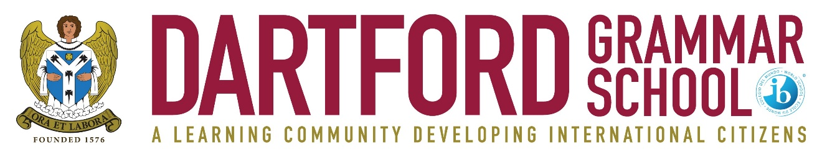

LEARNING SUPPORT ASSISTANT
Term-time + 5 INSET days 35 hours per week
DGS 5 (£20,595 - £21,693fte)
Are you passionate about supporting children, recognising individual qualities and strengths, and aspiring to attain excellence in learning support?
We are looking for enthusiastic learning support assistants to join our friendly team here at Dartford Grammar School.
We are looking for someone who:
- Has excellent communication and interpersonal skills;
- Is able to support children with a range of special educational needs and disabilities;
- Is able to deliver support, both in the classroom or with targeted groups or clubs;
- Is a committed team player with energy and drive;
- Is dedicated, enthusiastic, patient and caring.
You will be joining a team with a strong support structure in place, and a team that will look to develop candidates who wish to progress in this field. We believe in staff development, and there is an opportunity to undertake a funded level 3 apprenticeship course.
Our students are bright, curious and thrive in an environment of excellent behaviour, supported by first class pastoral care. We are interested to hear from any interested candidates regardless of experience in special educational needs.
For further details and an application form, please contact the HR Manager, Mrs M Bexley:
Telephone: 01322 223039 Ext 146; Email: mbexley@dartfordgrammarschool.org.uk

Please apply by letter with a completed application form to the Headmaster, Mr J C Metcalf, Dartford Grammar School, West Hill, Dartford, Kent DA1 2HW.

Start date: September 2023
Closing date: Monday 26 June 2023
(The school may interview early in the case of an exceptional candidate)

Dartford Grammar School is a selective secondary academy for boys, which admits girls to its sixth form. There are six forms of entry to Year 7, and all of the students joining the school are from the top 25% of the ability range. The current roll is 1,535, including 618 in the sixth form.

The school is committed to safeguarding and promoting the welfare of children and young people and expects all staff to share this commitment. An enhanced DBS check is required for all successful applicants.

