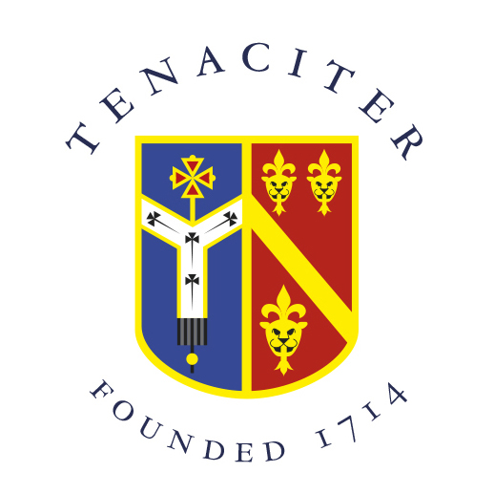

Archbishop Tenison’s CE High School,
Selborne Road, Croydon CR0 5JQ
Tel: 020 8688 4014
www.archten.croydon.sch.uk

LEVEL 1 LEARNING SUPPORT ASSISTANT

Location: Croydon, Surrey
Start date: As soon as possible
Contract: 1 Yr Temporary initially, Term Time plus staff development days,
26 hours per week
Salary: APT&C Grade 1, Point 1
(Part Time post; current full-time equivalent is £20,658)

- This position is required to support pupils with various Special Educational Needs.

- Work alongside knowledgeable and experienced colleagues

- Be part of a school that has been in Croydon for over 300 years, with strong traditions and wide-ranging extra-curricular activities

- Develop professionally and personally in a secure, but lively atmosphere

- Contribute to our pastoral care and our Christian ethos

We are an 11-18 Church of England mixed comprehensive school
Archbishop Tenison's is an equal opportunities employer and committed to safeguarding and promoting the welfare of children.
Enhanced DBS check required.

Closing date: 15th October 2021 (midnight)
Interview date: 20th October 2021

To apply please return an application form to patoheadteacher@archten.croydon.sch.uk.
For more information on the school, visit www.archten.croydon.sch.uk

