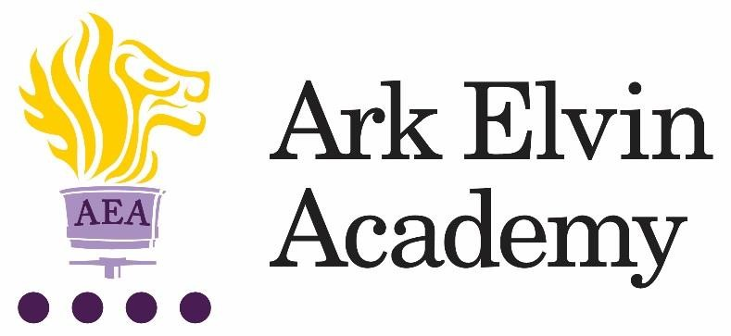

Learning Support Assistant

At Ark Elvin Academy we are working hard to provide all our pupils with an excellent education and are looking for committed teachers and support staff to join us at this exciting stage in our school improvement journey. Our team of enthusiastic, high expectations staff have transformed our school and we are just as excited about the next step in our school improvement journey as we work together to deliver the outstanding education our community need and deserve. We are deeply committed to our mission:
“To ensure that every pupil leaves Elvin confident, articulate, and culturally aware; able to pursue careers they are passionate about, contribute to society and live happy, healthy and fulfilled lives.”
In our OFSTED inspection (October 2019) it was recognised that Ark Elvin Academy:
“Pupils, parents and staff all agree that Ark Elvin Academy has improved out of all recognition. Pupils are proud of the school.”

“The headteacher and leaders have very high expectations…… Staff want all pupils to succeed in every area of their lives, not just academically.”

“The school is a calm, safe and supportive place for pupils. Pupils behave very well in lessons. They get on well with one another and with adults.”

We are a large non-selective secondary school in the London borough of Brent, with excellent transport links to central London. We are committed to ensuring teachers can focus on teaching and have the opportunity to refine and develop their practice in the classroom and develop their leadership skills, we have:

- twice as many training days as is standard
- weekly professional development for all staff

In recruiting for a Learning Support Assistant, we are seeking the following from applicants:

- A commitment to our school improvement process
- A commitment to serving our diverse community in Brent
- High expectation for themselves and our pupils
- A team player with high standards of professionalism and courteousness

You will become part of a close knit professional community of enthusiastic colleagues who benefit from the training, guidance and support from both the Ark network, one of the country’s top performing school groups and our North London region of schools where we work closely with six schools; Ark John Keats Academy, Ark King Solomon Academy, Ark Academy and Isaac Newton Academy.
We passionately believe in our six pillars and they drive all our thinking and our school improvement at Elvin:

Strong Discipline
Calm, purpose and order are established through the consistency of expectations and explicit teaching of discipline.

High Quality Teaching
Teachers are subject experts with an excellent understanding of the intellectual journey they are taking their pupils on and have mastery in effective teaching skills.

Mastery Curriculum
Our curriculum design enables pupils to make rapid progress and develop a framework of knowledge and understanding in each subject area that provides a solid foundation for further study.

Raising aspirations and enrichment
Pupils understand the opportunities that a school and university education will afford them in terms of careers and quality of life. Pupils develop their passions and interests through an Our extensive enrichment programme.

Character development
Pupils develop the characteristics that support their academic achievement, create thoughtful citizens and allow them to make reflective choices over their personal lives.

Developing leaders
All members of staff see themselves as leaders within an aligned community of professionals and are systematically trained in best practice. We create high performing teams to drive our school improvement.

Ark Elvin is on an exciting improvement journey – join us and be part of that change.
We encourage and welcome you to visit our school; to arrange a visit, please contact our HR Advisor, Chantel Mutongole c.mutongole@arkelvinacademy.org or 020 8902 6362.

Closing date: | Monday 25th October 2021
Interviews: | Week beginning 1st November 2021
Start date: | ASAP
Salary: | Band 5, Point 5 to 13– £23,427 - £27,021 pro rata, (Actual salary £22,291.83 - £25,711.68 per annum)

Ark is committed to safeguarding children; successful candidates will be subject to an enhanced DBS check

Job Description: Learning Support Assistant

Reporting to: SENCO
Start date: ASAP
Location: Ark Elvin Academy
Contract: Full-time, permanent (40 hours per week) – working
hours to be agreed with line manager.
Salary: Ark Support salary band 5, point 5 - 13 – £23,427 - £27,021 pro rata (Actual salary £22,291.83 - £25,711.68 per annum)

The Role
To work with the SENCO to provide tailored support to pupils who have special educational needs and/or disabilities. Learning Support Assistants play a vital role in supporting pupils, both in a one to one setting and in larger and whole class groups.

Key Responsibilities
- To plan tailored interventions for individual pupils.
- To provide in class support for pupils, as directed by the SENCO and class teachers.
- To work with class teachers to plan support in lessons.
- To liaise with families to gain a thorough understanding of the needs of pupils.
- To update pupil records as required.
- To assist student/s with their physical/personal care/medical needs as required.
- To share information about individual pupils with teachers and other colleagues so that all colleagues understand differentiation needs and how best to support learners.
- To prepare additional resources for pupils as required.
- To carry out duties around the school to support the smooth running of the school and promote school values.
- To carry out additional interventions and assessments as required, e.g. reading tests and phonics interventions.
- To liaise with primary schools to gather further information to support the learning of pupils before they join year 7.
- To support pupils with post-16 applications and understanding of post-16 education.

Other
- Undertake other various responsibilities as directed by the Principal

This job description sets out the main duties of the post at the time of drafting. It cannot be read as an exhaustive list. These responsibilities will be discussed annually as part of the postholder’s annual performance review and are subject to change. However, it may be altered at any time subject to need in consultation with the postholder subject to the Principal’s approval.

Person Specification: Learning Support Assistant

Qualifications
- Right to work in UK
- Good literacy and numeracy
- Degree level qualification (ideally 2:1 or above)
For those interested in training to teach:
- GCSE math’s and English at grade C or above or equivalent (this a national requirement to enter teacher training)

Knowledge, Skills and Experience
- Experience of establishing successful learning relationships with a variety of children at the relevant age
- Experience and/or understanding of the role of a learning support assistant
- Relentless drive to do whatever it takes to ensure all pupils succeed.
- Embody our core values – integrity, courage, community and mastery – in all aspects of work and conduct.
- The belief that with the right environment all of our pupils are able to excel at university, or in a meaningful alternative.
- The courage and conviction to make a difference.
- The ability to listen and communicate effectively.
- Empathy and the ability to understand the needs, aspirations and motivation of diverse individuals and groups.
- The ability to influence and motivate others.
- Develop and communicate a shared vision.
- Model desired behaviour and values.
- Empower, support and coach others.
- Hold others to account for high standards of performance.
- Understand and resolve conflict.
- Identify, analyse and resolve problems and issues.
- Develop plans with concrete outcomes and effective solutions.
- Evaluate results and identify necessary actions.
- Make fact-based decisions.

Personal Characteristics
- Sustain energy, optimism and motivation in the face of pressure and setbacks.
- Stay calm in difficult situations and maintain clarity of vision.
- Be adaptable in the face of adversity.
- Awareness of own strengths and limits.
- Commitment to ongoing improvement and learning.
- A passion for own role and that of others.
- Focus on achieving challenging goals and results.
- Resourcefulness and flexibility in delivering outcomes.
- Effective team worker and leader.
- Demonstrates resilience, motivation and commitment to driving up standards of achievement.
- Acts as a role model to staff and students.
- Vision aligned with Elvin’s high aspirations, high expectations of self and others.

Other
- Commitment to equality of opportunity and the safeguarding and welfare of all students
- Willingness to undertake training.
- This post is subject to an enhanced DBS check.

Ark is committed to safeguarding and promoting the welfare of children and young people in our academies. To meet this responsibility, we follow a rigorous selection process, details of which can be provided if requested. All successful candidates will be subject to an enhanced Disclosure and Barring Service check.

