Normand Croft Community School
Candidate Information Pack:

Learning Support Assistant
Normand Croft
Community School
Candidate Information Pack:
Primary Teacher (with ot without Leadership TLR)

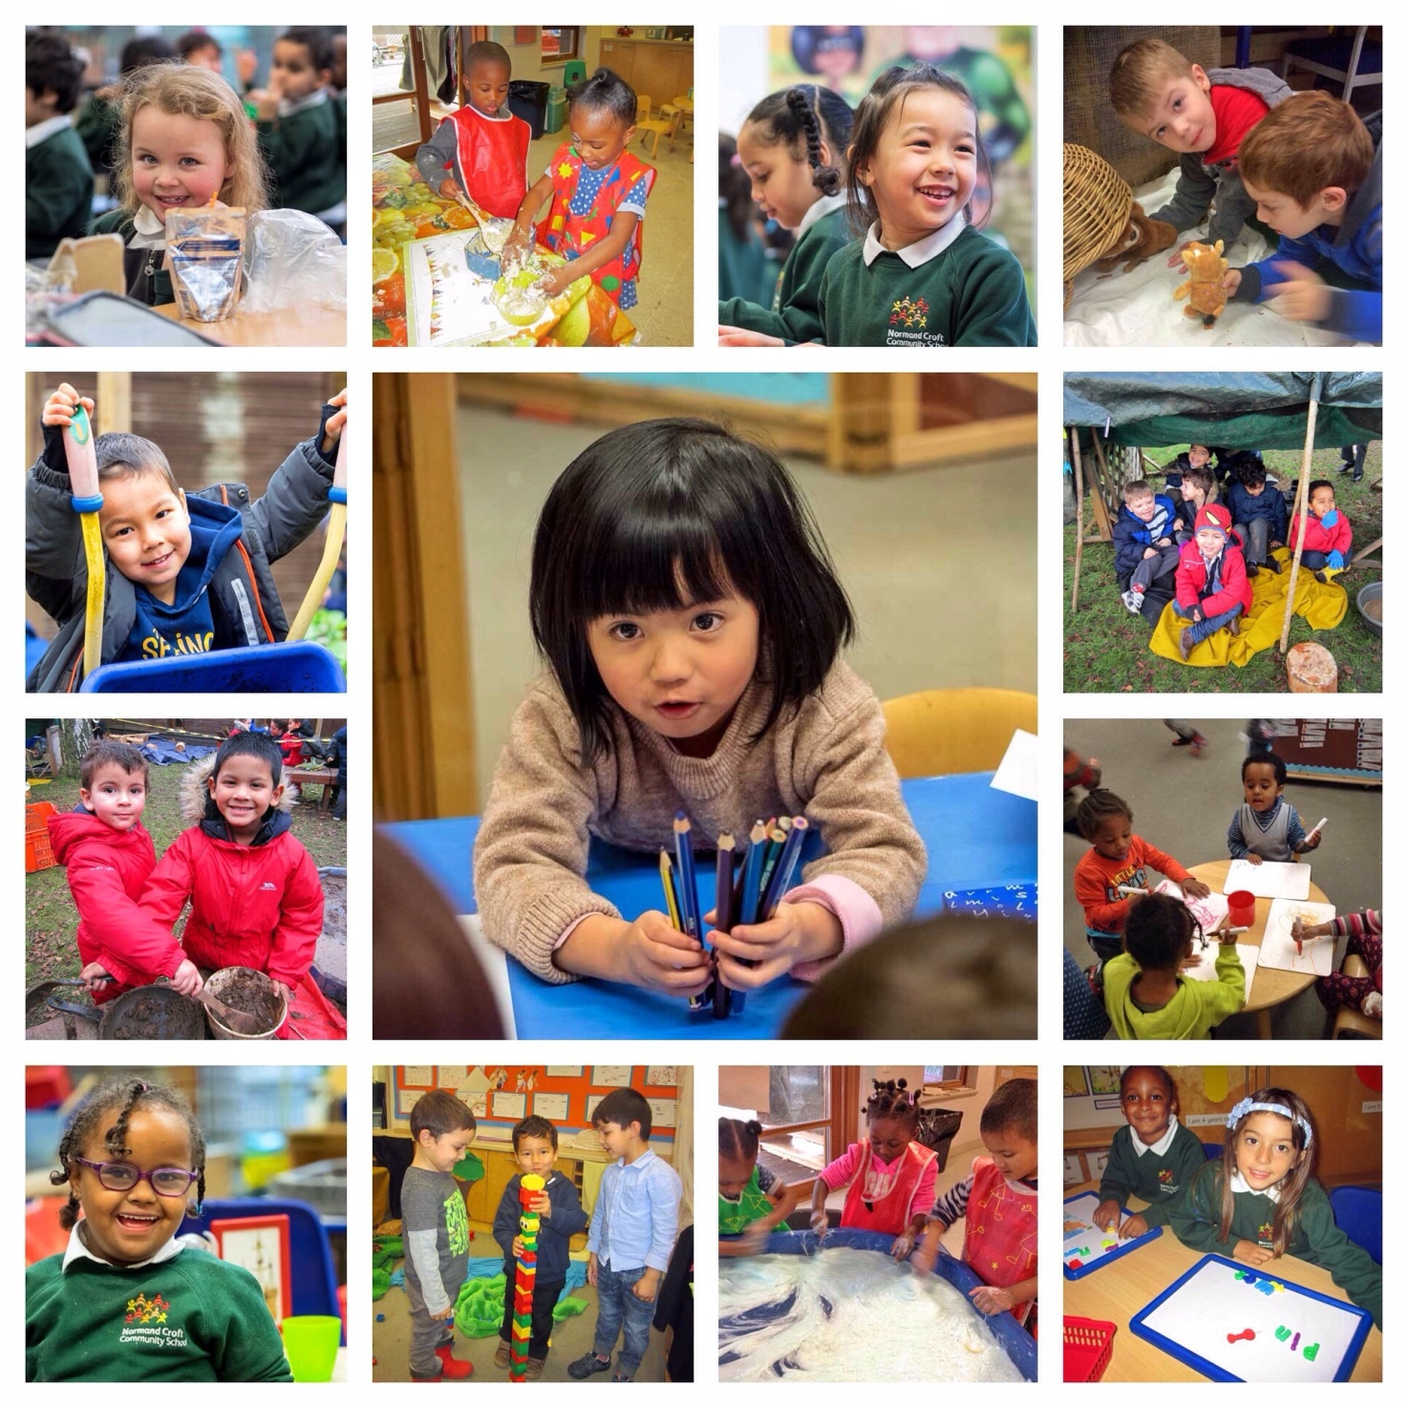
Welcome to Normand Croft
Dear candidate
To join Normand Croft is to join an international family of learners. We are passionate about children’s education and determined to go that extra mile to ensure that the children in our care have the very best opportunities to grow, learn and achieve.
We think deeply about what we do, we strive to give the children the most challenging and most exciting curriculum possible, and we treat each other with kindness and respect.

Our school is built on a foundation of shared values - excellence, responsibility & respect, determination, independence, tolerance and trust. They inform every aspect of school life.

As we continue on our journey to excellence we’re looking for enthusiastic and skilled support staff who’ll work alongside our teachers to create a wonderful learning environment for children.

To help you decide if this is the school for you here are a few things that we do at Normand Croft:
- We encourage collaborative partnerships and provide shared teaching opportunities with experienced colleagues.
- We believe in coaching, and will work with you to identify ‘small-step/ high leverage’ improvements to your practice.
- We believe in teaching the whole child, but also in developing your potential. Through demonstrating energy, resilience, enthusiasm and commitment you’ll find we offer a springboard to career development both in school and beyond.

We would love you to visit and see the school in action, or call to talk things through. Normand Croft is on an exciting journey, and we are looking for people to join us who have a belief that more of the same is just not ambitious enough.

With best wishes

About Normand Croft
Our Values and Vision
Normand Croft is a 2-11 community primary school in West Kensington, London. We have up to 12 children in our Under 3s Nursery Class (Willow) Children come with a wide variety of starting points and backgrounds to create a rich and diverse multi-cultural community of learners.
We all work hard to make a real impact on these children’s lives and learning. We have a strong sense of purpose which comes from serving children who, despite often living in socially disadvantaged and, at times, challenging environments, all have huge potential.
Our values guide everything that we do. We work to create a safe and happy ‘family’ atmosphere where every child has the chance to find their voice, be supported and be given a rich range of opportunities and experiences that will inspire them to enjoy school and make rapid progress.
We believe in a child-centred focus on learning and this is captured in our vision statement which defines our common ground as a school community as:
We put children at the heart of everything we do achieving
their safety, happiness and progress as learners underpins
every aspect of our work
We set high standards with high expectations of, and aspirations for, ourselves and all children
We support and challenge every child ensuring high quality teaching helps to overcome barriers to learning, and through building (and re-building) children’s self-belief enable them to achieve their potential
We value individuals ensuring that every child receives an education that is
tailored to their needs, and where enjoyment and achievement walk hand-in-hand
We enable children to shine giving them the opportunities, responsibility
and trust needed to learn for themselves, and explore/use their talents
We build bridges between children, parents, families and communities and work in partnership with others for the benefit of children
We celebrate core values such as excellence, responsibility, respect, determination, independence, tolerance and trust as expressions of our school ethos
Together we are re building a values-based learning ethos fit for the 21st Century.
Important Features of Normand Croft
Our school is a rich learning environment for both children and staff. It’s a special place, with a number of innovative features:
- Professional development is central to our school. Each member of staff collaborates with colleagues from across the school to improve their practice and develop new ways of supporting children.
- English language is at the heart of everything we do, with children given the chance to develop a love of books, of stories and early writing skills every day.
- Support & nurture. Our class sizes and teacher numbers mean that more time can be spent on really understanding the needs of each child. All children are supported and none fall through the cracks.
- Best practice. The way we teach and the way children learn doesn't happen by accident. We make sure our teachers keep up to date with the latest developments in teaching and learning and we're very proud of the fact that our bespoke approach to teaching and learning has evolved over time to meet the specific needs of our children. Importantly, it's an approach based on best practice drawn from the work of colleagues, academics and schools all over the world.
- Growth Mindset. We are on a 'Growth Mindset' journey. Inspired by the work of Carol Dweck, and her colleagues, we’re working to instil in children, teachers and hopefully parents/carers the belief that the brain is like a muscle. It grows, develops and indeed becomes more intelligent when mistakes are made and then corrected through feedback. We believe that intelligence and abilities can be significantly developed through practice; that an individual's end point is not pre-determined and that there is limitless potential for growth.
- Microcosm. We believe that our school should be a microcosm of the best of the world around us. Our approach to teaching helps us to achieve this by actively developing children's social and relationship skills and promoting a positive learning environment where children feel safe, valued and respected.

Job profile
Title: Learning Support Assistant
Salary and Grade: Scale 3 point 5Term Time Only 32.5 Hours per week from 8.45am to 3.45pm
£26,193 39 weeks a year – pro-rata

Temporary contract: 01.09.2023 to 31.08.2024
Subject to enhanced DBS check
This application is your chance to join a professional learning community where Learning Support Assistants have the chance to grow and develop through working in partnership, and in close collaboration with, experienced practitioners in school.
You will undertake all duties in accordance with the local authority’s and school’s policies and guidance; Health & Safety advice; and the Children’s Act.
The following description of accountabilities and tasks should be viewed in conjunction with the aforementioned document.

Job Purpose
- To work under the instruction/guidance of teaching/senior staff to undertake work/care/support programmes, to enable access to learning for pupils and to assist the teacher in the management of children and the classroom.

Description of duties

- Work in partnership with parents/carers, teachers and other professionals to provide effective support for learning activities, tailoring support to the needs of the individual pupils.
- Contribute to the planning, preparation, maintenance and evaluation of learning activities and environment, identifying areas of improvement and new developments where necessary.
- Establish constructive relationships with children, and interact with them according to their individual learning and emotional needs.
- Take a role in supporting and delivering all aspects of the curriculum.
- Monitor, assess, report and maintain records of pupils and their performance.
- Work with individual children/ small groups within the classroom and withdraw pupils from the class when required.
- Plan, prepare and deliver specific interventions linked to individual needs.
- Be proactive in the review of strategies and initiatives.
- Provide feedback to Key Workers, Teachers, SENDCo and parents/carers.
- Actively respond, and work flexibly, to children’s’ diverse needs both in and out of the classroom environment.
- Assist the designated teacher in creating differentiated resources and programmes to support pupils’ needs.
- Promote self-esteem by praising effort and ensuring identifiable success in the classroom.
- Ensure the safety and integration of students with physical and sensory difficulties.
- Accompany children on educational outings/ school activities, and take responsibility for a named child/group under the general supervision of the teacher.

This job description is not a comprehensive statement of procedures and tasks, but sets out the main expectations of the school in relation to the post holder’s professional responsibilities and duties.

Person Specification
Essential (E) Desirable (D)

Qualifications

- No formal qualification required
- English and Maths GCSE equivalent (D)
- Paediatric First Aid certificate (D)
- Willingness to undertake First aid training and Intimate care training (E)
- Willingness to carry out intimate care duties for children of primary age (E)

Knowledge and Understanding

- Understanding of the educational welfare and social needs of children (E)
- Working knowledge of implementing Individual Support Plans (D)
- Basic knowledge of ICT to effectively support the pupils (or willingness to train) (E)
- Understanding of the issues around safeguarding and behaviour in a school setting (E)
- A knowledge of some of the emotional, behavioural and social difficulties that may create a barriers to learning (D)
- Good communication, planning and organisational skills (E)
- Good literacy skills and the ability to communicate effectively in written form (E)
- Ability to work as a member of a team and contribute to the day-to-day practice of the school (E)
- An understanding of phonics, literacy, maths and communication and language strategies (D)

Experience
- UK-based experience – two years minimum (D)
- Experience of working with children under the age of 11 (E)
- Experience of supporting children with a range of special educational needs including ASD (D)
- Experience of communicating with a wide range of people from different backgrounds (E)
- Experience of record keeping (E)
- Experience of having planned (with teacher support), implemented and evaluated, imaginative group activities (D)
- Ability to deliver age-appropriate learning and teaching activities (E)
- Sound knowledge of appropriate behaviour management techniques (E)
- Good literacy skills and the ability to communicate effectively in written form (E)
- Ability to work as a member of a team and contribute to the day-to-day practice of the school (E)

Professional Practice and Commitment
- A commitment to uphold the school’s vision, values and staff code of conduct (E)
- A commitment to safeguarding and equal opportunities and assisting the school in raising achievement for all its pupils (E)
- A commitment to becoming familiar with and applying whole school policies, procedures and standards and be willing to implement them in a consistent manner; acting as a role model to children and the community (E)
- A commitment to attend in-service and external training courses and to develop and update knowledge and skills as required (E)

