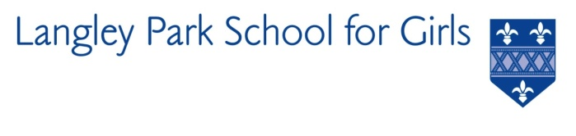

Langley Park School for Girls

Hawksbrook Lane

Beckenham

Kent BR3 3BE

Headteacher: Ms Helen Ralston

LEARNING SUPPORT ASSISTANT

REQUIRED ASAP

Salary: NJC Scale 2 Pt 3 (£24,012)

Actual salary £17,080 per annum depending on experience

Hours: 8.15am-3.25pm 30.83 hours per week / 38 weeks per year

(term time inc. PD Days)

Langley Park School for Girls is seeking to appoint an enthusiastic Learning Support Assistant to join the Student Support team as soon as possible.

LPGS is an exciting place to work; a school in which students are motivated to achieve their best and work hard to make exceptional progress. We want our students to leave LPGS empowered to shape their own lives, and those of others, as the leaders of tomorrow.

LPGS is an inclusive and academically successful school in South East London, with 1700 students including a large co-educational Sixth Form. The school is part of the Impact Multi Academy Trust which is made up of 4 secondary schools and 3 primary schools across the Bromley borough. Public transport links are good and staff travel from across London and the South Coast. Parking is also available.

This post will be supporting specific named or groups of students and those with medical needs. Working with class teachers across the curriculum, the SEND team and medical support staff, the successful candidate will assist students with their education and, where appropriate, support access to the curriculum for those who are physically or otherwise prevented from doing so themselves.

This post would be ideal for someone who has an interest in working within SEND or someone who is considering a future career in teaching. If you are keen to support students in a particular subject area or are looking for a role which enables you to develop your subject expertise, we would be interested in hearing from you.

Although experience and qualifications will be an advantage, first and foremost we wish to appoint the right people to complement our team. The successful applicants will have access to on-site training and support which is specifically linked to the needs of identified students.

For further details and an application form please visit our website: [**www.lpgs.bromley.sch.uk**](http://www.lpgs.bromley.sch.uk). If you would like to arrange an informal chat with the SENCO please contact Helen Partridge, [hpa@lpgs.bromley.sch.uk](mailto:hpa@lpgs.bromley.sch.uk). Please note that shortlisting will be based solely on our application form and covering letter. All applicants **must** complete the LPGS Application Form.

We are committed to equality of opportunity for all our staff. We particularly welcome applicants from ethnic minority backgrounds as they are currently under-represented on our staff body. We recognise the vital contribution that members of a diverse team make to our students’ learning. The range of cultural experiences, differing viewpoints and role models this brings is valued in our Trust.

The closing date for applications is **midday** on **Wednesday 11th October 2023** with interviews scheduled for week commencing 30th October 2023. You are encouraged to submit your application as soon as possible. Please note the school reserves the right to appoint prior to 11th October.

**This school is committed to safeguarding and promoting the welfare of children and young people and expects all staff and volunteers to share this commitment. The successful applicant will be subject to an Enhanced Disclosure & Barring Service check.**