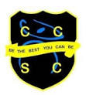

Learning Support at Chesterton Community Sports College
The Learning Support Department at CCSC is the largest department in the school, with 16 full time staff. The team work across the curriculum and the school to ensure pupils are well supported in their learning.

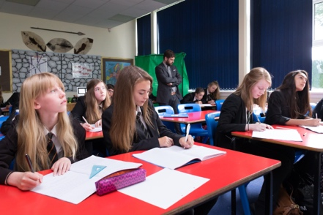
Roles vary across the department and are determined by individual strengths and areas of interest. Some members of the team are based in specialist subject areas where they are able to make a significant contribution to both individuals and specific groups of pupils. Other members of the team support individual pupils who have EHCs or are AEN funded - across their timetable of lessons

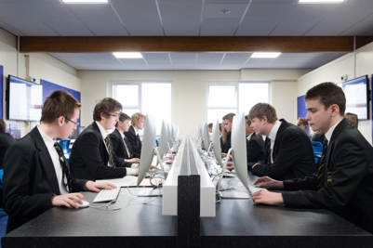
The learning support team are based in two large rooms that are used for intervention, safeguarding and pupil support. Each member of the team is equipped with an Apple MacBook to aid planning of interventions and to provide effective support alongside pupils

During the morning registration, the team offer interventions and pastoral care to support small groups of learners. This ensures as many pupils as possible are given the opportunity to develop their basic numeracy and literacy skills as well as support their social and emotional well-being. This support is essential to those pupils who are struggling to access the curriculum.

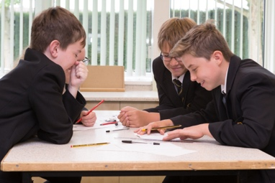
The progress of SEN pupils results have been consistently in line with or above national average for many years and we strive to continue with this high standard. It is our aim that all pupils should be the best that they can be and are fully prepared for future opportunities.
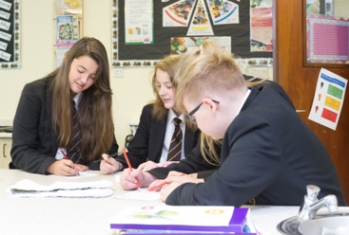
We are driven by the desire to ensure every child achieves their full potential and we are keen to appoint a member of staff who will bring energy, enthusiasm and commitment to the role. The person is as important as the qualifications and it is an opportunity to make a difference to many pupils’ progression.

