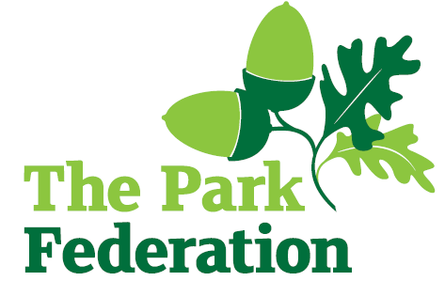
Learning Support Assistant

Salary (actual): £18,087 - £18,382
Grade: 2, SCP 3 - 4
Hours: 32.5 hours per week
Work Pattern: Term time only – 38 weeks
Contract: Permanent
Lake Farm Park Academy is a new three-form entry nursery and primary academy with an SRP for 12 children with ASD. It serves the children and families of the richly diverse and welcoming community of Hayes in West London and is the educational home to over 700 children. The academy is part of The Park Federation Academy Trust, allowing us to benefit from a wealth of expertise across our eight academies, as well as enabling us to provide opportunities for sharing of good practice and high quality training.
We are seeking to appoint a Learning Support Assistant who has high expectations of themselves and is committed to improving the lives of our children. The successful candidate will be part of a strong team of teachers and experienced support staff.

We are looking for individuals who:
- have experience of supporting young people;
- are proactive, positive, calm and flexible;
- have excellent communication, organisational and interpersonal skills;
- are committed to working as part of a team;
- are resilient;
- share our vision and aims for all of our pupils;
- are dedicated and committed to the success of the school.

For the right candidate, we will offer
- extensive support and CPD;
- the opportunity to work with other professional colleagues across the Multi-Academy Trust;
- a welcoming school, with friendly, enthusiastic and supportive staff team;
- an ambitious and dynamic Senior leadership Team;
- a dedicated Governing Body;
- supportive parents and children who are keen to learn;
- an employee assistance programme (EAP).
Visits to the academy are warmly welcomed, and can be arranged by contacting the school. Please visit the school website for an application pack.
CLOSING DATE: As and when we receive successful applications.
The school is committed to safeguarding and promoting the welfare of children and young people and expect all staff and volunteers to share in this commitment. The successful applicant will be required to undertake an Enhanced DBS Check with a check of the DBS Barred List.

