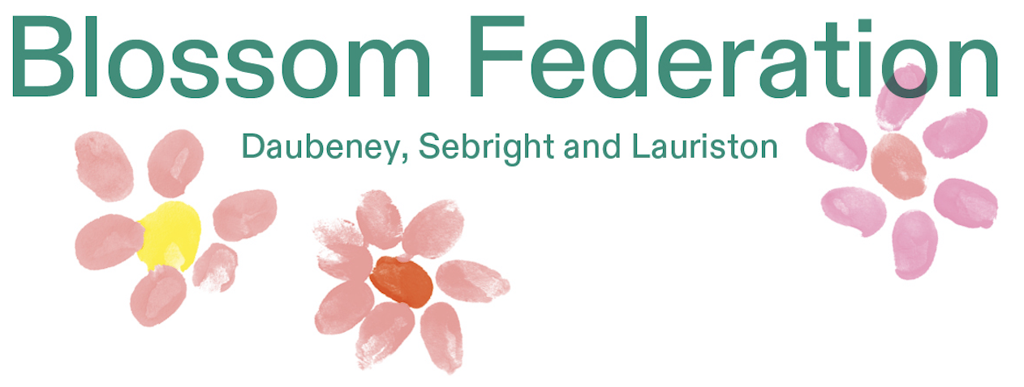

Learning Support Assistant
Full Time – 32.50 hours term time only
This position will initially be offered on a fixed-term basis for one year.
The salary is SC4, Point 7–10 (£31,980–£33,384 pro rata), with an actual salary of £25,056–£26,156.

Due to forthcoming staff changes, we require new Learning Support Assistants for the school.

The successful post holder will be supported by the SLT and Class Teachers to work with individuals, groups and classes to improve the teaching and learning for our children.

You will have experience of working in a school setting, preferably across all age groups and show a passion for learning. You will have excellent pastoral skills and be willing to work flexibly as part of a talented team.

We offer:
- A talented and supportive Senior leadership Team and committed staff
- CPD and training related to your role and the School Development Plan
- Wonderful children and parents
- A highly supportive Governing Body
- A close working relationship with families, the Local Authority, external professionals and across the Blossom Federation

Applications should be made to Shahidul Alom - Office Manager via salom@blossom.hackney.sch.uk

Closing date: Friday 6th February 2026 at 11:00 AM
Interviews on: Thursday 12th February 2026

The Blossom Federation is committed to safeguarding and promoting the welfare of children and expects all staff and volunteers to share this commitment.

