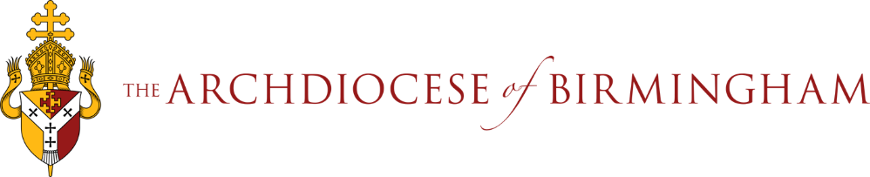
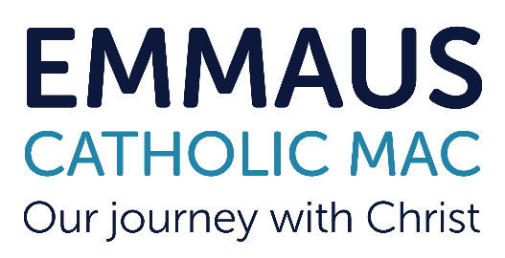
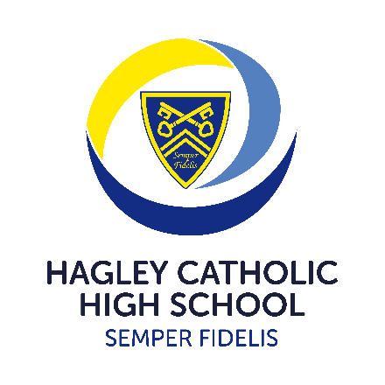

Emmaus Catholic MAC is committed to safeguarding and promoting the welfare of children and young people. This position is subject to an Enhanced Disclosure check under the Rehabilitation of Offenders Act 1974.
All applicants must be able to provide documentation to prove their right to work in the UK.
Effective from September 2022, KCSIE states as part of the shortlisting process schools and colleges
should consider carrying out on-line searches, as part of the due diligence on shortlisted candidates.
This is to determine suitability to work with children and keep them safe. All shortlisted candidates
are now subject to an on-line check and if there is anything concerning, then the shortlisted
candidate will be asked to comment on it either prior to or at interview.

We are recruiting for a
School Learning Support Assistant
Required To Start As Soon As Possible

Hours: 27.5 hours per week, Part Time/Permanent
Term Time Only (38 +1 weeks), which includes 5 teacher training days
Grade 4 SCP 5-6 £21,575- £21,968 to be Pro Rata according to hours and weeks worked
Principal – Mr J Hodgson
Contact Us
A full application pack is available from Hagley Catholic High School, by contacting the Principal’s PA or downloading the pack from the Emmaus MAC website:
Email - principalpa.hchs@emmausmac.com
Phone - 01562 883193
Online - www.hagleyrc.worcs.sch.uk
We warmly welcome visits to the school. For specific questions about the role and/or to request a visit, please contact Mrs Lindsay Imrie, SENDCO by email at limrie@emmausmac.com
Closing Date: 2nd October 2023 at 9am

Interviews: wc: 2nd October 2023 (Date TBC)
Hagley Catholic High School are seeking to appoint a Learning Support Assistant to join our Learning Support Team. The successful candidate will work under the direction of our SENDCO and teaching staff when in the classroom. The role may require the suitable candidate to work with specific student(s) at the direction of the SENDCO or HLTA and be involved in programmes of support and intervention.
Hagley Catholic High School has a very strong and nurturing SEND department based at the heart of the school in our Hub, a dedicated space for learning support, intervention and wellbeing.
We are looking to appoint a candidate with passion, drive, enthusiasm and dedication that will work to enable learners with additional needs to fully access the curriculum and school life and make progress.
Please refer to the job description and person specification for further details.
We welcome applications from both Catholics and non-Catholics but expect all employees to support the Catholic ethos and values of the school.

Closing Date: 21st May 2021 Date of Interviews: 24th May 2021

