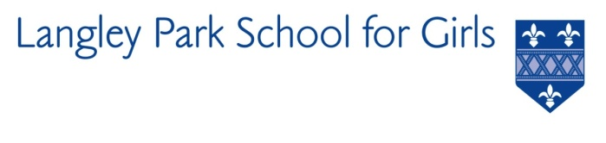

Langley Park School for Girls

Hawksbrook Lane

Beckenham

Kent BR3 3BE

Headteacher: Ms Katie Scott

REQUIRED FOR AUTUMN TERM 2021

LEARNING SUPPORT ASSISTANT

Salary: NJC Scale 2 Pt 3

Hours: 8.15am-3.25pm 31.5 hours per week / 38 weeks per year

(term time inc. PD Days)

Actual salary £15,255 per annum depending on experience

Langley Park School for Girls is seeking to appoint an enthusiastic Learning Support Assistant to join the Student Support team in Autumn Term 2021.

This post will be supporting specific named or groups of students and those with medical needs.
Working with class teachers across the curriculum, the SEND team and medical support staff, the successful candidates will assist students with their education and, where appropriate, support access to the curriculum for those who are physically or otherwise prevented from doing so themselves.

This post would be ideal for someone who has an interest in working within SEND or someone who is considering a future career in teaching.

Although experience and qualifications will be an advantage, first and foremost we wish to appoint the right people to complement our team. The successful applicants will have access to on-site training and support which is specifically linked to the needs of identified students.

We are particularly interested in those with an interest or experience in supporting students with numeracy difficulties.

For further details and an application form please visit our website: www.lpgs.bromley.sch.uk. If you would like to arrange an informal chat with the SENCO please contact Helen Partridge, hpa@lpgs.bromley.sch.uk.
Closing date for applications is Thursday 16th September 2021. It is anticipated that interviews will be held week commencing 20th September 2021. You are encouraged to submit your application as soon as possible. Please note the school reserves the right to appoint prior to 16th September.

Please note that whilst you are also welcome to submit a CV, shortlisting will be based solely on our application form and covering letter. All applicants must complete the LPGS Application Form.

This school is committed to safeguarding and promoting the welfare of children and young people and expects all staff and volunteers to share this commitment. The successful applicant will be subject to an Enhanced Disclosure & Barring Service check.

