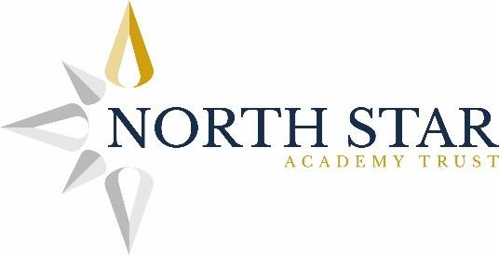
Job Description
Post Title | Salary | Reviewed
LSA | BG8 | December 2021

Managed by: A Member of the Teaching Team

Job Purpose
To provide support for learning activities and the social / emotional development of children on an individual or group basis, under the general direction of the teacher and in line with the ethos of the school. The role will involve supervising and developing the social skills of children during the lunchtime period.

Key Job Outcomes

Teaching and Learning

Follow work plans approved by the teaching staff, provide direct support for the learning of individual children or groups of children who have a wide range of special needs, to achieve defined progression targets in a child’s individual education plan and in class plans through:

· activities, interventions, empathetic and sympathetic listening, direct guidance and the provision of appropriate positive feedback to behaviour
· developing the physical, emotional and educational development of children through play
· supervising and encouraging safe behaviour of individual children and groups
· analysis of achievement to develop reinforcement of structured learning habits
· involvement in the planning and delivery of differentiated modules of work
· working with pupils who have complex learning difficulties where schemes of work need to be adapted considerably so learning can be accessed.
· taking classes without teacher present to deliver cover work (no active teaching).
· assisting in lesson planning and development of IEPs with the teacher.
· preparing assessment materials, delivering these to children and taking a role in marking and recording of progress data.

Monitoring and Assessment
Develop work plans, following guidance from the teaching staff, and prepare, store, retrieve, sort and display materials, finished work, equipment, topic work plans and/or assignment documents to provide an effective learning environment as determined by the teacher to:
· promote the required standards of achievement and performance, including feedback through structured assessment, for individuals and groups within the classroom
· support the development of continuous improvement in both personal performance in the job and the work of the team
· assist in the development, monitoring, reviewing and progression of children’s learning plans and behaviour plans
· support assessment processes, recording, keeping and retrieving accurate records and following defined procedures
· assist in the supervision of the work of support staff colleagues who work 1:1 with students and supply staff as required and defined by the line manager
· develop continuity and consistency in the work of the support team which achieves the attainment of standards in learning progress by the school required by the Head and Governors and OFSTED.

Pastoral Care and Safeguarding
Attend to the day to day needs of children, inside and outside the classroom, by:
· providing personal, social, hygiene, welfare and behaviour support
· providing intervention to promote the progress of individual children in attaining defined goals
· promoting effective pastoral care for individual children and groups, following defined procedures, and liaising with colleagues to create and retrieve accurate records to provide the basis for home/school liaison & contacts with other agencies
· reporting concerns about progress, identifying solutions, to the teacher
· assisting educational and therapeutic professionals in their delivery of specialist support programmes
· carrying out specified medical care procedures following direct specific training by a qualified practitioner
· promoting the social, emotional and behavioural standards defined by school and LA policies and procedures.
· undertaking Team Teach Training offered by the school and be physically able to put this into practice.
· being willing and available to work additional hours as a taxi escort for pupils (on a full-time or rota basis)

Developing North Star Academy Trust

- Contribute to achieving the vision and aims of the Trust.
- Contribute to the development of the Trust as an outstanding provider of SEMH provision.
- Contribute to the development of collaborative and team working between schools in the Trust, as a means of affecting change and improving standards.
- Contribute fully to the improvement of pupils’ attitudes to learning and behaviour across the Trust.
- To lead cross trust initiatives.

General Accountabilities
- So far as is reasonably practicable, the post holder must ensure that safe working practices are adopted by employees in school/work areas for which the post holder is responsible to maintain a safe working environment for employees and pupils. These practices are defined in the Trusts Health and Safety Policy and departmental codes of practice.
- Work in compliance with the Code of Conduct, Regulations and policies of the Trust, and its commitment to equal opportunities.
- Take responsibility for your own professional development by keeping up to date with new initiatives and current best practice.
- Ensure that output and quality of work is of a high standard and complies with current legislation and standards.

- Carry out any other duties as requested which are commensurate with the grade of the post.

