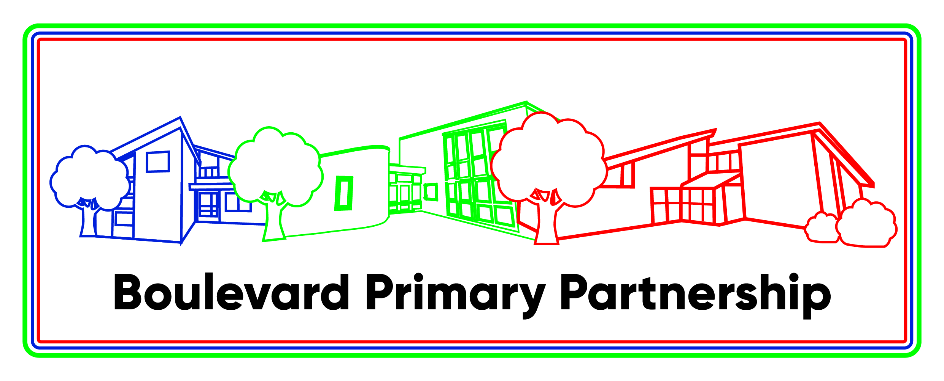

Executive Headteacher: Kate Mathews

Learning Support Assistant for our ASC Unit
Southwood School
Start date in April 2025 or September 2025
8.45am to 3.30pm, term time only
LSAs: Grade B (£23,500 FTE, Actual £16,781 - £17,452)

We have recently opened Autistic Spectrum Condition units at Germander Park and Southwood Schools, both part of the Boulevard Primary Partnership federation (along with Downs Barn School). The units currently have one class but will grow each year eventually to two classes at Germander Park and three classes at Southwood (each with 8 pupils). All children hold EHCPs.

We are in search of a Learning Support Assistant for one of the classes at Southwood school who can inspire our pupils and help them to enjoy their time at school and their learning. We have vibrant and inclusive schools dedicated to providing a nurturing and stimulating environment for our students.

The successful candidates will be able to:
- Support the delivery of creative and engaging lessons planned by the teaching staff, aligned with our curriculum
- Create a supportive and inclusive classroom environment where every student feels valued
- Differentiate to meet the diverse learning needs of our students so they can achieve their best
- Implement effective classroom management strategies promoting positive behaviour

You will:
- Be sensitive to the wide range of children’s needs experienced in main stream schools
- Be an excellent communicator, able to work collaboratively with the year group team
- Have a passion for education and a commitment for fostering a love of learning in students
- Be kind, caring and understanding and good role model for our pupils

Applications are welcomed from team players with high expectations for achievement. We can offer you good schools in a friendly and happy environment. If you would like to visit prior to application, please contact us and we will be more than happy to show you around. For further information contact Melanie Hornshaw on 01908 678366 or email office@southwoodschool.co.uk. The closing date for applications is 10th January 2024.

All Boulevard Primary Partnership schools are committed to safeguarding and promoting the welfare of children and expect all staff to share this commitment. We are an equal opportunities employer. The successful candidate will be required to complete an enhanced DBS check.

ASC UNITS at Southwood and Germander Park Schools
There are high expectations for behaviour, which pupils rise to.
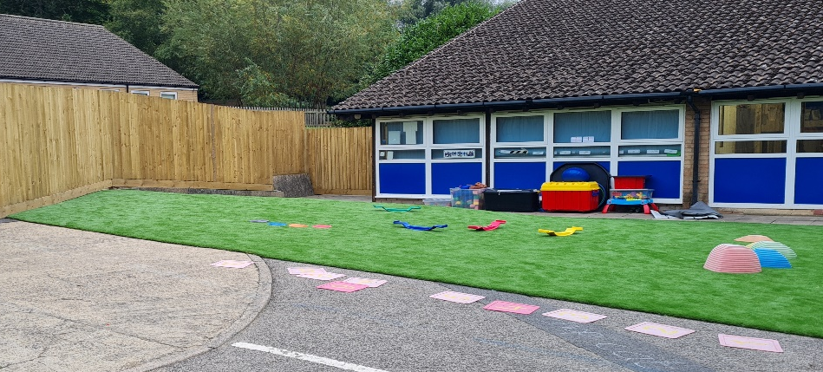
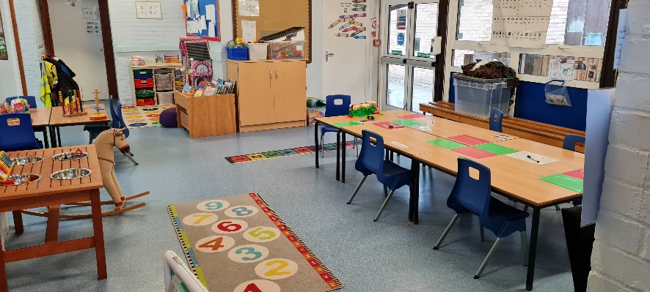
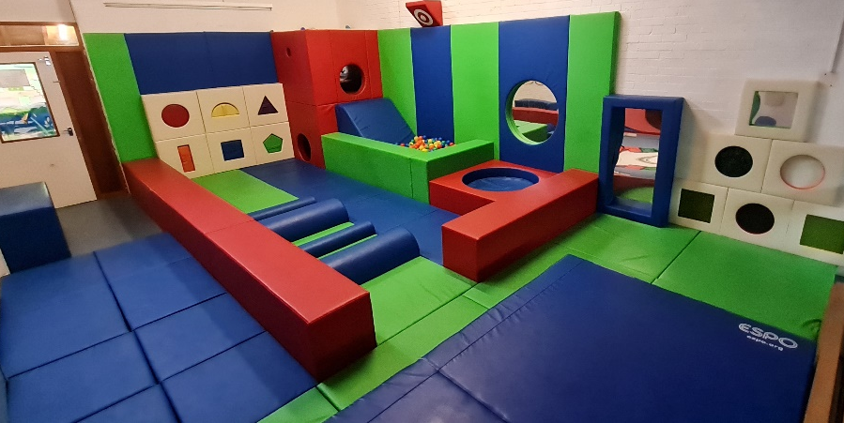
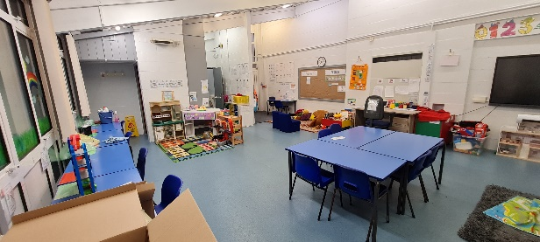
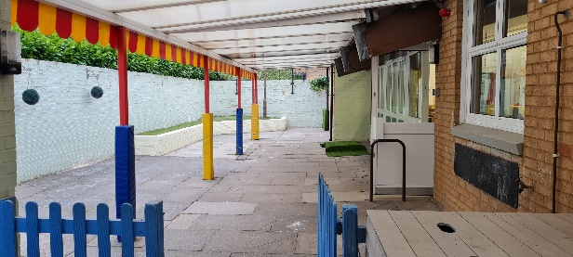
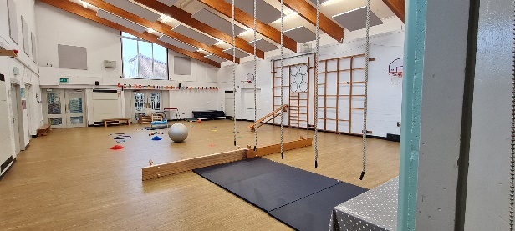
Pupils with special educational needs and/or disabilities (SEND) study an ambitious curriculum.
Leaders have high expectations for achievement and for the conduct of all pupils.
This is a welcoming and inclusive school.
Southwood School was inspected by Ofsted in May 2023 and were judged to be Good.
Germander Park School was inspected by Ofsted in June 2023 and were judged to be Good.

