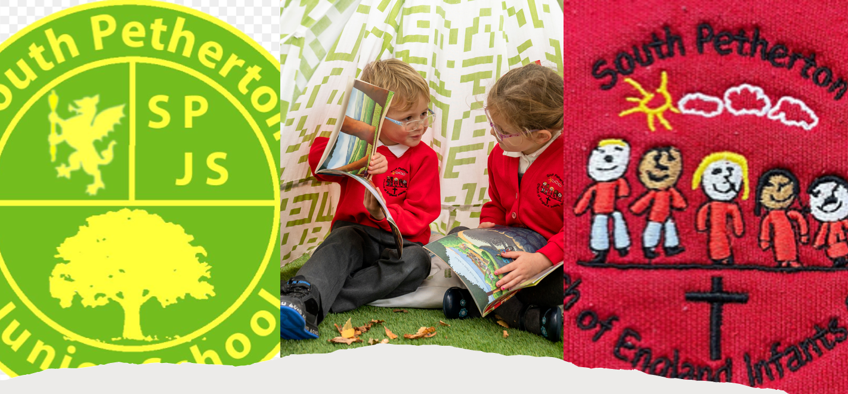

South Petherton Schools Partnership
Learning Support Assistant
South Petherton Junior School
Hours: 8.45am – 1:15pm (Term Time Only)
22.5 hours – Grade 14 Point 4

Are you passionate about working with young children and helping them to flourish in all areas of life?

This is an exciting opportunity to join a fantastic Junior School with a motivated and dynamic community. The Executive Head is now seeking to recruit a passionate individual to join the school team to support a particular pupil at the school. Read on to find out more…

South Petherton Juniors are seeking to appoint a Learning Support Assistant at the Infant School for a fixed-term contract, until August 2026 in the first instance.

The Junior School is a vibrant school where children are enthusiastic and motivated to achieve endless possibilities. The children are at the heart of every decision we make to ensure that they are confident, happy, and safe. We ensure that children can foster a passion for learning and curiosity that will help to develop high aspirations and a lifetime of memories.

South Petherton Junior School is looking for a Learning Support Assistant to join our friendly and supportive team from 23rd February 2026. We are looking for a flexible, reliable and enthusiastic colleague to support an individual child with learning, physical and emotional needs, assisting the child in the classroom and supporting the delivery of a personalised curriculum.

You will be committed to developing effective working relationships with the child, parents and staff, while contributing to the individual pupil’s development, working with the Class Teacher to support the pupil across a wide range of activities. With a creative and flexible approach to working with individual children you will be passionate about every child’s learning and progress and promote excellent behaviour and high standards.

This important post will be filled by someone who:
– Has an inclusive philosophy and a love for learning
– Is fully committed to our school community and its children

We offer:
– A happy, forward looking school with a hard-working team
– Strong systems to support all learners
– A dedicated vision for CPD
– Committed pupils, parents and wider community who are fully supportive

We are committed to safeguarding and promoting the welfare of children and young people and expect all staff to share this commitment, all posts are subject to a satisfactory Enhanced DBS Clearance.

If you would like more information regarding this role, please contact the School Office on 01460 240172.

Please read the Job Description and Job Specification before applying.

Please email the completed application form to office@southpethertonjuniorschool.co.uk

Visits to the school are encouraged; please contact the school to arrange a visit prior to application.

Closing date: Thursday 5th February 2026

Interview Date: Wednesday 11th February 2026

If you have not heard from us regarding an interview by Monday 9th February 2026, this will mean that on this occasion you have been unsuccessful.

