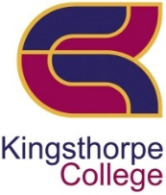 | Kingsthorpe College | 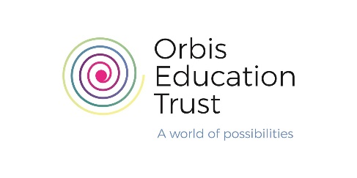

Learning Support Assistant (Level 2)

Do you believe that everything is possible?

If so, Kingsthorpe College has an opportunity just for you.

- Are you an optimistic, reflective, and determined leader who wishes to work with a forward-looking and ambitious Leadership Team at an oversubscribed and Ofsted Good (Dec 2019) school?
- Are you someone who enjoys being challenged and is not afraid to offer challenge?
- Are you someone who does the right thing even when no-one is watching?
We are seeking a positive, proactive and confident person to join our busy special educational needs and disabilities (SEND) team. You will provide high quality support across the College. Applicants should be organised, self-confident and possess excellent communication, interpersonal and IT skills along with the ability to multitask. We are especially keen to interview candidates with high levels of skills using Microsoft Office, Excel, Word and Outlook.

Why do we exist?
We exist to maximise the life choices of our students by being the catalyst in students’ artistic, athletic and academic lives.
How do we behave?
We behave with optimism, determination, thoughtfulness, and clarity.
What do we do?
We provide character and currency for our students to achieve success.
How will we succeed?
We will differentiate ourselves by creating a healthy organization, making student-centric decisions, and giving students opportunities to develop resilience, perseverance and creativity, and be curious, kind, well-rounded individuals.
At KC, we don’t value what we measure, we measure what we value. For us, this is team work.

Permanent Contract
Annual Salary – Orbis Pay Scale 2022 9 – 11 £19,068 - £20,034 per annum
Actual Salary Pro Rata - £16,553 - £17,392
depending on experience

Hours – 37 per week / 39 weeks
Monday, Tuesday, Wednesday & Thursday 8.15am – 4.15pm
Friday 8.15am – 3.45pm, 30-minute unpaid lunch daily
Start date – As soon as possible

Closing date for applications: 9am on Monday 17 October 2022
Interviews will be held the week commencing TBC
Please note that we may close applications early depending upon the number of applications received.

Please note the College cannot accept CV's. Applicants must complete a Support Staff Application Form that is available on the college website at www.kingsthorpecollege.org.uk/workwithus

Please email your completed application form to recruitment@kingsthorpecollege.org.uk
Kingsthorpe College, Boughton Green Road, Kingsthorpe, Northampton NN2 7HR Tel: 01604 716106

Kingsthorpe College is committed to safeguarding and promoting the welfare of children and young people and expects all staff and volunteers to share this commitment.

