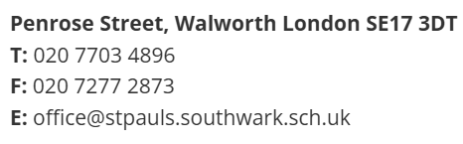


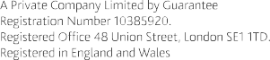

Job Advert – Learning Support Assistant

St Paul's is looking for an enthusiastic Learning Support Assistant to join our dedicated team.

Start date: | September 2026
Closing date: | 9am on Thursday 10th June 2026
Interview date: | Tuesday 16th June 2026
Salary: | Southwark Grade 5 – Points 6 (£31,530 FTE) to 13 (£34,863 FTE)  Actual pro-rata £20,809 to £23,008
Hours: | 27.5 hours term time

At St Paul’s Church of England Primary, we are proud of our diverse and inclusive school where in all we do we aim high, encourage and have faith. The post holder will support children with SEND, including those with EHCPs, on a 1:1 basis in the classroom.

At St Paul’s:

- We are committed to high quality teaching and to excellent professional development opportunities for all our staff
- We have a resilient staff team from a wide range of backgrounds and experiences who work closely together to secure the best outcomes for our children

The successful applicant will:

- Be committed to the development of all children in our inclusive church school
- Have the resilience and drive to work to secure the very best outcomes for all our children
- Work with our dedicated staff team to ensure the education, well-being, behaviour and personal development of children enhances their futures

If interested in joining our hard-working team, we can offer you:

- A well-resourced school set in extensive grounds
- Support and development from the SDBE MAT including a generous staff benefits scheme
- A school committed to wider education including a full extra-curricular programme
- Coaching and bespoke CPD opportunities
Thank you for your interest in this vacancy. We would be delighted to hear from you, arrange a visit to show you around our school, or simply have an informal discussion.
Applicants are expected to be sympathetic to the Christian ethos of the school.
St Pauls’s is committed to safeguarding and promoting the welfare of children and expects all staff and
volunteers to share this commitment.
All appointments are subject to a satisfactory enhanced DBS check and references.

