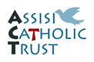
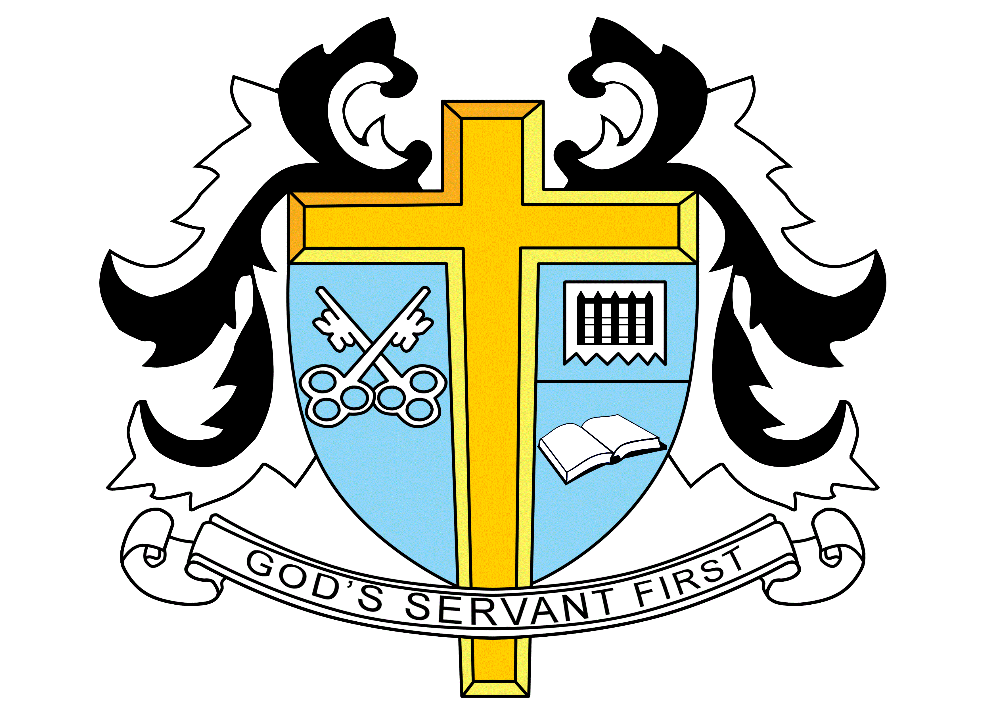

ST. THOMAS MORE HIGH SCHOOL
Kenilworth Gardens, Westcliff-on-Sea, Essex, SS0 0BW
www.st-thomasmore.southend.sch.uk, Tel: 01702 344933

LEARNING SUPPORT ASSISTANT(S)
One Year Contract

Scale 3 , Points Range 4-5
£14,000 approx. per annum
31 hours 40 minutes per week, Term-Time Only

At St Thomas More High School we are looking to recruit to our team of Learning Support Assistants to work alongside Teachers and specific students with particular needs. While experience of working in schools and TA/LSA qualifications are an advantage, they are not essential. Training will be provided. Candidates must be passionate and enthusiastic about working with children and possess excellent communication and interpersonal skills.

You’ll be joining a friendly and supportive team that has cultivated a genuinely cohesive working environment – sharing ideas, best practice and resources.

Please see the school’s website for further details and an application form or telephone the school for details to be sent to you. We are a Catholic School but applications are equally welcome from non-Catholic Christians.

The school’s application form must be completed. We are committed to safeguarding and promoting the welfare of children and young people and expect all staff to share this commitment. Appointments made are subject to an Enhanced DBS clearance and safeguarding checks.

Closing date: Monday 4th October 2021

