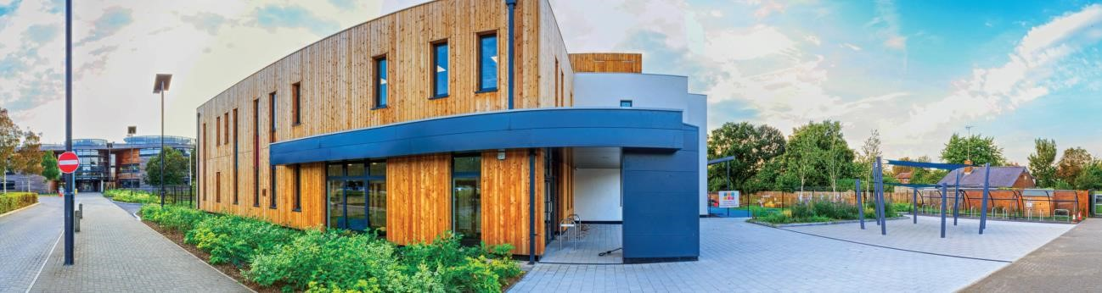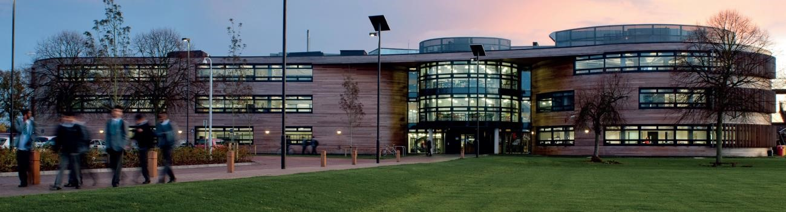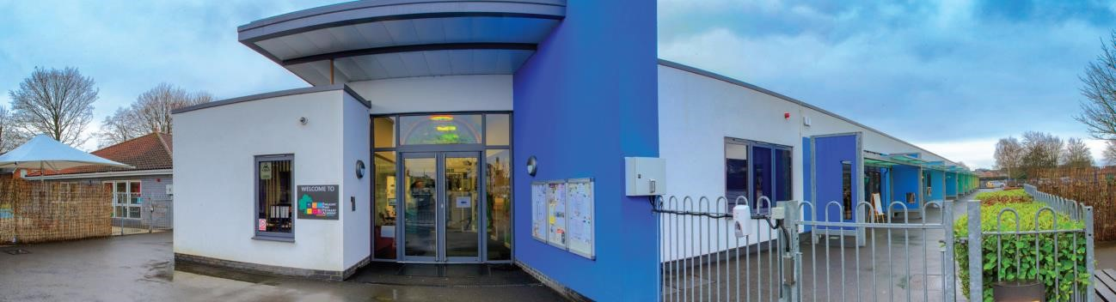

The Arbib Education Trust

Slough, Berkshire
Learning Support Assistant

Application Pack for
The Langley Academy Primary

2

Thank you for your interest
in the
L
earning
S
upport
A
ssistant

position at The
Arbib Education Trust
.

This pack contains:

-

Letter to candidates

-

Details about th
e Sponsor and The Annabel
Arbib

Foundation

-

Information about The Langley Academy
Secondary

-

Information about T
he Langley Academy Primary
and T
he
Langley Heritage Primary

-

The job description and
person specification

We hope that you find the pack informative and
useful. If you do have any further questions, then
pleas
e contact
Mrs D Singh
,
PA to the Headteacher
at
denise.singh@langleyacademyprimary.org or 01753
214450.

You can also visit our Tru
st website at

www.
arbibeducationtrust.org

Contents

Dear applicant
I am delighted that you have shown an interest in applying for the Learning Support Assistant position at The Langley Academy Primary. I would like to set out the reasons why this opportunity is so exciting.
The Langley Academy Primary is a new three form entry free school which opened in September 2015 with 90 Reception pupils. Our intake has grown by 90 pupils each year and reaches full capacity of 630 children in 2021. The Langley Academy Primary is sponsored by The Arbib Education Trust and shares the site with The Langley Academy (secondary).
We are committed to developing each and every one of our pupils to enable them to become the best they can be by providing each child with an outstanding educational experience.
To support us in our aims, we need support staff who are innovative, energetic and nurturing with knowledge and understanding of teaching and learning the primary curriculum. You will also need to have a passion to support us in creating a motivating environment which inspires children.
As a member of our growing team we are looking for teachers who are:

- Driven by their values and are passionate about the role a primary school can play in transforming children’s lives
- Excited by working in a collaborative environment across The Trust
- Committed to developing themselves as a practitioner and leader
- Highly professional with a ‘can-do’ approach
- Flexible, quick-thinking with lots of great ideas
- Energetic, creative and able to use your initiative
- Approachable with excellent communication skills
- Role models for the school community

We will look to you to create a commitment to learning, which enthuses children and gives them the motivation to do well. In return, you will benefit from leading edge training and professional development. As part of a dedicated team, you will have opportunities for your wider skills and interests to benefit our children.

As an academy we offer you the following benefits:

- Opportunity to work alongside primary and secondary practitioners
- Comprehensive internal and external CPD programmes to assist in the development of your career
- Internal promotion opportunities
- Well trained teaching assistants
- Additional non-contact time
- Complimentary school lunch through family dining
- Complimentary tea and coffee
- State of the Art £8 million school building

The successful applicant will be able to draw on support from across the Trust together with networking opportunities to further develop their own career.
Working from a blank page to develop The Langley Academy Primary has been my most exciting challenge so far and the rewards have been incredible. I look forward to welcoming you.
Yours sincerely,
Tracey Bowen
Headteacher

Dear applicant
I am delighted that you are showing an interest in the Class Teacher position here at The Arbib
Education Trust. The Multi-Academy Trust (MAT) encompasses The Langley Academy Secondary, The Langley Academy Primary and The Langley Heritage Primary. Our vision is to ensure we provide an exceptional education for every child in the Trust through high aspirations and quality learning through curiosity, exploration and discovery. By September 2021, when The Langley Academy Primary has a full complement of year groups, we will have approximately 2,500 students and 350 staff working in the Trust.
We are looking for someone who wishes to be part of this vision. The Trust is in its sixth year and most recently developed its strapline, “One community. Many ideas. Everyone’s future”. We believe in our wider responsibility of meeting the needs not just of our children/students and staff but those of the community. We believe that schools are communities that should focus on everyone, the children and the staff and consequently, staff development sits at the heart of our work and we believe that a culture of collaboration where we are all encouraged to share our ideas, allows us to meet our strategic objectives. The post holder for this position will provide robust, reflective, informed and high-quality support to ensure we provide an outstanding education for every child across our Trust.
Both Primaries are the main feeder schools with right of entry as part of the admissions policy. This means that the curriculum, assessment and pedagogy are continually being developed as a Trust to ensure our young people make rapid progress throughout.
One of the greatest qualities of the Trust is the Sponsors. Having worked with them since my appointment as Principal of The Langley Academy in April 2012, I cannot praise them highly enough. Annabel Nicoll as the Sponsor has boundless energy and enthusiasm all directed at giving youngsters a better life. As a result of her work, students here have quite simply been afforded opportunities that many young people elsewhere in the country just would not get. The successful applicant will be able to draw on this support and networking opportunity to develop their own career and importantly contribute towards bettering education for the young people across the Trust.
We are aspirational and want to be the best MAT in the country with each school rated outstanding as soon as possible. We believe the economies of scale, the cross-phase opportunities for students and staff development, the ability to respond to each other’s needs quickly and the ‘can do’ approach to everything we do, will make the working environment extremely exciting. Please apply if you understand what we are trying to achieve and you would like to be a part of our journey. Yours sincerely
Rhodri Bryant
Executive Principal

About the Sponsor and the Trust
The Annabel Arbib Foundation is a registered charity (number 296358) that supports the philanthropy of Sir Martyn Arbib and his daughter Annabel Nicoll. Sir Martyn set up the Henley-onThames based Perpetual Investment business in 1974 and established the Arbib Foundation in 1987. The Foundation has provided charitable donations and financial support to organisations and causes around the UK, with a focus on the Thames Valley. Sir Martyn Arbib, and the Foundation, took a leading role in establishing the River & Rowing Museum in Henley-on-Thames that opened in 1998 and attracts over 100,000 visitors per year. The Annabel Arbib Foundation continues to be the main sponsor of the educational side of the museum.
The principal beneficiary of the Annabel Arbib Foundation is The Arbib Education Trust in Slough.
The Annabel Arbib Foundation is the sponsor of The Langley Academy Trust, which comprises The Langley Academy, The Langley Heritage Primary and The Langley Academy Primary. Annabel Nicoll is Sponsor at The Langley Academy Trust.
In 2015 Sir Martyn Arbib retired as Chairman of The Arbib Foundation and his daughter Annabel took up the Chair and uses the Foundation, which has been renamed The Annabel Arbib Foundation, to support her own philanthropy continuing the focus on The Arbib Education Trust.
The Arbib Education Trust is a unique Trust that serves the young people of Langley, Slough and further afield. Our Trustees are a Board of interesting and experienced professionals who bring energy, enthusiasm and wisdom to their role. They share the ambitions of the Trust senior leaders to achieve the best possible outcomes for all children and students within the Trust.
The Langley Academy Primary is a three-form entry Free-School, sponsored by The Langley Academy Trust. It opened in September 2015 with 90 very excited Reception children and parents; the intake will grow year on year until it reaches capacity of 630 children in September 2021.
The Trust’s strong vision, high aspirations and determination to succeed in providing an outstanding education for children in the community are clearly evident throughout The Langley Academy Primary’s positive learning environment. Our supportive ethos, child-centred approach, rich curriculum based on first-hand experiences have ensured children are confident, independent learners, displaying Curiosity, Exploration and Discovery.
The school has been outstanding from day 1. From the very beginning, the school received very positive feedback from a DfE monitoring visit and the Local Authority Early Years Team. The visits confirmed the Trust’s review of the school and highlighted that the likely judgment in any future Ofsted inspection would be outstanding. This was shown to be accurate, when, during our first Ofsted inspection in July 2018, we achieved an outstanding judgement:
“There are four key factors that contribute towards making teaching outstanding at this school. Firstly, teachers know every pupil well as an individual. Secondly, teachers have the very highest expectations of what can be achieved. Thirdly, teachers understand how young pupils learn best and, finally, teachers have excellent subject knowledge.”
Throughout our growth period, under the guidance of The Trust and by working closely with The Langley Heritage Primary, The Langley Academy Primary looks forward to shaping a new 21st Century Educational Experience.
The Langley Heritage Primary is a popular school with recently modernised buildings that converted to a sponsored Academy within The Arbib Education Trust in September 2014.
The Langley Heritage Primary caters for children between the ages of 3 and 11 years. The school was originally built in 1952 as a separate Infant and Junior School. The two schools were amalgamated in 1987 under one Headteacher. Major works were undertaken to enlarge its buildings following an expansion to a three- form entry school in 2009. The demographics in Slough have changed and there are far fewer children so the school decided to reduce its size back to a two-form entry Primary school from 2020. The school currently has 506 children on roll plus a part time 30 fte Nursery provision.
The pupils come from diverse ethnic backgrounds which is typical for Slough, with the major groups being White British, Indian and Pakistani. There are smaller proportions of pupils from a wide range of other minority ethnic groups including Eastern European as well as a small group of Traveller children. The proportion of pupils with learning difficulties and/or disabilities is average. Just over a third of pupils speak English as an additional language. The proportion of pupils known to be eligible for free school meals is average. There is a breakfast and an after-school club.
Every child who attends The Langley Heritage Primary is viewed as unique and treated as such. Children are encouraged to become independent thinkers with a love for life and learning. Their enthusiasm is stimulated by dedicated staff members who share the ambitions of The Arbib Education Trust to motivate the pupils to be inquisitive and thoughtful learners who will go on to success at Secondary School and beyond.
The Langley Heritage Primary has developed holistically since it joined the Trust in September 2014. The curriculum has been honed to reflect the learning needs of the children and the strengths of the staff. The wider curriculum is under review with both The Langley Academy Primary and The Langley Heritage Primary embarking on an exciting journey over the next six years to map a new Primary curriculum and educational direction for the children encompassing first hand experiences, based on a thematic approach to learning and linked to visits and journeys and encompassing Museum Learning. The school achieved a good Ofsted with outstanding leadership and management in November 2019.
The Langley Academy Secondary is housed in an iconic building, it specialises in Science, pioneers the use of museum learning and aims to become a centre of excellence for sports, notably rowing and cricket. We have won our first rowing competition on the water and we have several National and European indoor champions. At the heart of our vision, The Langley Academy aims for the highest achievement for all and to provide a welcoming, imaginative and creative environment which enriches the lives of all involved. You will see this in our building. We aspire to instil traditional values and promote respect for other beliefs. The Academy strives to be at the forefront of Science education and has developed links with national and regional museums to add an external dimension to learning. We are proud of what we and our students have achieved and we are confident that we will continue to achieve high standards for all our students and our local community.
In our most recent Ofsted inspection, in November 2017, we were rated as good and improving. Highlights from the report include:
“Governors and leaders actively promote the vision through fostering a shared love of learning together with high aspirations for all pupils.”
As one parent commented: ’My son and daughter have both made spectacular progress under the guidance of passionate teachers …The leadership team, along with the staff, are an absolute asset to the school community and in helping shape the next generation of learners.’
‘Morale is high and staff recognise that the school is improving. Pupils and sixth formers confidently welcome visitors and are proud to share their work and enjoy working with their teachers. There is a sense of pride, both in The Langley Academy and in the outcomes pupils achieve, that is shared between staff, governors, trustees and pupils.’
Our results are strong. At Key stage 4 we achieved 63% good passes (4+) in English and Maths with a Progress 8 score of +.23. KS5 results dipped last year but we anticipate a return to previous high standards this summer. A growing number of our leavers move on to university and we were very proud to have our first student take a place at Oxford this academic year. You will be able to find out more about our results and trends if you are invited to interview.

The Langley Academy Primary
Job Description
Learning Support Assistant

Salary/Grade
L1 1 of 2

Hours
Full Time: 08.00 – 16.00 Term Time plus inset days

Reporting to
Head of Key Stage

Liaising with
Class Teacher and parents

Main purposes of the job

To work with the Heads of Key Stages at The Langley Academy Primary in all aspects of developing learning and teaching, curriculum, assessment and enrichment.

Learning Support Assistants should be role models and strive for the very best in their practice. They will support the teachers within the school to facilitate the active participation of pupils in the academic and social activities of the school. They will implement the daily routine and contribute to raising standards of achievement for all pupils

Main responsibilities and tasks
To work under the guidance of the Deputy Headteacher within an agreed system of supervision to:
- Support the implementation of an agreed range of activities with individuals/groups of children within or outside of the class to promote learning.

Supervision
- To ensure the safety and welfare of the children.

- To assist with the general supervision of pupils during break times or when required, interacting with children.

- To accompany teaching staff and children on visits, trips and out of school activities as required and take responsibility for a group.

Promote Pupil Learning
Under the guidance of the teacher:
- Support the teacher in the day to day learning activities in the classroom.

- Contribute to the assessment and tracking of pupil progress, including observation feedback, raising the awareness of teaching staff to the strengths and difficulties of individual pupils and contributing to the planning of learning activities.

- Support pupil well-being, behaviour and personal development, understanding the emotional and social needs of pupils, in order to enhance their learning and life skills.

- Assist teachers in maintaining the learning environment, inside and out, and preparing teaching materials.

- Lead the learning in intervention groups, including booster provision, extension and SEND, working on targets set by teaching staff.

- Cover the class in the short term absence of the teacher, delivering planned work.

Working with the children
- Establish productive working relationships with children, acting as a role model and setting high expectations for behaviour and learning.

- To promote and reinforce pupils’ self-esteem.

- Encouraging children to interact and work co-operatively with others and engaging children in activities.

- Promoting independence and employing strategies to recognise and reward achievement of selfreliance.

- Interacting with children and supporting development of their knowledge, skills, attitudes, problem solving and thinking.

- To understand the required areas of learning, stages of development and assessment in order to support pupils’ learning and progress.

Working with teachers and other professionals
- Working with the teacher to establish an appropriate, safe and secure learning environment.

- Working with teachers and other team members to share information, liaise and agree upon a recommended course of action, prior to discussion with parents.

Working with parents/carers
- To ensure that parents/carers are welcomed, involved and regularly informed of each child’s activities.

- Liaising sensitively and effectively with parents/carers as agreed with the teacher.

Safeguarding
- To be aware of and comply with policies and procedures relating to child protection, health, safety and security, confidentiality and data protection; and report all concerns to an appropriate person.

- Recognise and challenge any incidents of racism, bullying, harassment, victimisation and any form of abuse of equal opportunities, ensuring compliance with relevant school policies and procedures and making sure the individual/s involved understand it is unacceptable.

Physical demands
- The post requires working with young children, including bending, kneeling and crouching for periods of time. It may also involve occasionally lifting or holding children during planned activities, and also may include cleaning bodily fluids as well as toileting duties.

Working Conditions

- The post involves significant elements of inside and outside work, including leading learning in an outside environment e.g. building a snowman with young children.

- Exposure to moderate noise, especially whilst working inside the class, e.g. a music session with young children.

- Other environments may include occasional trips to places of interest, e.g. local farm.

CPD/Training

- To attend relevant courses and learning activities in order to update knowledge as required.

- To take opportunities to develop own areas of interest and expertise and to use these to advise and support others or to organise specific projects
General

- LSAs may be called upon to perform other duties that the Headteacher considers reasonable, that are commensurate with the grading and designation of the post.

- Contribute to the overall ethos, work and aims of the school.

Person Specification
The Langley Academy Trust is committed to Safeguarding and promoting the welfare of the children and expect all staff and volunteers to share this commitment. In choosing a Learning Support Assistant, The Langley Academy Trust will be looking for a candidate who closely matches the following:

Qualifications and Training | Essential | Desirable
NVQ Level 3 or equivalent in Childcare |  | ✓
Education to a minimum of GCSE standard (or equivalent) in Maths and  English |  | ✓
Paediatric First Aid training |  | ✓
Child protection / safeguarding training |  | ✓
Excellent written and oral communication skills | ✓
Suitable training in phonics/interventions |  | ✓

Relevant Experience and Knowledge | Essential | Desirable
Proven experience of positive impact on pupil progress |  | ✓
Prior experience of working collaboratively as a member of a team in a primary school |  | ✓
Previous experience working with SEND children |  | ✓
Clarify and explain instructions to pupils | ✓
Ability to show initiative and undertake work with minimal direction and supervision | ✓
Communicate effectively with adults and pupils | ✓
Motivate pupils to learn | ✓
Demonstrate relevant Numeracy, Literacy and ICT skills | ✓
Ability to prepare resources for teaching and learning activities and creating displays | ✓
Follow and interpret instructions and guidance | ✓
Assist with the organisation of the learning environment | ✓
Undertake administrative procedures to support the work of the teacher |  | ✓
Knowledge and understanding of the primary curriculum |  | ✓

Personal Qualities and Attributes | Essential | Desirable
Model high standards of safe working practice to create a very effective environment | ✓
High aspirations and a belief in all children reaching their full potential | ✓
Inspirational, enthusiastic and motivated to create the highest quality care | ✓
Flexible approach to working | ✓
Nurturing and passionate about delivering high quality care to SEND children | ✓
Reliable and willing to do what is best and necessary for the children to progress | ✓
Adaptable and able to cope with a range of tasks | ✓
Understanding of safeguarding issues | ✓
Strong interpersonal and teamwork skills | ✓
Resilient | ✓
Possess a positive approach to work | ✓
Use initiative to create solutions to problems | ✓
Ability to maintain confidentiality at all times | ✓
Demonstrate an understanding and commitment to equal opportunities | ✓
Committed to developing a new school as we grow to fulfil The Trust’s vision of creating “A School for Life” | ✓

Working Environment:
- The post will be based at the Trust Head Office. The post holder must be willing to work and travel across the Trust if required.
- The above responsibilities are subject to the general duties and responsibilities contained in the statement of Conditions of Employment.
- This job description allocates duties and responsibilities but does not direct the particular amount of time to be spent on carrying them out and no part of it may be so construed.
- This job description in not necessarily a comprehensive definition of the post. It will be reviewed at regular intervals and it may be subject to modification or amendment at any time after consultation with the holder of the post.
- This job description does not form part of the contract of employment. It describes the way the post holder is expected and required to perform and complete the particular duties as set out in the foregoing.

Benefits of working across the Trust
We offer the following benefits, designed to promote your wellbeing and make your time at The Arbib Education Trust enjoyable and rewarding.

Core benefits
- Holiday – 30 days’ paid holiday a year plus bank holidays (statutory leave for teaching staff)
- Paid leave – enhanced sick pay, maternity pay and adoption leave pay (linked to service) and paid leave for unforeseen personal situations
- Pension – a generous defined benefit pension with the Local Government Pension Scheme or Teachers’ Pension Scheme
- Death in service payment – lump sum payment and an ongoing pension for your partner & children (subject to conditions & membership of our pension scheme)

Health and wellbeing
- Private healthcare – a Trust contribution towards your voluntary membership of Benenden Health for speedy private healthcare
- Flu vaccinations – offered free on-site every year
- Employee assistance programme – free, independent 24/7 help and advice for work-related issues, as well as problems affecting your home life
- Wellbeing groups – each academy has a dedicated budget specifically for wellbeing activities
- Gym – free use of the Trust gym
- Environment – modern working environment with excellent facilities, where you might also discover a life-size plane hanging from the ceiling or an Iron Age roundhouse

Professional development
- Professional development – full and part-funded training courses (including higher cost courses such as Masters, PhD) and a wide range of learning opportunities available to all
- Museum learning – dedicated on-site team to support the creation of powerful and exciting experiences for our students and staff

Employee discounts
- Car parking – free and on-site
- Hot drinks – free tea & coffee provided for all staff
- Cycle-to-work scheme – save up to 32% on a new bike and accessories
- Discounts through Sodexo – discounts on shopping, restaurants, days out, holidays, cinema tickets

Family
- Nursery – onsite nursery for children over 3 years
- School – school place for your child with 2 years’ service within the Trust

Work-life balance
- Trustee day – an extra day of paid holiday that can be taken during term time
- Flexible working – all staff can make a request to work flexibly from day one and many of our staff work part-time and / or term-time only
- Teacher cover - We have Cover Supervisors reducing the amount of cover required by teachers and PPA periods are on timetables and not used for cover purposes
- Staff social activities – a range of fitness and social events throughout the year
- Christmas party – subsidised by the Trust each year

How to apply
Please complete the online application form which can be found at:

https://langleyacademyprimary.org /

References will be sought when we shortlist. Your application will be treated in the strictest confidence.

Closing Date: Monday 27th September 2021 at midday

If you have any queries about the role or would like to arrange a visit to the school sites, please do not hesitate to contact Denise Singh, PA to the Headteacher at denise.singh@langleyacademyprimary.org or 01753 214450

References will be sought when we shortlist. Your application will be treated in the strictest confidence. The Annabel Arbib Foundation and The Arbib Education Trust is committed to safeguarding and promoting the welfare of children and young people and expects all staff and volunteers to share this commitment. This post is subject to Funding Agreement and subject to preemployment checks. Successful candidates will need to undertake an enhanced Disclosure & Barring Service (DBS) check. TAET is an equal opportunities employer.

The Arbib Education Trust Child Protection Policy can be found at

https://resources.finalsite.net/images/v1606994102/langleyacademytrustorg/kv56vlubxgvsjh8itq rb/ChildProtectionPolicyTAETNovember2020.pdf

