****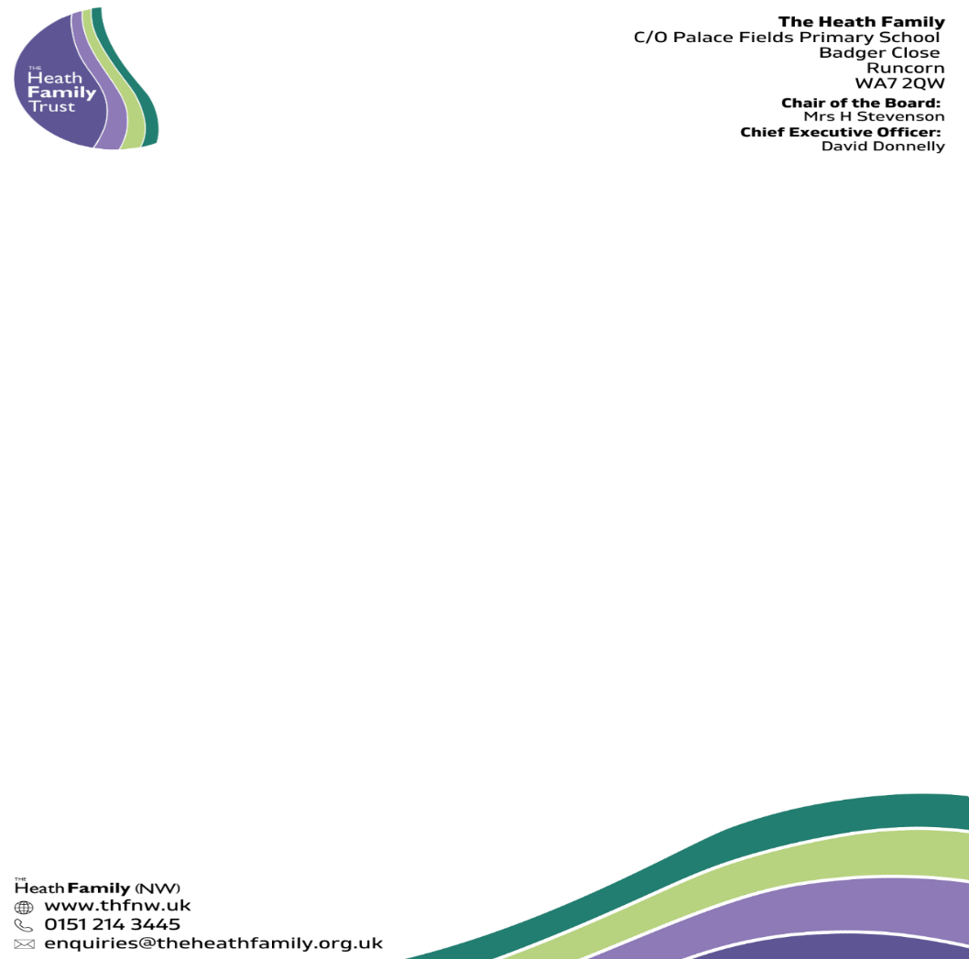

**How to Apply**

Thank you for your interest in this exciting opportunity at Daresbury Primary School.

In order to apply, please submit the following completed application forms:

* Application form

For this position you should submit a covering letter demonstrating and summarising experience and giving evidence or examples of your proven experience against the criteria listed in the person specification.

**Application closing date: Friday 29th September 2023 11:59 PM**

**Completed applications should be returned by email** [**recruitment@theheathfamily.org.uk**](mailto:recruitment@theheathfamily.org.uk)

*We will endeavour to acknowledge receipt of all applications within 24 hrs. Should you fail to receive a confirmation, please call 01928 716521.*

Please ensure that your application accounts for any gaps in employment.

Please include the names and addresses of two professional referees (one of which must be your current employer). Referees will be contacted if your application is successful in making the shortlisting stage.

Applicants are warmly encouraged to visit our school. Please contact Mrs Pam Staveley (School Office) on 01925 740309 or email [PStaveley@dps.theheathfamily.org.uk](mailto:PStaveley@dps.theheathfamily.org.uk) to arrange an appointment.