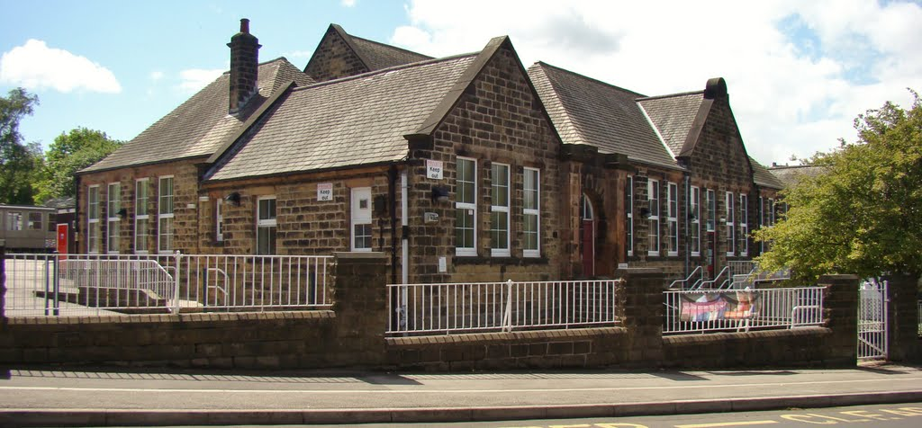
Stannington Infant School, Stannington Road,
Sheffield
S6 6AN
Teaching Assistant Level 2

Hours per week: 32.5 hours per week (Monday to Friday) 38 weeks per year (term time)
To start September 2026
Contract type: Permanent
Job salary: Grade 3 SCP 5 £25,583 (£18,832.96)
Closing date: 11.5.26 (11.30am)
Stannington Infant school is a friendly and creative school with an inclusive ethos where families, staff and children work together. The children’s happiness and well-being are our priority. We are an outstanding school.
We are situated in the north west of the city and are part of the Peak Edge Trust. The governors of Stannington Infant School are seeking to appoint an excellent Teaching Assistant Level 2 to support children in Foundation Stage. Enthusiasm, patience and being hard-working are attributes we would appreciate.
We are looking for someone who:
- Is enthusiastic about working with young children and has a positive attitude.
- Has experience of working with EYFS children and children with additional needs.
- Has a commitment to inclusivity.
- Is committed to providing high quality and enjoyable learning opportunities for pupils.
- Is an effective and reflective practitioner with a desire to learn and develop.
- Works well as part of a team and have good interpersonal skills with colleagues, children and parents.
- Holds or is working towards a Level 2 certificate in Supporting Teaching and Learning or equivalent.
We offer:
- A friendly, welcoming school.
- Happy, kind and enthusiastic children
- A supportive staff and governor team
- A commitment to your professional development
- A positive ethos where everyone is valued.

If you think you are the right person to join our team we would love to hear from you. Visits to the school are warmly welcomed, please contact Mrs Rebecca Juggins, Administration Officer, on 0114 2344401 or email enquiries@stannington.sheffield.sch.uk to make arrangements.
School visit dates are Friday 24th April 9.30am / Monday 27th April 3.30pm / Wednesday 29th April 9.30am / Friday 1st May 11am. Please contact us even if these dates and times are not suitable.
Application forms and further details are available electronically from the school by emailing enquiries@stannington.sheffield.sch.uk or by contacting the school on 0114 2344401.
Completed application forms should be returned to Mrs Rebecca Juggins by the closing date of 11th May 2026 at 11.30am
Further details are included in the job description. The school is committed to safeguarding and promoting the welfare and safety of children and young people and expects all staff to share this commitment.
The successful candidate will be required to complete a Disclosure and Barring Services DBS check in line with section 115 of the Police Act 1997. A 'prohibition from teaching' check will be completed for all applicants
We value our diverse workforce and aim to work together to make the most of our differences. We welcome applications from everyone. Under the Disability Confident Scheme, disabled applicants, who meet the essential criteria of this job, are guaranteed an interview

