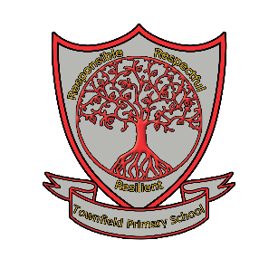
Townfield Primary School
Respect, responsibility and resilience
Level 3 Teaching Assistant – Deaf Resource/In Class Support

Personal Attributes & Specification

 | Essential |  | Desirable
 | Attributes | State Identified | Attributes | State Identified
Qualifications | - Level 3 Teaching Assistant qualification  - Good numeracy/literacy/ICT skills  - To have at least level two British Sign Language | App  App | - Training in the relevant learning strategies, e.g. Literacy  - First aid training as appropriate  - Evidence of further related training or interests | App  App  App
Experience | - Working with or caring for children in an educational setting  - To have experience of working with deaf children  - To have experience of working with children with special needs | App | - To be flexible and to respond positively to the changing needs of the school | Int
Knowledge and Skills | - Effective use of ICT to support learning  - Understanding of child development and learning  - Ability to work well with children and adults  - Ability to work as part of a team  - Good communication skills | App  Int  Int  Int  Int | - Ability to use other equipment/technology, e.g. photocopier  - Understanding of relevant policies/codes of practice and awareness of current, relevant legislation  - Ability to self-evaluate own learning needs and seek learning opportunities | App  App  App
Personal Qualities | - Ability to establish and develop relationships with parents  - A passion for working with children and ability to engage with them  - Ability to contribute to the life of the school and its community by delivering an after-school activity  - Commitment to safeguarding and promoting the welfare of children and young people | App/Int  App  Int  App/Int

