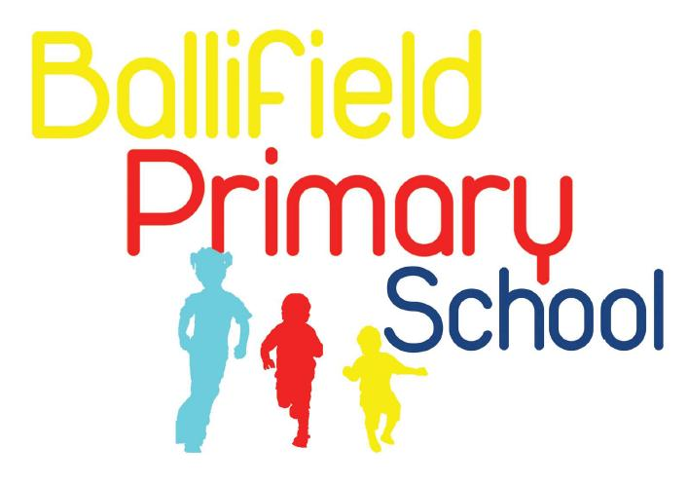
Handsworth Grange Road
Sheffield
S13 9HH

Tel/Fax: (0114) 269 7557 www.ballifield.co.uk

Headteacher: R Binns, BA Hons, NPQH

Advert – Level 3 Teaching Assistant with HLTA hours

Ballifield Primary School are looking for an enthusiastic Teaching Assistant to join our team. This is a permanent position, starting date 1st September 2025.

Total hours are 33.5 hours per week for 39 weeks per year.

Level 3 hours are paid as Grade 4, SCP 7 – 12 (£25584 - £27711 pro rata)
Higher Level Teaching Assistant hours are paid at Grade 5, SCP 15 - 20. (£29093 to £31586 pro rata)
- Three days will be Level 3 TA and two days will be Higher Level TA.

Closing date: Tuesday 15th July
Interview date between 16th – 18th July

The children, staff and governors of Ballifield Primary School are looking to appoint an outstanding, enthusiastic and dedicated Teaching Assistant to start in the Autumn term 2025.
This is a great opportunity to become part of our two-form entry “Good” primary school - judged by Ofsted 2022. Ballifield Primary School is committed to nurturing staff to support the development of the skills, knowledge and understanding needed for this role.

About us:
Ballifield is a vibrant and forward-thinking school in the heart of Sheffield S13, committed to providing a high-quality education for all learners. We are seeking a passionate and dedicated Level 3 Teaching Assistant with Level 4 HLTA hours to join our supportive team.

The Role:
This is a fantastic opportunity to contribute to our school’s success by supporting the learning and development of students, while gaining valuable HLTA (Higher Level Teaching Assistant) experience. You will be working closely with teachers and other staff to deliver effective instruction, manage classroom activities, and provide individualised support to students.

Key Responsibilities
- Support classroom teaching: Assist teachers with lesson preparation, delivery, and assessment.
- Manage classroom activities: Ensure a positive and productive learning environment
- Provide individual support: Offer targeted interventions to students with specific needs
- Contribute to the curriculum: Assist with the planning and delivery of educational activities
- Contribute to HLTA responsibilities: Opportunity to take on more complex tasks and responsibilities as a HLTA, in line with Ballifield’s policy and with appropriate training and support

Requirements:
- Level 3 Teaching Assistant qualification or equivalent
- HLTA qualification or equivalent not compulsory and can be discussed at interview
- Experience working with children or young people
- Strong communication, interpersonal and organisational skills
- Ability to work effectively as part of a team
- Commitment to continuous professional development

Benefits:
Opportunity to gain valuable HLTA experience, a supportive and collaborative work environment and professional development opportunities

How to apply

For more information or to request a recruitment pack including full job description, please email recruitment@ballifield.sheffield.sch.uk or phone the school office on 0114 2697557.

If you have any questions regarding this role please contact Rachael Binns (Headteacher) on 0114 2697557.

Completed application forms can be returned by email to recruitment@ballifield.sheffield.sch.uk by the closing date.

Ballifield Primary is committed to safeguarding and promoting the welfare and safety of all our children. We expect all our staff and volunteers to share this commitment. This post is exempt from the Rehabilitation of Offenders Act (ROA) 1974. All shortlisted candidates will be asked to disclose any cautions or convictions prior to interview. The amendments to the ROA 1974 (Exceptions Order 1975, (amended 2013 and 2020)) provide that when applying for certain jobs and activities, certain spent convictions and cautions are ‘protected’, so do not need to be disclosed to employers, and if they are disclosed, employers cannot take them into account. Guidance and criteria on the filtering of these cautions and convictions can be found on the Ministry of Justice website:

https://www.gov.uk/government/publications/dbs-filtering-guidance/dbs-filtering-guide.

In addition, an online search will also be conducted for all shortlisted candidates prior to interview. If appointed, the successful candidate will be required to complete various vetting checks, including an enhanced DBS criminal records check, a Children’s Barred List check and a prohibition from teaching check. Please note that it is a criminal offence to apply for this post if you have been placed on the Children’s Barred List. Before applying, candidates are asked to read the school’s safeguarding policy which can be found through this link https://ballifield.co.uk/wp-content/uploads/2024/09/Child-Protection-and-Safeguarding-Policy-September-2024.pdf and the recruitment of ex-offenders policy, which we will send with the application pack.

We value our diverse workforce and aim to work together to make the most of our differences. We welcome applications from everyone. Under the Disability Confident employer scheme, disabled applicants who meet the essential criteria of this job are guaranteed an interview.

