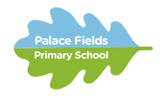
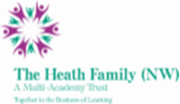

How to Apply

Thank you for your interest in this exciting opportunity at Palace Fields Primary School.

In order to apply, please submit the following completed application forms:

- Application form
- Equal Opportunities form
- DBS Statement

For this position you should submit a covering letter demonstrating and summarising experience and giving evidence or examples of your proven experience against the criteria listed in the person specification.

Application closing date: Friday 2nd December 2022 @ 5pm.

Completed applications should be returned by email to: LibbyConnor@palacefieldsschool.co.uk

We will endeavour to acknowledge receipt of all applications within 24 hrs. Should you fail to receive a confirmation, please call 01928 716521.

Please ensure that your application accounts for any gaps in employment.

Please include the names and addresses of two professional referees (one of which must be your current employer). Referees will not be approached until the final stages of the process.

Session observations and Interview date TBC

Applicants are warmly encouraged to visit our school. Please contact Mrs Libby Connor (School Office) on 01928 716521 or email LibbyConnor@palacefieldsschool.co.uk to arrange an appointment.

