

Level 3 SEND Teaching Assistant

Discovery Special Academy

Job Ref:DSA378



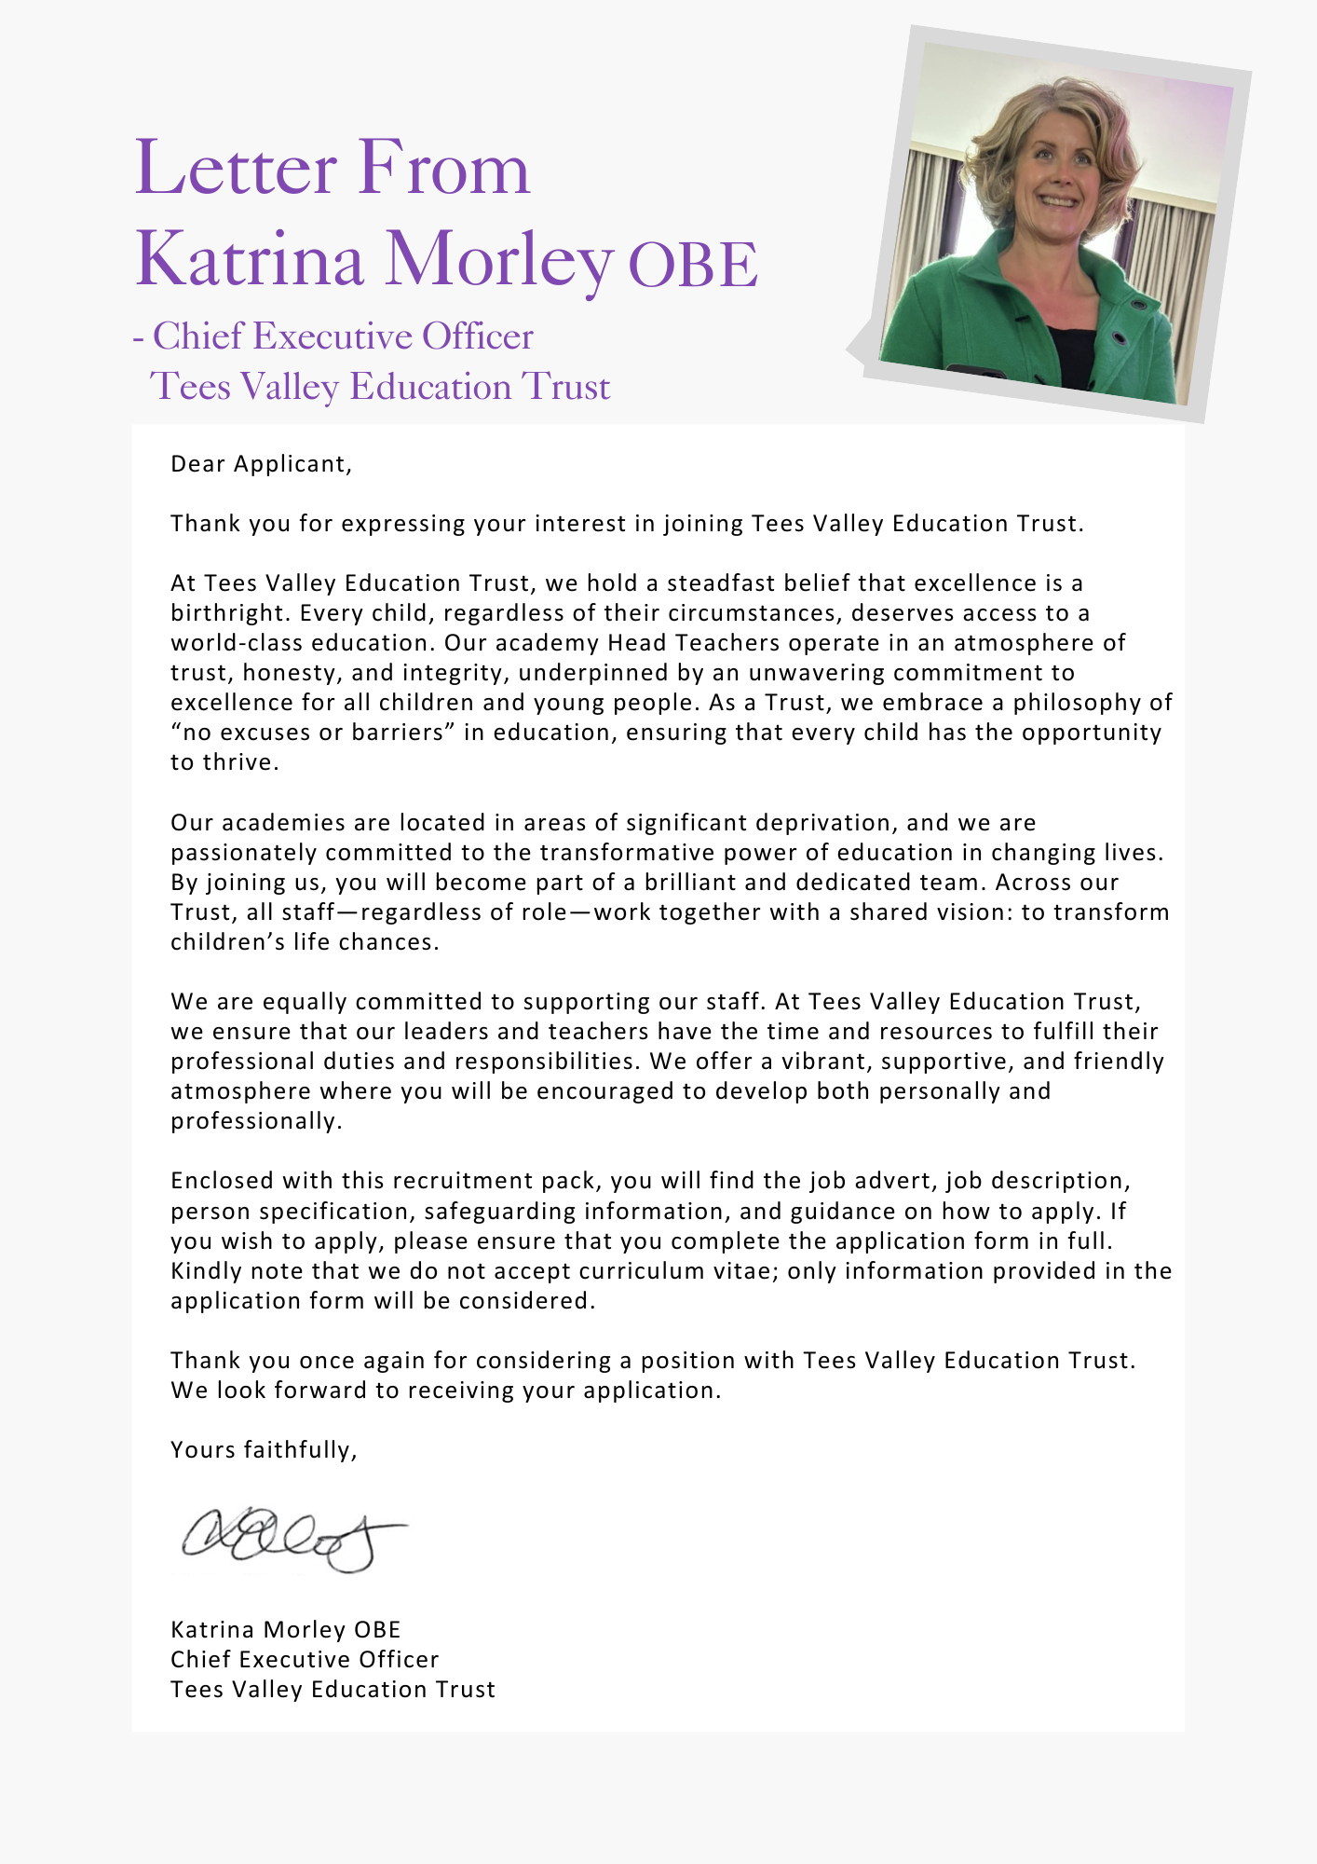





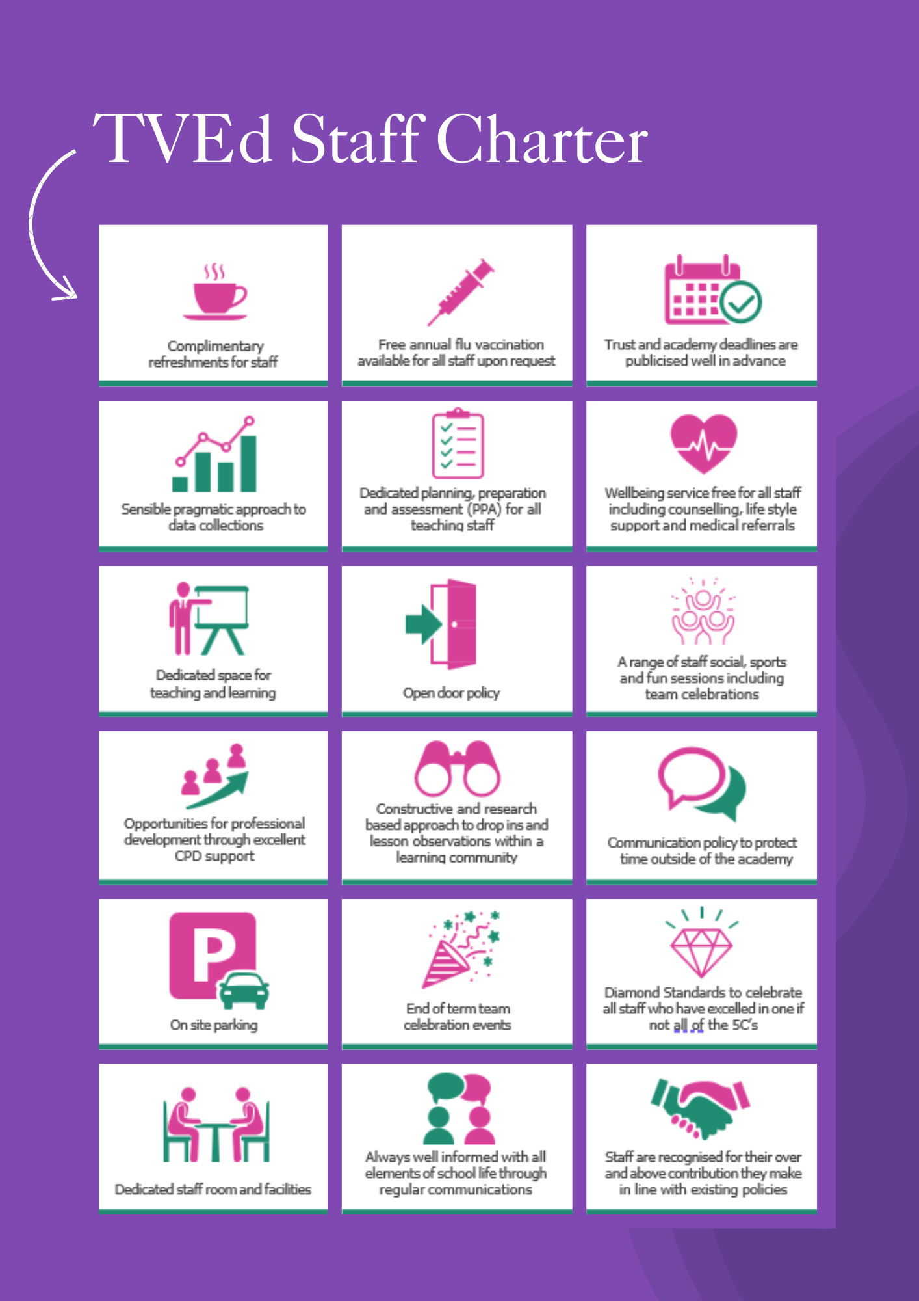

ADVERTISEMENT

Level 3 SEND Teaching Assistant
Status: Permanent
Required: 1.9.2025
Salary: NJC point 12 – 15 £28,598- £30,024 (Pending agreed award) Actual Salary (£25,340 - £26,604) ( Pending agreed award)
Hours: 37 hours per week, term time only + 2 week (5 x PD days and 1 week of holiday club)
Reporting to: Executive Headteacher
Academy: Discovery Special Academy

About the Trust
The Trust was established in 2015 and provides education and enrichment activities to more than 1100 children across five Academies, located in Middlesbrough and Redcar and Cleveland local authority areas. Academies within the Trust are:
- Brambles Primary Academy (2 to 11 years),
- Discovery Special Academy (3 to 16 years),
- Dormanstown Primary Academy (2 to 11 years),
- Pennyman Primary Academy (2 to 11 years), and
- Wilton Primary Academy (3 to 11 years).

About the role we are looking to appoint:
Discovery Special Academy is seeking to appoint a pro-active, enthusiastic, energetic and reliable Level 3 Teaching Assistant to join the Tees Valley Education Trust. This position would be to work with children from nursery to Year 11 with complex learning, sensory, communication and behaviour needs. Experience working with children with significant sensory and behaviour needs is required. As a Level 3 Teaching Assistant, you will work alongside the class teacher, helping pupils to get the most out of their learning and supporting individuals or groups of pupils.
You will be contributing to and participating in the team working ethos of the provision whilst maintaining its core values by:
- supporting families to ensure that their children attend school regularly and make good progress;
- supporting children to be kept safe and work positively with a range of stakeholders to protect children;
- and enabling children to be successful through supporting excellent attitudes towards learning and behaviour.

What we are looking for:
We are looking for people who have experience of working with children with complex SEND, are interested in their development and learning and have good organisational and communication skills. We ask that all staff working with our children hold qualifications in English and mathematics that are at least equivalent to GCSE grade ‘C’. Qualification as a teaching assistant (or equivalent) is essential.

What the Trust will provide the successful candidate with:
- A workplace where all staff are valued and treated with respect as outlined within the Trust’s Diamond Standards
- A passionate, enthusiastic and supportive Leadership Team
- A listening and learning organisation where all staff are encouraged to be curious and share ideas for the Trust/academies/team to improve
- Hard working, committed and dedicated staff who strive to gain the best outcomes for all children across the Trust’s academies
- Dedicated approach to children’s learning to encourage them all to be the best they can be
- Career enhancement opportunities within areas of interest as well as supporting ongoing professional development and training specific to job role
- Dedicated line manager to discuss work streams and capacity
- Free access to the Trust’s Wellbeing offer, which includes counselling, access to GP, Mindfulness and so much more.
- Free parking
- Enrolment into the local government pension scheme
- All support contracts are employed on National Joint Council (NJC) for local government services (also known as Green book)
- Benefits of the Trust’s Staff Charter which can be found at TVED Staff Charter.

Safeguarding requirements for the role:
Tees Valley Education Multi Academy Trust is committed to safeguarding and promoting the welfare of children. All appointments will be subject to a satisfactory enhanced DBS check.
This post is exempt from the Rehabilitation of Offenders Act 1974 and, therefore, all convictions, cautions and bind-overs, including those regarded as “spent” must be declared. The Trust’s Recruitment of Ex-Offender policy can be requested or visit the Trust’s website.
Applications are invited from prospective candidates who demonstrate that they are able to meet the essential criteria set out in the person specification and who have the vision, values and tenacity to join an outstanding team and help continue the journey towards excellence.

JOB DESCRIPTION
To work with the class teacher to support teaching and learning of children with significant learning needs, providing specialist support to the teacher. This could include those requiring detailed and specialist knowledge in particular areas and will involve assisting the teacher in the whole planning and assessment cycle and the management/preparation of resources. Staff may also supervise whole classes occasionally (e.g. short-term absence of teacher) or for regular short periods with teacher’s planning provided (including PPA cover).
MAIN DUTIES AND RESPONSIBILITES
- Use specialist (curricular/learning) skills/training/experience to support all pupils with a range of needs within specialist provisions within the trust
- Promote the inclusion and acceptance of all pupils
- Work with classes, small groups and individuals in order to support them in accessing learning across the curriculum as directed by the class teacher
- Encourage pupils to interact with others and engage in activities led by the teacher
- Support pupils in their own personal development to be successful through promoting excellent attitudes towards learning and behaviour
- Supervise and provide particular support for pupils, including those with special needs, ensuring their safety and access to learning activities
- Provide feedback to pupils in relation to progress and achievement under the guidance of the teacher Establish constructive relationships with pupils and interact with them according to individual needs
- Assist with the development and implementation of individual plans e.g. behaviour, healthcare and learning
- Supervise pupils and ensure they are happy and safe at playtime and lunchtime
SUPPORT FOR THE TEACHER
- Work with the teacher to establish an appropriate learning environment
- Work with the teacher in lesson planning, evaluating and adjusting lessons/work plans as appropriate
- Monitor and evaluate pupils’ responses to learning activities through observation and planned recording of achievement against pre-determined learning objectives
- Provide objective and accurate feedback and reports as required, to the teacher on pupil achievement, progress and other matters, ensuring the availability of appropriate evidence
- Be responsible for keeping and updating records as agreed with the teacher, contributing to reviews of systems/records as requested
- Undertake feedback/marking of pupils’ work and accurately record achievement/progress
- Promote positive values, attitudes and good pupil behaviour, dealing promptly with conflict and incidents in line with established policy and encourage pupils to take responsibility for their own behaviour
- Liaise sensitively and effectively with parents/carers as agreed with the teacher within your role/responsibility and participate in feedback sessions/meetings with parents with, or as directed
- Provide general resource support and ensure the learning environment is in good order e.g. photocopying, preparation of classroom resources, displays and good classroom organisation
SUPPORT FOR THE CURRICULUM
- Implement agreed learning activities/teaching programmes, adjusting activities according to pupil responses/needs
- Implement agreed learning strategies e.g. PIVATS, Literacy, Maths, Foundation Stage curriculum and make effective use of opportunities to support the development of relevant knowledge and skills
- Help pupils to access learning activities through specialist support
- Determine the need for, prepare and maintain general and specialist equipment and resources
SUPPORT FOR THE ACADEMY
- Be aware of and comply with policies and procedures relating to child protection, health, safety and security, confidentiality and data protection, reporting all concerns to an appropriate person
- Understand and fully implement the academy’s Behaviour Management Strategies
- Be aware of and support difference and ensure all pupils have equal access to opportunities to learn and develop
- Contribute to the overall ethos/work/aims of the academy
- Establish constructive relationships and communicate with other agencies/professionals, in liaison with the teacher, to support achievement and progress of pupils
- Attend and participate in regular meetings
- Participate in training and other learning activities as required
- Recognise own strengths and areas of expertise and use these to advise and support others
- Have an area of specialism e.g. a subject area
- Provide appropriate guidance and supervision and assist in the training and development of staff as appropriate
- Supervise classes in the absence of the teacher with teachers planning provided
- Undertake delivery of extended schools’ provision e.g. before/after school and holiday clubs/activities
The job holder may be required to undertake additional duties as could be reasonably required in exceptional or emergency situations.
The job holder may be required to work flexibly between the hours of 8am and 6pm.
The job holder may be required to work across the academy group.
The job holder may be required to undertake additional training e.g. first aid, Positive Handling.

Signed (Employee)
Date:
Signed (on behalf of employer): |  | Name and Role:
Date:

PERSON SPECIFICATION
QUALIFICATIONS | E/D
GCSE grade C or above in English and Mathematics (equivalent qualifications considered) | E
NVQ level 3 or above qualification (or equivalent) in a relevant area - in exceptional circumstances, where local circumstances dictate, qualifications may be viewed as desirable | E
EXPERIENCE
Experience of working with pupils with complex SEND | E
Experience of working in a relevant classroom environment | E
Experience of supporting the delivery of learning tasks to groups of pupils with complex needs | E
Experience of supporting pupils with challenging behaviour | D
KNOWLEDGE, ABILITIES AND SKILLS
Ability to relate well to children | E
Knowledge and experience of a range of strategies to support children with SLD and complex needs such as: PECS, Makaton, Eye Gaze, Sensory Integration | E
Good understanding of child development and learning processes | E
Ability to support the provision of a stimulating, organised and educationally rich learning environment | E
Ability to supervise and assist groups and classes of children in the absence of the teacher | E
Full working knowledge of relevant policies/codes of practice/legislation | E
Have a working knowledge of how technology can be used to support learning | E
Ability to work as part of a team, following instructions and on own initiative, leading when required | E
Good communication skills including the use of standard English | E
Ability to use time effectively to enable work to be prioritised and for deadlines to be met | E
Ability to relate well to parents/carers | E
Knowledge of the concept of confidentiality | E
Commitment to safeguarding and protecting the welfare of children and young people | E
Ability to assess pupil’s development | D
Be able to plan and deliver structured learning and after school activities successfully for individuals and groups of pupils | D
Experience of delivering interventions and being able to provide feedback on progress | D
First Aid Certificate | D
AM (Assessment Method), A- Application Form, I – Interview, R – Reference,
E – Essential, D - Desirable
Important: In the first instance, applications are assessed against the criteria listed above, in addition to overall presentation, use of standard English and grammatical accuracy.
Where applications do not meet the expected standard, they will be rejected before being matched to the person specification.

HOW TO APPLY AND EXPLANATORY NOTES OF THE PROCESS

Please submit a letter (maximum 2 sides of A4) outlining your experience and suitability for the position.
For your information, the recruitment timetable is detailed below:

Closing date: 11th May 2026
Shortlisting date: 11th May 2026
Interview date: 18th May 2026

UK General Data Protection Regulation
Refer to our privacy policy on how we will process your personal data including how you can request to access your personal data via Tees Valley Education website: http://www.teesvalleyeducation.co.uk.



