



Literacy Specialist (Secondment)
Recruitment Information Pack

www.yeatenglishhub.co.uk

Contents

Our Aims 3
Home School Expectations & Funding 4
Application Process 5
Job Description and Person Specification 6

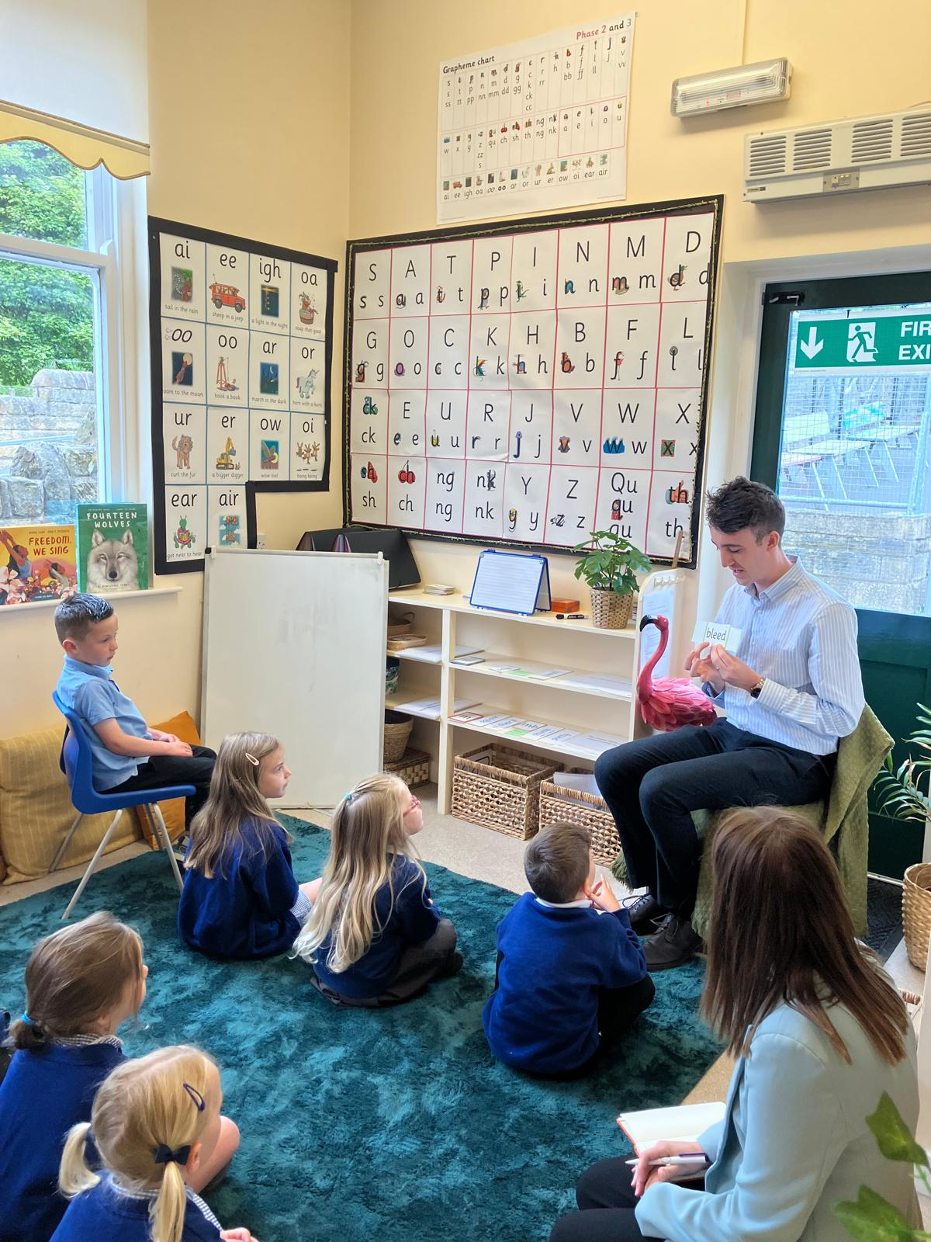

Our Aims
Our Hub focuses on three crucial priority areas:
Age-appropriate phonics provision
Encouraging best practice in systematic synthetic phonics teaching from school based early years provision to the end of key stage 1 and as the primary reading strategy throughout the school.
This includes:
- Encouraging fidelity to a single systematic synthetic phonics programme
- Supporting effective use of decodable books in the early stages of learning to read to establish phonic decoding
- Supporting effective practice in formative assessment in relation to phonics / early reading.
Early language development
Providing evidence-based approaches to early language development and closing the word gap in school-based early years settings, including appropriate use of formative assessment. Building children's speaking and listening skills in a language rich provision that are well matched to the children's individual abilities. This allows for planning for progression and preparing children to learn to read.

Promoting a love of reading
Encouraging reading for enjoyment; supporting whole school reading approaches, reading to children at least once a day and encouraging reading at home as well as developing teachers’ knowledge of appropriate children’s literature. Ensuring that reading and language is embedded across the curriculum and is taught in a purposeful way. Children are confident presenting their work and using different types of texts to achieve their goals. Developing reflective practitioners who can talk confidently about books and use this creativity in their own work.

Home School Expectations & Funding

Time commitment:
The Literacy Specialist will be seconded from their home school for the following time during the 2025-2026 academic year:
- Training Day with Hannah, English Hub Lead, and Chrissy, Deputy Hub Lead. (Wednesday 10th December. Location to be confirmed)
- 2 Shadow Days with existing Literacy Specialists in Partner Schools (January 2026 - locations and dates to be confirmed)
- *Between 6-15 days of support in allocated Partner Schools from Early February to the end of July (Hannah and Chrissy and will join all your first visits with you for support).

- 2 Development Days with the LS team (Monday 12th January - Malmaison, York. Friday 10th July - location to be confirmed)

*0.2 PPA time provided by the home school in addition for each release day. (Home school to specify the maximum number of Partner School days, in addition to the training above, the potential LS is able to complete)
Funding:
- For each day working as a Literacy Specialist with a partner school, the releasing school will be funded at an ‘SLE rate’ of £350 per day. For Partner School support visits 0.2 days (£70) is added to total £420 for backfill.

Expectations of the Literacy Specialist’s home school
The Head Teacher commits to:
- Ensuring the specialist appointed is given the allocated release time to carry out the LS role.
- Supporting the application and recruitment process by providing a reference and supporting statement (see attached application form).
- Supporting the Specialist develop and embed effective early years/phonics practice, ensuring the teacher receives the required release time to improve outcomes, within their own school.
- Engage in Hub Lead visits to audit practice within the hub school for quality assurance purposes
- Cover costs of sickness if the specialist is unable to deliver a Partner School visit.
- Cover costs of travel expenses.

Application Process

Submit the following to NYES.Resourcing@northyorks.gov.uk

- Application form completed in conjunction with your headteacher (or equivalent)
- A 10-minute video clip of yourself teaching a phonics lesson
- Pictures/videos of your Reading Environment

The closing date for all applications is 11:59pm, Thursday 27th November 2025

An email will be sent to candidates by the end of Friday 28th with the outcome of the shortlisting process.

We do not accept CV’s.

Zoom Interview - Tuesday 2nd December

If successfully shortlisted, you will participate in a Zoom interview.

Queries

Please contact Chloe Bullen at Chloe.Bullen@northyorks.gov.uk or on 01609 536 964

Job Description

Literacy specialists (LS’s) are experienced primary teachers, often middle leaders in their own settings, who have an excellent knowledge of phonics and a proven track record in improving early reading in their school. They support partner schools’ head teachers and reading leaders to ensure partner schools are driving improvements in phonics and early reading. LS’s must have the leadership skills to evaluate, action plan and challenge leaders following rigorous data analysis on each LS visit.

What are my main responsibilities as an LS?
- To attend English Hub training days (new LS’s will receive 6 days training 2026).
- To audit the phonics and early reading provision of eligible schools in order to help them secure grant funding from the DfE and possible follow up support from YEAT English Hub.
- To support partner school leaders to implement the ‘Challenge Checklist’ (a list of DfE approved objectives to drive achievements in early reading).
- To monitor progress using the criteria on the ‘Challenge Checklist’ and report progress to hub lead every half-term.
- To ensure partner schools adhere to program expectations such has completing half termly data drops, attending progress meetings and training events.
- Produce a report after each visit (using DfE proforma) detailing specific advice and actions for implementation.
- To lead ‘medium level support’ virtual training sessions underpinned by evidence based research.

Person Specification

Attributes / Qualities | Essential | Desirable
Qualifications | - Qualified teacher status | - Training in at least one DfE approved synthetic phonics programme.  - Coaching/mentoring training.  - A middle or senior leadership qualification/NPQ.
Experience | - Teacher in current practice, with at least 3 years experience, currently teaching phonics at least 3 days a week.  - Experience teaching the Little Wandle SSP program  - Senior or Middle Leadership experience.  - Experience of leading English/Reading and/or Early Years/KS1.  - Good understanding of the Early Years Foundation Stage and KS1 curriculum.  - Proven record of excellent teaching & learning, particularly literacy.  - Demonstration of high expectations of pupil and staff achievement.  - Effective and supportive coaching of colleagues.  - Track record of creative and effective engagement with families, particularly those who are harder to reach. | - Experience in supporting other schools to improve outcomes.  - Experience of effective teaching across the key stages.  - Experience of teaching in schools with different contexts, such as high levels of disadvantage, mobility, EAL or SEND.
Professional Development & Training | - Undertaking of appropriate INSET & further relevant training.  - A desire to develop and extend skills in teaching, learning and leadership. | - Commitment to own professional development  - Confidence in supporting other practitioners  - A NPQ  - A lifelong learner
Skills, knowledge & expertise | - Evidence of excellent understanding and practice in early language development; systematic synthetic phonics provision; and the promotion of a love of reading.  - Understanding and experience of effective action planning.  - Excellent communication skills.  - Good organisational skills.  - Ability to meet deadlines.  - Interest in supporting children and teachers beyond own school.  - Ability to lead and develop the teaching and practice of others.  - Experience of analysing, and overcoming, barriers to effective teaching and learning.  - Evidence of providing effective support and challenge to others. | - Knowledge of supporting children with SEND and EAL to read.
Personal | - Ability to form strong professional relationships based on trust and respect.  - Be committed to a ‘nurturing and supportive’ approach to support.  - Ability to set and sustain high standards in all areas of teaching.  - Ability to work collaboratively.  - Ability to lead and motivate others.  - Willingness to contribute to the English Hub’s ethos and values; ethical, nurturing and brave.  - Passion for reading

IMPORTANT ADVICE ON COMPLETING THIS APPLICATION
Your application form plays an important part in your selection. Please ensure you address all the essential requirements listed in the specifications. The following advice should help you to complete the application form as effectively as possible.
Data Protection
The information that you state on this application form will be used to consider you for a job vacancy. To find out about how we use your personal data for the purposes of recruitment please see our Privacy Notice at https://www.yeatenglishhub.co.uk/privacy/

Rehabilitation of Offenders
The post you are applying for requires you to have an enhanced Disclosure and Barring Service criminal records check for work with children, with a barred list check if you work in regulated activity. This check for disclosure of criminal history will include spent convictions, pending prosecutions / current court proceeding and police enquiries.

Should you be shortlisted, you will be asked to disclose full details of your criminal history prior to your interview. This includes any information deemed relevant as part of Keeping Children Safe in Education which may arise in an online search undertaken on shortlisted candidates. This information may be discussed with you at your interview in order to assess job related risks, but we emphasise that your application will be considered on merit and ability and you will not be discriminated against unfairly. Failure to disclose this information will result in any offer of employment being withdrawn.

Please also see the policy statement on the Recruitment of Ex-offenders below.

Information in Support of your Application
Every post advertised is supported by a full person specification. The specification lists all the essential skills, experience and qualifications which are necessary for the job and the criteria against which you will be assessed, both through your application form and at interview.

As part of the application process, you may have been asked to demonstrate within this application form how you meet some or all of the criteria or key competencies outlined in the person specification. Rather than simply repeating your career history, look at the skills and experience required by the job and provide evidence that you possess them by giving specific and detailed examples which include a focus on outcomes and on your own contribution to the scenario. Try to use different and varied examples wherever possible.

When completing these sections, do not forget the skills and experience you have gained outside full-time work. Outlining your previous work experience or other responsibilities may help you to uncover skills which you have taken for granted and which are clear signs of your ability to do the job.

Canvassing
You must not try to influence an elected Council Member, any council employee or a member of the school governing body, to act in your favour, as this will disqualify you. If you are related to a Councillor, a Council employee or a governor you must indicate this in the relevant section of the application form.

Policy Statement on the Recruitment of Ex-offenders (Source www.gov.uk)
- As an organisation assessing applicants’ suitability for positions which are included in the Rehabilitation of Offenders Act 1974 (Exceptions) Order using criminal record checks processed through the Disclosure and Barring Service (DBS), this school complies fully with the DBS code of practice and undertakes to treat all applicants for positions fairly.

- This school undertakes not to discriminate unfairly against any subject of a criminal record check on the basis of a conviction or other information revealed.

- This school can only ask an individual to provide details of convictions and cautions that it is legally entitled to know about. Where a DBS certificate can legally be requested (where the position is one that is included in the Rehabilitation of Offenders Act 1974 (Exceptions) order 1975 as amended, and where appropriate Policy Act Regulations as amended) this school can only ask an individual about convictions and cautions that are not protected.

- This school is committed to the fair treatment of its staff and potential staff, regardless of race, gender, religion, sexual orientation, responsibilities for dependents, age, physical/mental disability or offending background.

- This school has this written policy on the recruitment of ex-offenders, which is made available to all DBS applicants at the start of the recruitment process.

- This school actively promotes equality of opportunity for all with the right mix of talent, skills and potential and welcome applications from a wide range of candidates, including those with criminal records. Candidates are selected for interview based on their skills, qualifications and experience and criminal record information is only requested from short-listed candidates.

- A disclosure is only requested from the DBS after a thorough risk assessment has indicated that one is both proportionate and relevant to the position concerned. For those positions where a criminal record check is identified as necessary, all application forms, job adverts and recruitment briefs will contain a statement that a DBS certificate will be requested in the event of the individual being offered the position.

- This school ensures that all those who are involved in the recruitment process have been suitably trained to identify and assess the relevance and circumstances of offences.

- This school also ensures that they have received appropriate guidance and training in the relevant legislation relating to the employment of ex-offenders, e.g. the Rehabilitation of Offenders Act 1974.

- At interview, or in a separate discussion, this school ensures that an open and measured discussion takes place on the subject of any offences or other matter that might be relevant to the position. Failure to reveal information that is directly relevant to the position sought could lead to withdrawal of an offer of employment.

- This school makes every subject of a criminal record check submitted to DBS aware of the existence of the code of practice and makes a copy available on request.

This school undertakes to discuss any matter revealed on a DBS certificate with the individual seeking the position before withdrawing a conditional offer.

