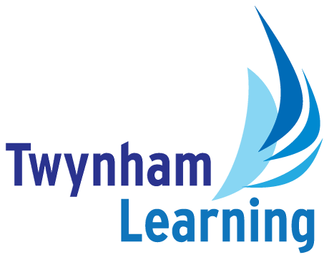
Job Description: Literacy Specialist Teaching Assistant

Post Details
School/setting: | Twynham School or The Grange School
Post type: | Support staff
Grade/Pay Level: | Grade 7
Reports to: | SENDCo

Main Purpose
To support high-quality teaching and learning in literacy by delivering targeted interventions, supporting whole-class learning, and promoting reading, writing, and communication skills to raise attainment and progress.

Duties and Responsibilities
- To assist teaching staff in the development and implementation of literacy-focused interventions for individuals and small groups, under the direction of the Literacy department and SENDCo.
- Support the provision of a stable, caring and supportive learning environment, which enables students to achieve their full learning potential, encouraging, resilience and confidence in literacy.
- Support behaviour for learning in accordance with the school’s behaviour policy.
- Work with students, either individually or in small groups, who have some special educational needs, learning difficulty, or may occasionally exhibit behavioural difficulties.
- Complement the professional work of qualified teachers by taking responsibility for agreed learning activities which may occur without the supervision of teaching staff.
- Lead whole-class learning where appropriate, including covering planned lessons in line with school policies.
- Support the planning, delivery and recording of interventions in line with Education, Health and Care Plans.
- Support the planning and delivery of Entry Level and then Functional Skills Level 1 and 2 English.
- Work collaboratively with the SENDCo, pastoral teams and exam team to support individual student needs.
- Adapt learning activities, literacy resources and programmes, to meet the needs of students with SEND, EAL, lower literacy levels, or identified learning barriers.
- Assess, monitor and record student progress in literacy using agreed school systems.
- Contribute to baseline assessments, progress reviews and intervention evaluations.
- Provide clear feedback to students to support improvement and independence.
- Assist with the implementation of whole-school literacy strategies, such as reading initiatives, disciplinary literacy, or writing across the curriculum.
- Promote a love of reading through reading schemes, library use, and enrichment activities.

Safeguarding Duties and Responsibilities
Promoting and safeguarding the welfare of children and young people in accordance with the school’s Safeguarding and Child Protection policies.

Other Duties
All Twynham Learning staff may periodically be expected to carry out tasks and duties within their area of competence that are not listed herein, as directed, to meet the needs of the Trust. The particular duties and responsibilities may vary from time to time.

Twynham Learning Attributes for all Staff
- Ambition for excellence  - Professionalism  - Humility  - Championing change | - Inclusiveness  - Positivity  - Community-mindedness  - Being collaborative

Qualifications, Knowledge, Skills and Attributes Required
Essential
- Minimum 5 GCSEs (A-C), including Maths and English, or equivalent qualifications/grades (e.g. NVQ Level 2).
- Ability to motivate pupils and support learning processes and procedures effectively.
- Skilled in promoting and maintaining order, calmness, and positive behaviour.
- Comprehensive understanding of child safeguarding practices.
- Ability to think creatively to deliver engaging and innovative learning experiences.
- Strong ability to work collaboratively and supportively within a team.
- Capable of working on own initiative while remaining flexible and responsive.
- Excellent interpersonal and communication skills, fostering effective relationships with students, parents, staff, and the wider community.
- Maintains high standards of integrity, discretion, and professionalism, consistently modelling school values.
- Focuses on students' overall well-being and educational needs.
- Ability to work under pressure, manage time effectively, and handle challenges with resilience.
- Dedicated to providing equal opportunities and meeting individual needs.
- Actively committed to ongoing learning and self-improvement.

Desirable
- Relevant Teaching Assistant Qualifications
- Relevant literacy qualifications
- Previous experience working in a school or similar setting

Notes
- This job description may be amended at any time in consultation with the postholder.

Glossary
- Explanations of any abbreviations or jargon contained in this job description can be found in our Twynham Learning Glossary.

