NORTH YORKSHIRE COUNTY COUNCIL
Kildwick CE VC Primary School Telephone: 01535 633682
Priest Bank Road
Kildwick Email: admin@kildwick.n-yorks.sch.uk
Keighley
West Yorkshire BD20 9BH Web Address: www.kildwickceschool.org.uk

Mr T Whitehead
Headteacher
Kildwick CE VC Primary School
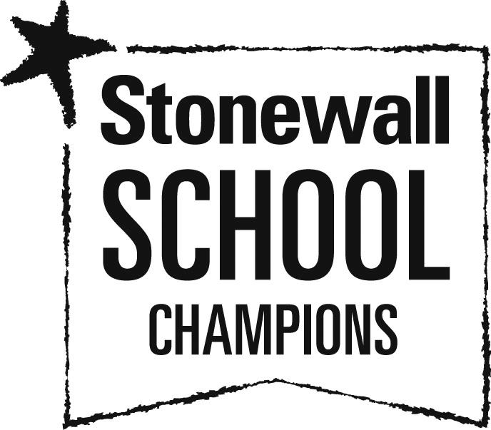

TEACHER JOB DESCRIPTION

JOB TITLE: Teacher
RESPONSIBLE TO: Headteacher
RESPONSIBLE FOR: Deployment of support staff allocated
Job Purpose
promote effective learning, appropriate achievement and educational, social and personal progress of all pupils for whom the teacher is designated as being responsible, consistent with the aims of the school and the unique needs of each individual.

KEY RESPONSIBILITIES:

1. Develop and maintain an up-to-date knowledge and understanding of the areas of teaching and pupil support for which post-holder is responsible
2. Plan work to meet the learning needs of allocated pupils in a consistent and effective way
3. Use appropriate teaching and classroom management strategies to motivate pupils and enable each to progress
4. Monitor the progress of pupils for whom the postholder is responsible to set expectations and give constructive feedback
- Maintain appropriate records to demonstrate progress made by pupils
- Participate fully in professional development activities to develop practice further, sharing the learning from these as appropriate
- Make an active contribution to the policies and aspirations of the school
- Lead on a specific subject area.

To fulfil all of the requirements and duties set out in the current Pay and Conditions Documents relating to the conditions of employment of teachers

To fulfil all of the responsibilities and duties required by the School’s policies on teaching and learning.

To achieve any performance criteria or targets arising from the School’s Performance Management arrangements

This job description will be reviewed annually.
Equal Opportunities

Kildwick CE VC Primary School supports the principle of equality of opportunity in employment and has a clearly stated policy for Equalities and a copy can be downloaded from www.northyorks.gov.uk.

Yours sincerely,

