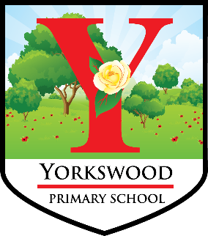
Yorkswood Primary School
Kingshurst Way
Kingshurst
B37 6DF
0121 779 8770

YORKSWOOD PRIMARY SCHOOL – TEACHING VACANCY FIXED TERM UNTIL AUGUST 2023.
The post is a Lower KS2 position and is offered as a fixed term contract, in the first instance.
Closing Date for Applications: Friday 06 January 2023
Interviews Week commencing Monday 09 January 2023.

Yorkswood School is looking to appoint an exciting and dedicated teacher to join our team. This exciting opportunity will start during February if possible or Monday 17 April 2023 if not (subject to availability)
Yorkswood School is ‘Proud to be AICE’.
We are proud to be a part of this vibrant new school and proud to be a significant part of our community. We are ‘A’ for achievement – looking for all children to achieve in all aspects of their school life and beyond. We are ‘I’ for Inclusion. In our recent OfSTED, it was recognised that our children and staff accept everybody and strive to make everybody feel welcome. We are ‘C’ for Commitment – expecting everybody to commit themselves to our journey and to each other. We are ‘E’ for enjoyment. A quick visit to our school and you will instantly recognise that children and staff create a warm, friendly and enjoyable environment.
At Yorkswood Primary School we offer:
- Fabulous children who are looking to make the best possible start to their learning journey.
- Fabulous staff who are committed to providing the lessons and broader school experiences which will enable a successful learning journey.
- Fabulous inclusion staff and partnerships, dedicated to families and community working.
- A new school building and associated facilities which form part of the wider regeneration of the area.
We intend to appoint someone who:
- Is an individual who can make an outstanding contribution to our school and our purpose.
- Is ambitious for themselves and for the school.
- Is an enthusiastic, highly motivated, team driven individual who will bring a sense of energy and passion to the role.
- Shares our beliefs, values and common purpose (Yorkswood is Proud to be AICE).
- Has ideas and wants to take a leading role in making a difference to children, families and the community.
- Is looking for development and further career opportunities.
For further information about the school please visit www.yorkswood.solihull.sch.uk.
Visits to the school are encouraged and welcomed.
If you would like to discuss this position, or require further information, please contact Mr Andy Tunstall (Headteacher) on 0121 779 8070 or 8771or email s61atunstall@yorkswood.solihull.sch.uk.
This school and Solihull MBC are committed to rigorous safeguarding procedures and the promotion of welfare systems for all children and young people. We expect all staff and volunteers to share this commitment. This post is subject to an enhanced DBS disclosure and clearance of all relevant safeguarding procedures.
Please note we do not accept CVs.
Solihull Council is proud to be an Equal Opportunities Employer. We celebrate diversity and are committed to creating an inclusive environment for all employees - a place where we can all be ourselves and succeed on merit.
Your application should be sent to:
Mr A D Tunstall – Yorkswood Primary School (address above)
or sent by email to: s61atunstall@yorkswood.solihull.sch.uk

