Lunchtime Supervisory Assistant
Recruitment Information Pack

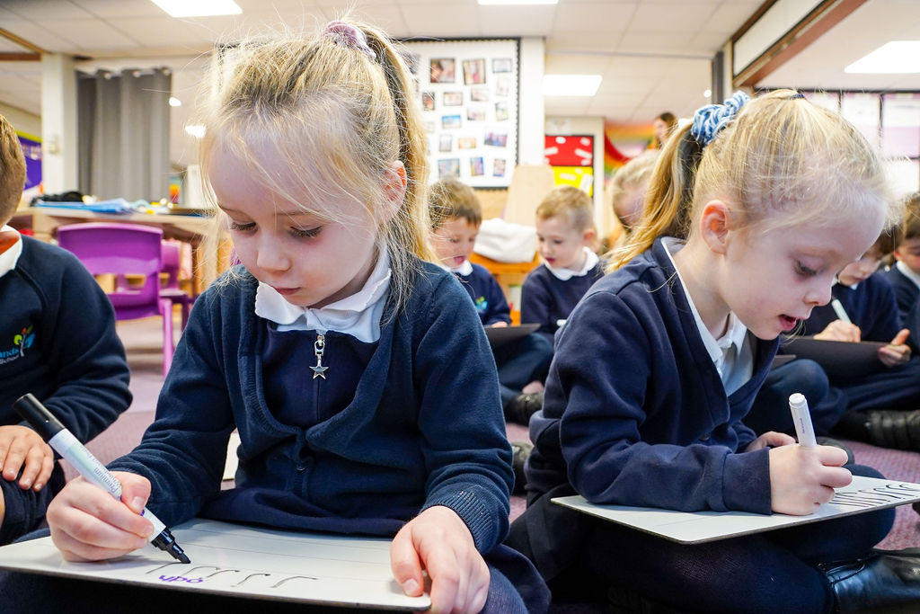

Ninelands Lane
Garforth
Leeds
LS25 1NT
office@ninelands-school.co.uk
www.ninelands-school.co.uk
@NinelandsPS

Lunchtime Supervisory Assistant
Recruitment Information Pack

Contents

Letter from Headteacher…..……………………………….............................……….…….. 3

Ninelands Primary School Mission Statement……………………………….………..……. 4

Application Process……………………....................………………………….…………………….5

Vacancy Advert………………….................................................................................6

Job Description…………………………………………………………………..…….…………………….8

Key Skills and Competencies...………………………………………………………….…………….9

Dear Applicant

Re: Lunchtime Supervisory Assistant

Thank you for your interest in our Lunchtime Supervisory Assistant post at Ninelands Primary School.

This is an exciting time for Ninelands Primary School, with a fairly newly established Senior Leadership Team and a ‘Good’ overall outcome following our May 2023 Ofsted inspection. We are looking for an inspirational and highly motivated practitioner who is particularly passionate about working with children in early Years.

Despite being the largest Primary School in Garforth, we are a friendly, close and supportive staff who work well as a team. Our Governing Body is knowledgeable, efficient and focussed on raising standards and is incredibly supportive of the school. We have an active PTFA, the Friends of Ninelands, who raise considerable funds for the school and have an excellent relationship with the school leadership. In short, Ninelands is an exciting, happy and stimulating place to work, and a good prospect for anyone looking to further their career.
I hope that after finding out more about our school, you will feel encouraged to apply for this post.

Yours in learning,

Mrs Katie Pashley
Headteacher

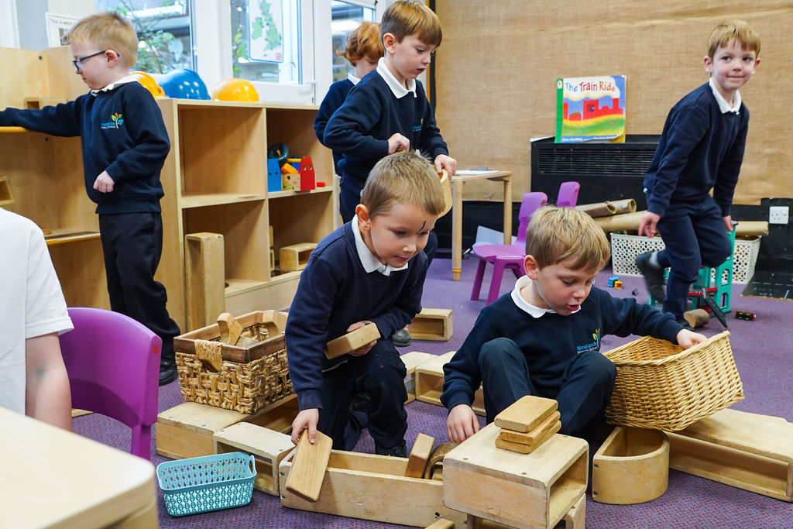

Ninelands Primary School Mission Statement

At Ninelands, we believe in making learning irresistible, meaningful and memorable. We want all our children to thrive in a happy, secure and inclusive environment where they develop enquiring minds, enjoy learning and have high aspirations, every lesson, every day. We challenge our children to be independent and self-motivated with the resilience to continue their lifelong learning journey so they can flourish, contributing positively to society with strength and compassion.

The aims of our school are:

- To develop enquiring minds, an enthusiasm for learning, and ability to co-operate and a desire to achieve.
- To encourage everyone to understand their strengths, creating growth mindsets which embrace challenge.
- To maintain a broad, balanced, exciting and meaningful curriculum which enables every child to experience success and a strong sense of achievement through a wide range of experiences.
- To promote self-discipline so that children become increasingly responsible for their own behaviour, growing themselves as self-reliant and self-motivated learners.
- To foster in all members of the school community, a positive appreciation of the importance of inclusion, diversity and cultural heritage, and of the role we all play in our society.
- For children to be a part of the school and wider town and city community and for them to understand and value how they can actively contribute.
- To establish and maintain positive relationships with parents and carers so their child’s learning journey is a partnership.
- To support, value and empower staff to create an environment that enables our aims and mission.

The Application Process

Interested candidates are welcome to contact Mrs Jackie Coyle, School Business Leader for further information on the post on 0113 2878370 or at office@ninelands-school.co.uk. Visit our website www.ninelands-school.co.uk and X (formerly known as twitter) @ninelandsps for more information about Ninelands Primary School.

How do I apply?
Please complete the relevant application form providing full details of your education and employment history, including any unpaid or voluntary work. Where there are gaps in your employment, please state the reasons why (e.g. gap year, career break, unemployed etc.). Use the job description and person specification as your guide and give specific examples, where possible, to demonstrate how you match the requirements for this post. We require details of two referees, one of which must be your current or most recent employer; if you currently work in school, the reference must be from the Headteacher. Please provide their names, email addresses and daytime contact numbers.

Supporting information
This section of the form is very important. It gives you an opportunity to explain why you are applying and why you are the best person for this job. Use the job description and person specification as your guide and give specific examples, where possible, to demonstrate how you match the requirements for this post detailing your experience and why you are an ideal candidates.

CVs are not accepted as part of the application process.
Where & when do I need to send my completed application?
Your completed application form and covering letter should be returned to office@ninelands-school.co.uk

Closing date: 05.01.26 8.00am
Interview Date: TBC

When will I hear if I have been shortlisted?
Applications will be evaluated against the requirements of the post, with those candidates that best fit the requirements being shortlisted. We are unable to contact all applicants, but all shortlisted candidates will be contacted by email or phone within 24 hours of the closing date. If you have any queries on any aspect of the application process or need additional information please contact Mrs Jackie Coyle, School Business Leader by email to office@ninelands-school.co.uk or telephone school on 0113 2878370.

Vacancy Advertisement
Lunchtime Supervisory Assistants x 3

Monday – Friday 12.00 pm - 1.00pm
5 hours per week TERM TIME ONLY
Grade A1- B1 (SCP 02 - 04) £24,480 FTE – £12.69 per hour

Ninelands Primary School is a large and popular two form entry school in Garforth, Leeds. The governing body are seeking to employ three Lunchtime Supervisory Assistants to work Mondays to Fridays. The successful candidates will supervise children during their lunch in the dining hall and supervise safe indoor / outdoor play, encouraging good behaviour, healthy eating and positive play during the lunchtime period.

No experience is necessary and full training will be given, however, enthusiasm and the ability to build good relationships with pupils, colleagues and visitors to the school is essential. The role would suit someone looking to gain experience of working in a primary school.

If you are interested in working at our successful school, then this is the job for you!

We are seeking an individual who:

- Works effectively as part of a team, having excellent communication skills
- Is able to work on their own initiative
- Has enthusiasm and passion for the job
- Is committed to delivering the best possible lunchtime provision for all our pupils

We can offer you:
- Respectful and motivated children who are curious and eager to explore
- a dedicated and professional staff team
- a well-resourced and attractive environment
- a happy school with strong support from its stakeholders
Hours of work are Monday to Friday, 12.00-1.00pm Term Time Only.
Interested candidatess are welcomed to contact Mrs Jackie Coyle, School Business Leader for further information on the post on 0113 2878370 or at office@ninelands-school.co.uk. Visit our website www.ninelands-school.co.uk for more information about Ninelands Primary.

Ninelands Primary School is committed to safeguarding and promoting the welfare of children and young people and expects all staff and volunteers to share this commitment. Appointments made are subject to a DBS enhanced check.

We promote diversity and want a workforce which reflects the populations of Leeds.

Enhanced Disclosure

Thank you for your interest in this post at Ninelands Primary School. The post you are applying for involves working with young people. It is therefore exempt from the Rehabilitation of Offenders Act and any offer of employment will be subject to an Enhanced Disclosure.

As an organisation assessing applicants’ suitability for positions which are included in the Rehabilitation of Offenders Act 1974 (Exceptions) Order using criminal record checks processed through the Disclosure and Barring Service (DBS), the School complies fully with the Code of Practice and undertakes to treat all applicants for positions fairly. The School undertakes not to discriminate unfairly against any subject of a criminal record check on the basis of a conviction or other information revealed.

An Enhanced Disclosure is carried out by the Disclosure and Barring Service (DBS) and will check criminal records for information on any convictions, cautions, reprimands and warnings held on the Police National Computer and on local Police records.

All information on criminal records provided both by you and within the Enhanced Disclosure will be used, stored and disposed of in confidence and in line with the Disclosure and Barring Service (DBS) Code of Practice of Disclosure Information.

If your application is shortlisted for an interview, you will be required to complete a self-disclosure form which must be returned to us at least one day prior to the interview. If we do not receive this, we reserve the right to withdraw the offer of interview.

If your application is successful and proceeds to the conditional offer stage, you will receive further information on how to complete the Enhanced Disclosure.

It is illegal to apply for this position if you are on the Children’s Barred List.

Ninelands Primary School has a written policy on the recruitment of ex-offenders, which is made available to all DBS applicants at the outset of the recruitment process. Further information can be found on our school website at http://www.ninelands-school.co.uk/nps_vacancies.html

We are committed to safeguarding and promoting the welfare of our pupils and expect all staff and volunteers to share this commitment.
Job Description

Responsible to: Headteacher

To actively supervise the pupils in the dining room / nursery / classroom, playground and throughout the school premises during the lunchtime period.

Main Duties

- Supporting pupils while they eat their lunch and making sure tables are clean and that water is available

- Ensure standards for healthy eating and table manners are maintained

- Report accidents to the Senior Lunchtime Supervisor and complete accident forms if necessary

- Ensure that school discipline policies are implemented

- Support the work of other Lunchtime Supervisory Assistants

- Support induction and training of new staff as required by the Senior Lunchtime Supervisor

- Respond to duty delegation as required by the Senior Lunchtime Supervisor

- Lead the children in the establishment of suitable outdoor games/activities

- Record inappropriate pupil behaviour and convey serious incidents to the Senior Lunchtime Supervisor
- Maintain checks throughout the lunch break to ensure pupils are safe

- Follow advice given by the Senior Lunchtime Supervisor on action to be taken in cases of inclement weather

- To undertake other duties that are commensurate with the post

Key Skills and Competencies

Essential Criteria | Desirable Criteria
Skills
- Ability to relate well to children and adults
- Can work constructively as part of a team
- Ability to engage children in play
- A calm, patient and understanding manner
- Good communication skills
Experience  - Experience of dealing with a wide range of people  - Experience of working as part of a team | - Working with or caring for children of relevant age
Knowledge and understanding
- General understanding of health and safety
Qualifications & Training  - Good standard of general education including Maths and English at GCSE grade C or above or equivalent | - Commitment to own personal development and training
Other conditions  - Holder of an Enhanced DBS | - Willingness to contribute to the wider success of school

