INFORMATION PACK
Lunchtime Organiser
Bright Futures Educational Trust
Bright Futures Educational Trust (The Trust) is a multi-academy trust set up in 2011. The Trust is made up of a richly diverse group of schools in Greater Manchester and Blackpool. We are passionate about working together within and beyond the Trust to achieve our aspirational vision: the best for everyone, the best from everyone. We are an organisation that is underpinned by values of: community, integrity and passion. In everything we do, we remember that we are accountable to the children, families and communities that we serve.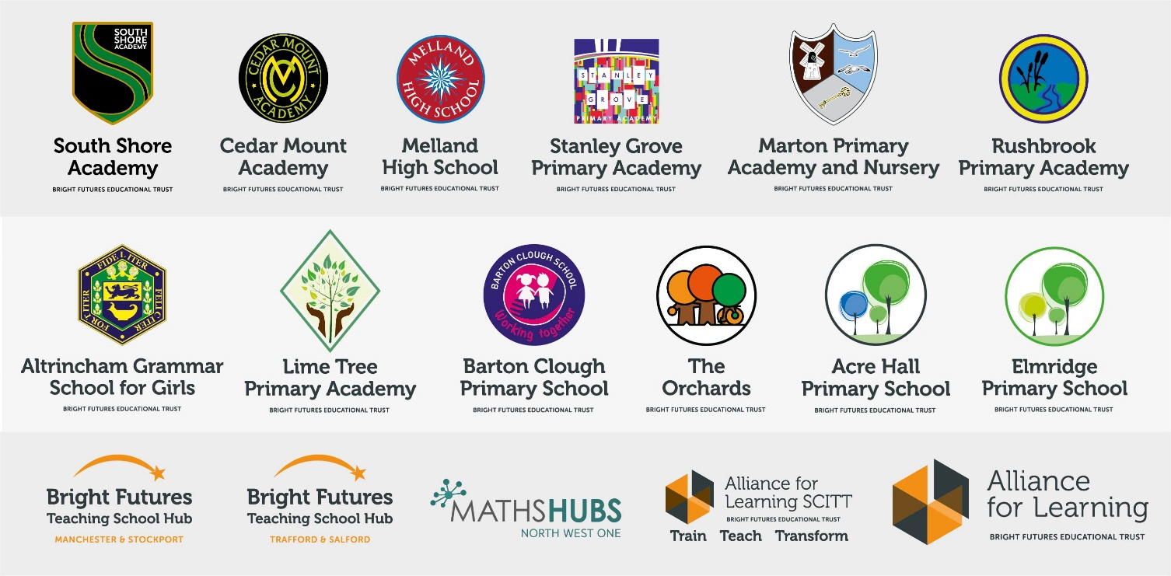
Our schools have their own identities and form one organisation and one employer, Bright Futures Educational Trust. Bright Futures’ Board of Trustees maintains strategic oversight of the Trust and delegates some of its responsibilities to the Executive Team, Principals and local governing bodies. We place a high value on integrity and probity and take seriously our accountabilities for making the best use of public money. How decisions are made is described in our delegation framework. You can find out more about the Trustees and the Executive Team on our website: http://bfet.co.uk/about-us/.

The central team, comprises the Executive Team: John Stephens, CEO; Edward Vitalis, Chief Operating Officer; Gary Handforth, Director of Education; Lisa Fathers, Director of Teaching School and Partnerships and Lynette Beckett, Director of HR & Strategy. The focus of these roles is to work with schools, providing high quality and timely guidance, leadership, challenge and support. In addition to the executive team, we have central operations for finance, HR, educational psychology and Digital Technologies. Please see our website brochure which explains our central operations: Working together for a Bright Future.
Bright Futures Development Network is another important outward facing component of our organisation. Underneath this umbrella we have 5 network hubs. ‘The Alliance for Learning’ (AFL) which provides school improvement services and CPD to over 700 schools (http://allianceforlearning.co.uk/); a North West Maths’ hub providing mathematics training and coaching to 500 schools: a SCITT (School Centered Initial Teacher Training) which is the largest in the North West. After significant national reforms to the teaching school policy, Bright Futures was designated with two new large-scale Teaching School Hubs in 2021. The areas we serve are Manchester, Stockport, Salford and Trafford.

Collaboration and strong relationships form one of the ‘commitments’ in our Strategy and all components of the Bright Futures’ family work closely together. Our Strategy was developed collaboratively and can be found on our website: Our Strategy.

Rushbrook Primary Academy

I am proud to welcome you to Rushbrook Academy, the ‘Rushbrook Family’ as we are known.

Our school is a happy school. We have a vibrant, friendly and welcoming environment with a diverse group of pupils and staff. The behaviour of our pupils is very important and we place great importance on aiming for, and achieving high standards in everything that we do.

We have a Nursery for 40 children aged 3-4 years old and we have a three-form intake from Reception upwards. We have a free breakfast club each day for all our pupils and many after school enrichment clubs.
Developing a lifelong love of learning is at the heart of all we do at Rushbrook. We believe that all pupils are entitled to a curriculum which is exciting and engaging. Children are supported in developing their skills across a broad range of subjects. There are also many opportunities for enrichment of the curriculum, including after school clubs and educational visits.
Our vision at Rushbrook is to support every child in their quest to become the best they can be, through engaging them in our rich learning environment and caring for them with genuine affection. We foster a passion for learning and exploration that will last the children a lifetime, and instil in them moral values which respect the environment as well as people and their cultures. Our children leave us with excellent skills of independence, an ability to engage in meaningful play, and knowledge that they are capable and valuable members of the community.
I have been a senior leader in primary schools in Manchester for many years and I value our local community. Since joining Rushbrook in September 2019 I have worked closely with the staff and governing body to identify the changes that we need to make, the areas that we need to improve, and establish what our pupils and parents value at the school. We have made significant improvements to making the classrooms engaging, developing our enrichment clubs and working closer with parents. I am excited to be on the journey of improvement at Rushbrook Academy and our ambition is that the school improves greatly over time, results increase year on year, children enjoy their time with us and achieve the very best that they can in all aspects of their learning.

Rushbrook Academy is proud to be part of the Bright Futures Educational Trust. Being part of the Trust provides a wide range of opportunities and gives pupils direct access to our partner high school, Cedar Mount.
I welcome you to come and visit the school to see what we have to offer, see our environment and meet some of our staff.

Matt Carroll
Principal

Why work for us?

We offer a great opportunity to join an organisation which really lives its values. Our working environment is very inclusive and whilst you can expect to be challenged in your role, you will be supported through professional learning, treated fairly and with dignity and respect. Please see the Equality, diversity and inclusion statement on our website: http://bfet.co.uk/vacancies/.

Terms and Conditions
Salary: NJC scale points 1 (Bright Futures Grade 1 point 1). The full time equivalent pay is £17,842. The actual pay based on the below working pattern is £4.350 per annum actual pay.

Working weeks: This is a great opportunity for flexible working as the role will work 38 weeks during school term time.
Hours: 10 hours per week over 5 days. Flexible working will be considered, please discuss at interview if you wish this to be considered.
Holidays: You will be paid for the prorata equivalent of 25 days, plus 8 public holidays. This increases to 30 days plus 8 public holidays after 5 years’ service.
Pension: Local government pension scheme. Please take a look at the website: https://www.gmpf.org.uk/

Other: We offer salary sacrifice schemes for purchasing cycles and technology, through monthly interest free salary deductions.
How to Apply
We can only accept completed application forms, rather than CVs. This is because the regulatory guidelines of Keeping Children Safe in Education, require us to check various details of job applicants and an identical application format for each candidate enables us to do this.
Application forms and criminal disclosure forms will need to be completed by 12 noon on Friday 24th September 2021 using this link https://bfet.jotform.com/211106351650947

The selection process may or may not be conducted virtually, so candidates will need access to a device with a camera and a microphone to participate. The selection will take place during week commencing 27th September 2021.

Keeping Children Safe in Education
Bright Futures Educational Trust is committed to safeguarding and promoting the welfare of children and young people and we expect all staff and volunteers to share this commitment. This post is exempt from the Rehabilitation of Offenders Act 1974; pre-employment checks will be carried out and references will be sought for shortlisted candidates and successful candidates will be subject to an enhanced DBS check and other relevant checks with statutory bodies.
Data Privacy
You can the details of how we use the personal data that you provide us with in our Job Applicants’ privacy notice on our website: http://bfet.co.uk/wp-content/uploads/2018/07/BFET-Applicant-privacy-notice-002.pdf

