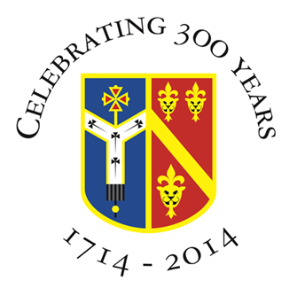

Archbishop Tenison’s CE High School
Selborne Road, Croydon CR0 5JQ
Tel: 020 8688 4014
www.archten.croydon.sch.uk

Job Title: Lunchtime Supervisor

School: Archbishop Tenison’s CE School

Hours: 12.30pm – 13.50 Monday to Friday (6 ¼ hours per week term-time only)

Salary: Grade1 Point 2 to 3 (£25,854.00 -£26,238.00 (pro rata)

Reports to: Deputy Headteacher

Responsible for: Supervising pupils during lunchtimes

Required by: As soon as possible

Closing Date: Friday 15th November 2024

We are seeking a reliable and enthusiastic Lunchtime Supervisor to join our team to ensure the safety and well-being of pupils during lunch times.

Archbishop Tenison’s CofE School is a 11-18 Church of England mixed comprehensive school. We have a distinctive character and purpose. Our school motto is ‘Academic excellence for each person in a Christian community’ and we aim to instil these values in everything that goes on at Tenison’s.

Overview of Role (see full Job Description):

- Supervise pupils in the dining hall, outside areas, and other areas during lunchtimes
- Ensure pupils follow the school rules and promote positive behaviour
- Support pupils with any issues or concerns, acting as a point of contact
- Assist in setting up and tidying the lunch areas
- Deal with minor incidents or accidents, following the school’s health and safety procedures
- Report any serious incidents to senior members of staff.

Requirements:
- Previous experience working with children or young people (desirable but not essential)
- Strong communication and interpersonal skills
- A calm, patient, and friendly attitude
- Ability to manage situations fairly
- Commitment to the safeguarding and welfare of all pupils
- Willingness to undergo a DBS check (Disclosure and Barring Service).

What We Offer:
- A supportive and friendly school community
- Opportunity to make a positive impact on young people’s lives.

How to apply
If you would like to apply, please submit your application and a covering letter to Mr Parrish, Headteacher detailing your suitability for the role by 15th November. Please visit the staff recruitment page via the school website https://www.archten.croydon.sch.uk/staffrecruitment

Total number of pupils - 793 pupils (Sixth Form 76)

Archbishop Tenison's is an equal opportunities employer and committed to safeguarding and promoting the welfare of children. Successful candidates will be required to undertake an enhanced Disclosure check by the Criminal Records Bureau; online checks will be carried out.

