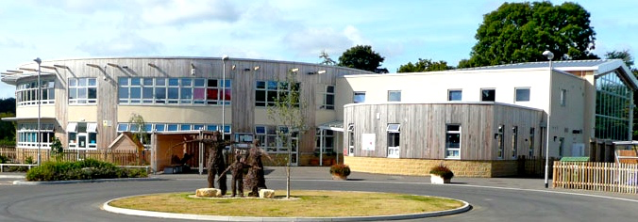

|  |  |
| --- | --- |
| **Job vacancy title** | **Lunchtime Supervisor (MDSA) (10 hrs)** |
| **Salary range** | Grade B – SCP2, £12.26 per hour plus enrolment into the local government pension scheme.  Actual pay per annum: £5,357 - £5,478 |
| **Hours of work** | 11:15 to 13:15 Monday to Friday (10 hours per week), term time only (38 weeks per year). |
| **Contract type** | Permanent |
| **Planned start date** | As soon as possible |
| **Closing date for applications** | 21st August 2025 |
| **Interview date** | 1st September 2025 |
| **Job Location** | Malmesbury C of E Primary School |
| Malmesbury C of E Primary School is a thriving, two-form entry primary school, rated 'Good' by OFSTED in June 2024. With a dedicated and enthusiastic team, we aim to make learning both challenging and fun, ensuring that every child experiences an exciting, infectious, and rewarding educational journey.  We wish to appoint a committed and caring lunchtime assistant to join our outstanding staff team. They must share our aspiration of ‘growing together in wisdom and love; discovering life in all its fullness’ for every child in our care. This post will be to serve food from our dispensary to pupils, and supervise in the hall and then help clean in the hall in preparation for afternoon lessons. Please see the job description for a full list of responsibilities.  **We wish to appoint someone who:**   * Is an excellent team worker. * Is passionate about working with children of all ages and supporting them to achieve independence. * Can build positive relationships and relate well to a wide range of children and adults. * Can support our values of respect, kindness, courage, creativity and love and is sympathetic to our Christian foundation.   **We can offer you:**   * A friendly, collaborative environment where all professionals work as a team. * The chance to work with some wonderful children. * Membership of the Local Government Pension Scheme.   **Additional information**  A full application pack is available from the school’s website ([www.malmesburyprimaryschool.co.uk](http://www.malmesburyprimaryschool.co.uk)) or by contacting the school.  Visits to the school are encouraged. Please contact the school office to arrange a visit (01666 823514) or [hr@malmesbury-pri.wilts.sch.uk](mailto:hr@malmesbury-pri.wilts.sch.uk)  **Malmesbury C of E Primary School is committed to safeguarding and promoting the welfare of children and young people and expects all staff and volunteers to share this commitment. All applicants will be subject to an enhanced Disclosure and Barring Service check before appointment is confirmed. Full training in Child Protection must be undertaken before taking up post and all appointments are subject to satisfactory references.**  Our academy trust believes firmly in equality of opportunity in employment. It therefore commits itself to developing policies, practices and procedures, which promote equality of opportunity and anti-discriminatory practices. To this end our academy is committed to ensuring that job applicants or employees receive equality of treatment. No applicant or employee will receive less favourable treatment on the grounds of race, colour, nationality, ethnic or national origin, sex or marital status, disability, sexual orientation, age, religious beliefs and practices or offending background, nor be disadvantaged by conditions or requirements which cannot be shown to be justifiable. | |