



Lunchtime Support Assistant

Childhaven Community Nursery School

Recruitment Information Pack



Contents

About the School 3
Application Process 4
Job Description and Person Specification 5
Applying for a job with North Yorkshire Council 8



Childhaven Community Nursery School

Discover, Play, Learn – Providing Outstanding Early Education

An OUTSTANDING school in the heart of Scarborough, at Childhaven, we are committed to supporting our children develop into resilient, independent life-long learners. We were judged to be OUTSTANDING by Ofsted in 2012,2015, 2019, and then again in 2024!

We provide a vibrant, welcoming and inspirational setting and serve the communities around the Scarborough Town. We are one of only 3 maintained nursery schools in North Yorkshire and we offer children a unique start to their education. Children aged between 2 and 4 play and learn together in our wonderful Victorian building and garden.

As a designated DfE Early Years Stronger Practice Hub we share best practice and are committed to training the next generation of teachers and support staff.

Thank you for your interest in joining our team. This is an exciting time for us as we strengthen and develop our nurturing provision for our children, as we support children with a wide range of additional needs.

We look forward to receiving your application.

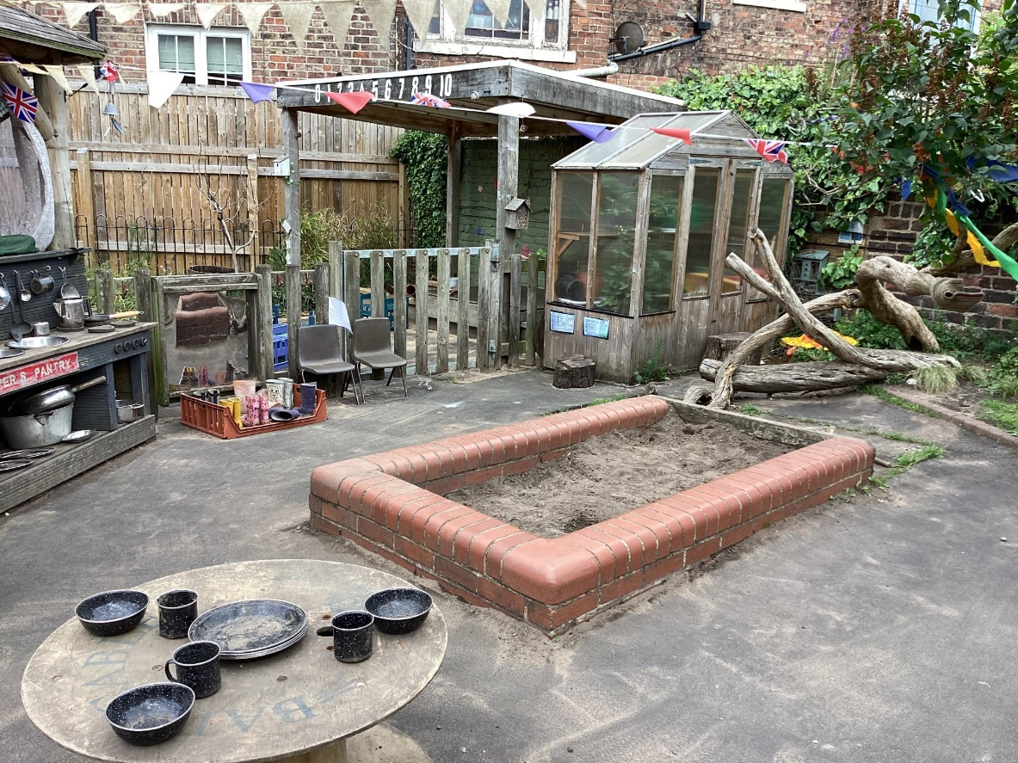

Application Process
Please apply via NYC Jobs

The closing date for all applications is 11:59pm Tuesday 17th March 2026

Interviews will be held Monday 23rd March, 11am

An email will be sent to candidates with details of the shortlisting process.
We do not accept CV’s.
Please get in touch if you require the form to be sent in a different format.

Queries
Please contact Chloe Bullen on 01609 536 964 or via chloe.bullen@northyorks.gov.uk
Chloe has been engaged to support us with recruiting to this exciting opportunity.



Job Description

Post title: | Midday Supervisory Assistant (MSA)
Grade: | AB
Responsible to: | Senior MSA or Office Manager
Staff managed: | None
Directorate: | Children and Young People's Service
School name:
Job family: | C&S - Care & Support
Date of issue: | August 2023

Safeguarding Statement | - Required to work indoors and outdoors when supervising the children and young people to ensure their safety.  - Enhanced DBS Clearance required
Job Purpose: | - To work as part of a team monitoring pupil behaviour during the midday break to ensure a caring and safe environment.
Operational Issues: | - Supervise children whilst eating.  - Engage children in conversations and support them in their indpendence  - Assist with the removal of food and equipment once pupils have eaten their lunch.  - Deal with minor first aid incidents; follow appropriate procedures for recording and reporting (if in possession of a Paediatric First Aid qualification)  - Assist in the implementation of appropriate behaviour management strategies as required  - Observe a child or young person’s behaviour, understand its context, and notice any unexpected changes and report any inappropriate behaviour to the correct member of staff.  - Assist in the supervision of other activities during the midday break, including setting out and storing equipment
Communications: | - Establish rapport and respectful, trusting relationships with children, young people and those caring for them.  - Report any concerns about pupil welfare to the appropriate member of staff in a confidential manner.  - Communicate effectively with all staff, pupils, families and carers.  - Provide support and encouragement to children and young people.
Safeguarding | - To be committed to safeguarding and promote the welfare of children, young people and adults, raising concerns as appropriate.  - Be aware of and comply with policies and procedures relating to child protection, confidentiality, health, safety and security.  - Be aware of own (and others’) professional boundaries.  - Be responsible for promoting and safeguarding the welfare of children and young people that you are responsible for and come into contact with
Systems and information: | - Participate in the school’s performance management scheme.  - Participate in training and other learning activities and performance development as required.  - Attend staff meetings and training days by agreement with the Headteacher.

Person Specification:
Essential | Desirable
Knowledge and Experience  - Awareness of health and hygiene issues  - Experience appropriate to working with children | - Behaviour management.  - Good written and verbal communication skills.
Occupational Skills
- Judgemental skills
- Demonstrable interpersonal skills.
- Ability to work successfully in a team.
- Confidentiality.
- Initiative
Behaviours
- link
Qualifications  - English and Maths GCSE level ‘C’ equivalent | - Appropriate first aid training or willingness to undertake training
Other Requirements  - Enhanced DBS Clearance  - To be committed to the school’s policies and ethos.  - To be committed to Continual Professional Development.  - Motivation to work with children and young people.  - Ability to form and maintain appropriate relationships and personal boundaries with children and young people.  - Emotional resilience in working with challenging behaviours; and attitudes to use authority and maintaining discipline.  - To assist in ensuring that NYC’s equalities policies are considered within the school’s working practices in terms of both employment and service delivery. | - Creativity

APPLYING FOR A JOB WITH NORTH YORKSHIRE COUNCIL
IMPORTANT ADVICE ON COMPLETING THIS APPLICATION

Your application form plays an important part in your selection. Please ensure you address all the essential requirements listed in the specifications. The following advice should help you to complete the application form as effectively as possible.
Data Protection
The information that you state on this application form will be used by the school and the Council to consider you for a job vacancy. To find out about how we use your personal data for the purposes of recruitment please see our Privacy Notice at www.northyorks.gov.uk/working-us.

Rehabilitation of Offenders
The post you are applying for requires you to have an enhanced Disclosure and Barring Service criminal records check for work with children, with a barred list check if you work in regulated activity. This check for disclosure of criminal history will include spent convictions, pending prosecutions / current court proceeding and police enquiries.

Should you be shortlisted, you will be asked to disclose full details of your criminal history prior to your interview. This includes any information deemed relevant as part of Keeping Children Safe in Education which may arise in an online search undertaken on shortlisted candidates. This information may be discussed with you at your interview in order to assess job related risks, but we emphasise that your application will be considered on merit and ability and you will not be discriminated against unfairly. Failure to disclose this information will result in any offer of employment being withdrawn.

Please also see the policy statement on the Recruitment of Ex-offenders below.

Information in Support of your Application
Every post advertised is supported by a full person specification. The specification lists all the essential skills, experience and qualifications which are necessary for the job and the criteria against which you will be assessed, both through your application form and at interview.

As part of the application process, you may have been asked to demonstrate within this application form how you meet some or all of the criteria or key competencies outlined in the person specification. Rather than simply repeating your career history, look at the skills and experience required by the job and provide evidence that you possess them by giving specific and detailed examples which include a focus on outcomes and on your own contribution to the scenario. Try to use different and varied examples wherever possible.

When completing these sections, do not forget the skills and experience you have gained outside full-time work. Outlining your previous work experience or other responsibilities may help you to uncover skills which you have taken for granted and which are clear signs of your ability to do the job.

Canvassing
You must not try to influence an elected Council Member, any council employee or a member of the school governing body, to act in your favour, as this will disqualify you. If you are related to a Councillor, a Council employee or a governor you must indicate this in the relevant section of the application form.

Policy Statement on the Recruitment of Ex-offenders
(Source www.gov.uk)
- As an organisation assessing applicants’ suitability for positions which are included in the Rehabilitation of Offenders Act 1974 (Exceptions) Order using criminal record checks processed through the Disclosure and Barring Service (DBS), this school complies fully with the DBS code of practice and undertakes to treat all applicants for positions fairly.

- This school undertakes not to discriminate unfairly against any subject of a criminal record check on the basis of a conviction or other information revealed.

- This school can only ask an individual to provide details of convictions and cautions that it is legally entitled to know about. Where a DBS certificate can legally be requested (where the position is one that is included in the Rehabilitation of Offenders Act 1974 (Exceptions) order 1975 as amended, and where appropriate Policy Act Regulations as amended) this school can only ask an individual about convictions and cautions that are not protected.

- This school is committed to the fair treatment of its staff and potential staff, regardless of race, gender, religion, sexual orientation, responsibilities for dependents, age, physical/mental disability or offending background.

- This school has this written policy on the recruitment of ex-offenders, which is made available to all DBS applicants at the start of the recruitment process.

- This school actively promotes equality of opportunity for all with the right mix of talent, skills and potential and welcome applications from a wide range of candidates, including those with criminal records. Candidates are selected for interview based on their skills, qualifications and experience and criminal record information is only requested from short-listed candidates.

- A disclosure is only requested from the DBS after a thorough risk assessment has indicated that one is both proportionate and relevant to the position concerned. For those positions where a criminal record check is identified as necessary, all application forms, job adverts and recruitment briefs will contain a statement that a DBS certificate will be requested in the event of the individual being offered the position.

- This school ensures that all those who are involved in the recruitment process have been suitably trained to identify and assess the relevance and circumstances of offences.

- This school also ensures that they have received appropriate guidance and training in the relevant legislation relating to the employment of ex-offenders, e.g. the Rehabilitation of Offenders Act 1974.

- At interview, or in a separate discussion, this school ensures that an open and measured discussion takes place on the subject of any offences or other matter that might be relevant to the position. Failure to reveal information that is directly relevant to the position sought could lead to withdrawal of an offer of employment.

- This school makes every subject of a criminal record check submitted to DBS aware of the existence of the code of practice and makes a copy available on request.

- This school undertakes to discuss any matter revealed on a DBS certificate with the individual seeking the position before withdrawing a conditional offer of employment.

