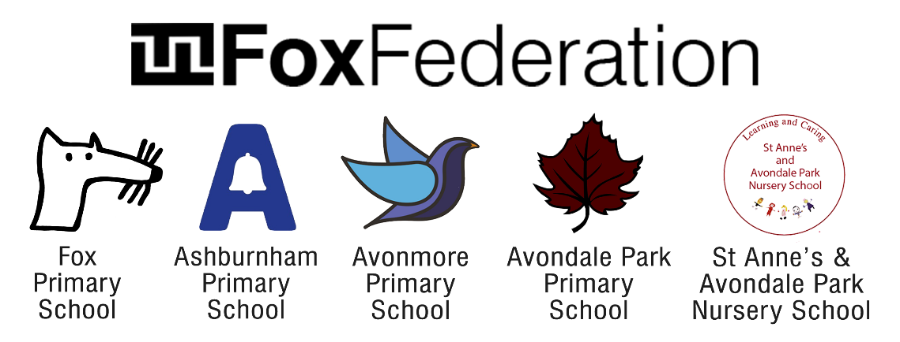

Respect, Resilience, Collaboration, Curiosity and Inclusion.

Position: Main Pay Scale Class Teachers (ECTs welcome to apply)

Required for: Fox Federation

Closing Date: Tuesday 18th April 2023

Interview Dates: 1st Round via zoom - Thursday 20th April

2nd Round in person - Thursday 27th April 2023

We are committed to building a diverse team and strongly encourage applications from underrepresented groups such as people from minority ethnic backgrounds, LGBTQ+ people and people with disabilities

Fox Federation is a passionate community of 4 schools and a nursery working collaboratively to ensure equal access to consistent, excellent education for all pupils. Our schools are Fox Primary School in Notting Hill, Ashburnham Community School in Chelsea, Avondale Park Primary School & St Anne’s Nursery in North Kensington and Avonmore Primary School in Olympia.

Our schools are nurturing places to work, committed to innovation and have high academic standards. Teachers who join our team are supported to grow and develop outstanding practice through exceptional CPD and support from a warm, passionate team of dedicated teachers and leaders.

We are looking for inspiring teachers to work in all our schools from 1st Sept 2023. The positions would suit ECTs or experienced teachers. We offer competitive salaries and pay progression and, as a Federation, there are opportunities for staff to progress into areas of expertise and passion across the Federation.
If you are ambitious and determined to make a difference, we would like to meet you.
What the school staff say about the Fox Federation:
‘Fantastic schools. Great staff. Supportive leadership team. Amazing children.’
‘A genuine educational family, providing a community beyond our gates. A network of schools, committed to providing the best education for children whilst creating a safe a happy place for them.’

‘It is incredible to be surrounded by so many competent, hard-working, passionate people - so committed to delivering fantastic education opportunities to our pupils.’
‘Management are always available to speak with, unbelievably approachable and create time to listen and come up with solutions.’
‘It is run in an extremely compassionate, supportive and nurturing manner for both staff and pupils, and I really do feel that the wellbeing of the whole community is at the heart of the school's ethos.’
‘A place of supportive colleagues who are constantly striving to improve what we do for our children and families.’

‘A shared vision of always going the extra mile to support and care for the families in our community.’

‘It is somewhere that has nurtured my career, but also a place where I have met friends that I know will be friends for life.’

‘The Fox Federation is an incredible support network of teachers and staff working together to ensure children's education is kept at the highest possible standard.’

Our ideal candidates would:
- Be hard working, flexible and resilient.
- Be friendly and want to be part of a team, who embodies our schools’ values and vision for excellence.
- Be willing to learn, reflect and become an excellent classroom practitioner who is self- reflective and is ambitious for our children.
- Be a skilled communicator with the potential to support staff through sharing best practice to get the best out of others.
- Be committed to inclusion and understand that different children learn in different ways and have a range of skills to ensure all children reach their full potential in all areas of school life.
- Enjoy teaching and want to make a real difference.

What else do we offer?

- An experienced Leadership Team with a shared vision working in partnership across the Federation.
- Hard-working leaders who strive to ensure that both pupils and staff enjoy coming to school.
- We are passionate about supporting our teachers in their career development and success through care and guidance.
- A working environment that values wellbeing and supports work-life balance through working in partnership across year groups, co-planning, mentoring etc.
- Vibrant, multicultural and inclusive city schools that have positive, diverse communities and a determination that all children will succeed.
- A comprehensive range of CPD for all our staff through the partnership including maths hub projects, mentoring and coaching to support career progression at all levels of your career.
- Well-behaved children who love to learn.
- A relaxed and fun working environment where all adults are equally valued and supported.

Please look at the school’s websites to get a feel for our schools. Shortlisted candidates who are successful after round 1 are welcome to visit our schools prior to round 2.

The schools and the local authorities are committed to safeguarding and promoting the welfare of children and young people and expect to share this commitment. An enhanced Criminal Records Bureau Certificate is required for this post prior to commencement.
For an application pack please contact Michelle.Foster@foxprimary.co.uk
Recommended Resources for Interview

https://www.ted.com/talks/christopher_emdin_teach_teachers_how_to_create_magic

https://www.ted.com/talks/rita_pierson_every_kid_needs_a_champion

https://www.ted.com/talks/taylor_mali_what_teachers_make

