Bedale Church of England Primary School

Firby Road
Bedale
North Yorkshire
DL8 2AT

Headteacher: Mrs Elizabeth Turnbull
______________________________________________________________________________

School Telephone: 01677 422401

E-mail: admin@bedale-ce.n-yorks.sch.uk

Dear Sir/Madam May 2022

Thank you for your interest in the post of Class Teacher at our school. We are seeking to appoint a dedicated and outstanding professional on a fixed term contract from September 2022 to August 2023.

The successful applicant will be an enthusiastic and inspirational teacher. They will also be able to utilise excellent interpersonal skills and have the ability to work effectively as part of a team.

This post is ideally suited to someone who is interested in their own professional development and is looking for opportunities to progress their career.

Please ensure that your areas of interests and strengths are clearly outlined within your application.

After reading the job description and person specification carefully, please support your application with a covering letter which outlines how your knowledge, skills and experience relate to this post. This letter should be no longer than two sides of A4.

To receive an electronic copy of the application pack, please email admin@bedale-ce.n-yorks.sch.uk.

Visits to the school are strongly encouraged. These are available on Monday 28th March at
10.30 am or 3.30 pm or Wednesday 30th March at 4.00 pm. Please contact Sara Pennock to make an appointment. Applications are to be returned by 9.00 am on Thursday 7th April 2022. Interview date is to be confirmed.

Please find enclosed the following:

1. Job Description
2. Person Specification
3. Application Form

Yours faithfully

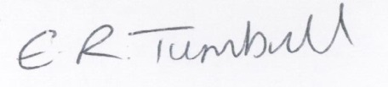

Mrs E Turnbull, Headteacher

