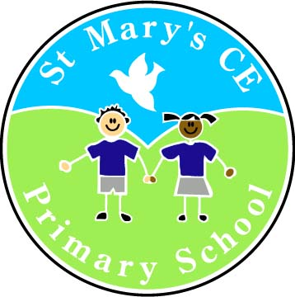 | St Mary’s CE Primary School, Deane  www.st-marys-deane.bolton.sch.uk  office@st-marys-deane.bolton.sch.uk  01204 333494

MAINSCALE CLASS TEACHER – KEY STAGE ONE
FULL TIME
FIXED TERM FOR 12 MONTHS WITH THE POSSIBILITY OF BECOMING PERMANENT

Required to start September 2025

The Governors at St Mary’s CE Primary School are seeking to appoint a Class Teacher, working within Key Stage One, to join our outstanding team.

Candidates must:
- have experience of whole class teaching in Key Stage One
- have outstanding teaching skills which motivate and inspire children
- demonstrate a commitment to establishing high expectations
- have excellent interpersonal skills and be able to develop effective relationships with colleagues, parents and the wider school community
- be reflective and able to respond positively to feedback
- be prepared to contribute to all aspects of school life
- be enthusiastic, professional and friendly.

Early Career Teachers are welcome to apply.

Candidates are encouraged to visit the school prior to applying for the post. Please contact the school office to arrange a visit on 01204 333494.

Completed application forms should be returned to the Ross Powell (Headteacher) by 4:00pm on Friday 30th May. Shortlisted candidates will be invited into school for a lesson observation. If successful at this stage, candidates will be invited to interview on Thursday 12th June.

The school is committed to safeguarding and promoting the welfare of children and young people and expects all staff and volunteers to share this commitment. This post is subject to a fully enhanced DBS check.

